View this in your browser
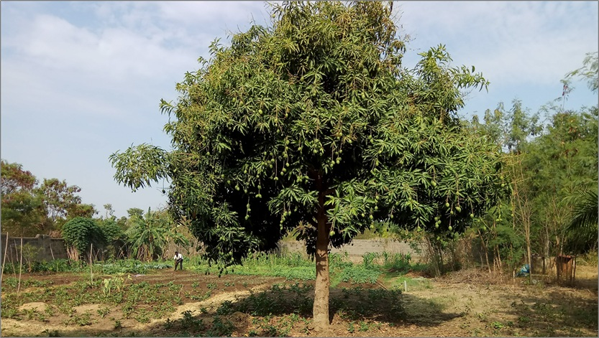

The Structure of Prosperity: Constraint

“Improvement can increase effort without improving outcomes.”

Misconception. In the early agricultural settlements established under the Ottoman Empire, where the State of Israel sits today, in the second half of the 19th century, known as Moshavot (the Hebrew word for village), farmers received financial support, access to modern agricultural knowledge, and infrastructure designed to support agricultural production. The settlers were educated, and significant resources were invested in their success. Over time, effort increased, new methods were introduced, and activity expanded across the system. Yet despite these improvements, the economic outcomes of these communities remained constrained, and many continued to depend on external support. As effort increased and activity expanded, results did not improve in proportion; the system became more active, but not more effective. This outcome contradicts the common assumption that increasing inputs necessarily improves results. What appears to be a need for more input is, in fact, a structural condition in which additional activity intensifies the system's limits rather than resolving them. This condition does not remain confined to specific cases but appears systematically as systems expand their activity.

Effort
Across systems, a consistent pattern emerges in which effort increases, activity expands, and outcomes fail to improve proportionally. In agricultural systems, yields can rise significantly while income per hectare remains largely unchanged, revealing a widening gap between activity and outcome. In organizations, teams grow, resources increase, and operations become more sophisticated, yet effectiveness declines as friction accumulates. In social systems, communities expand and diversify yet struggle to maintain coherence as the complexity of their internal relationships increases. In each case, effort intensifies, capability appears to expand, and activity grows, yet progress slows and, in some cases, reverses.
In many cases, this deterioration is not immediately visible because systems approaching their structural limits can continue to produce results that look like success. Output may rise, participation may increase, and visible indicators of growth may remain positive, yet the system’s ability to translate activity into coherent outcomes weakens. This creates a divergence between what the system does and what it achieves, explaining why systems often appear strongest just as they become most fragile. This pattern cannot be explained by a lack of effort, knowledge, or technology, since all three often increase even as outcomes deteriorate. Farmers adopt better methods, organizations invest in new tools, and communities accumulate experience, yet the gap between effort and outcome persists.
The problem, therefore, does not lie in what is being added to the system but in the structure that can no longer organize it. As effort continues to increase, actions that once improved performance yield diminishing returns and, in some cases, intensify friction and instability. At this stage, the problem is no longer insufficient effort but the structure's inability to translate increasing activity into coherent outcomes.

Capacity
The pattern described above points to a limit that is not immediately apparent while systems are still expanding, yet becomes increasingly dominant as their internal complexity grows. This limit does not arise from a shortage of resources, effort, or knowledge, but from the system itself, which must sustain the relationships it creates.
Every structure has a finite capacity to sustain coherence across the relationships it organizes. As long as this coherence is maintained, growth can increase capability. Once this capacity is approached, coherence begins to weaken, even as activity continues to expand. This limit is rarely visible in advance and is often recognized only when the system begins to struggle under the weight of its own activity. Systems that appear similar in their resources or intentions can therefore diverge significantly in their outcomes, depending on how much complexity their structure can sustain.
As this capacity is approached, the nature of improvement shifts. Actions that once enhanced performance yield diminishing returns, and additional activity places increasing pressure on a structure that can no longer absorb it. Growth remains visible, yet its ability to translate into coherent performance diminishes. At this point, the system has not yet broken down, but the conditions for strain are already forming. Beyond this point, the system no longer operates within its capacity but under conditions that begin to undermine its coherence.

Strain
As systems approach their structural capacity, the behavior of improvement begins to reverse. Actions that once contributed to progress start to yield diminishing returns and, in some cases, create instability. The system continues to expand its activity, yet its ability to sustain coherence begins to deteriorate, not as a sudden collapse but as a gradual loss of coordination across the relationships it depends on.
This deterioration does not stem from isolated failures but from the accumulation of interactions that can no longer be coordinated. As coherence weakens, disruptions no longer remain localized but begin to propagate across the system, affecting components that may still be functioning correctly. What appears to be a series of independent problems is, in fact, a single structural condition in which the system can no longer sustain the relationships it has created. Coordination becomes increasingly difficult, decisions diverge, and actions that once reinforced one another begin to interfere.
At this stage, improvement within the existing structure begins to lose effectiveness, as additional effort intensifies the conditions that are already straining. When structure becomes the constraint, improvement intensifies the problem rather than resolving it. The system does not fail because it lacks resources or capability, but because the structure that organizes those resources can no longer sustain the level of complexity it has created. Strain is no longer temporary but becomes a persistent condition as the system operates at its limits.

Inertia
As strain persists, systems rarely depart from the structures that produce it. Instead, they continue to operate within arrangements that can no longer sustain their level of complexity, maintaining activity even as coherence declines. This persistence is not accidental but reflects a structural condition in which the system depends on the very relationships that constrain it. The system relies on its existing structure to continue operating, making the arrangement that must change also the one that sustains it in the present. Relationships, roles, and flows become embedded in the system’s functioning, shaping how decisions are made and resources are allocated. As a result, change is not simply a matter of redesign, but of altering the structure the system depends on to continue operating.
In response to emerging problems, systems attempt to improve performance by making adjustments within the existing structure. New tools are introduced, additional layers of coordination are added, and localized improvements are implemented. While these measures may provide temporary relief, they do not address the underlying constraint. Instead, they further increase complexity, adding new interactions that must be coordinated and thereby intensifying the conditions that produced the problem. The system becomes caught in a cycle in which each attempt to solve the problem reinforces the structure that sustains it. As structures become more complex, they tend to reinforce the arrangements that sustain them, making alternative configurations increasingly difficult to realize.
As this condition intensifies, the system becomes increasingly constrained by the structure on which it depends. The closer it operates to its limits, the more its responses reinforce the conditions that sustain those limits. What emerges is not simply resistance to change but a structural inertia, in which the system remains locked into a pattern of behavior it can no longer sustain yet cannot easily alter.

Reversal
The progression shown in this column leads to a condition in which the forces that once enabled systems to grow begin to produce the opposite effect. Complexity, which initially expands what a system can achieve by enabling specialization and interdependence, becomes a source of vulnerability when the structure that must organize it can no longer maintain coherence. What begins as an advantage becomes a liability, not because complexity itself is undesirable, but because its benefits depend on the system’s ability to coordinate the relationships it creates. This transition does not occur because the system loses capability, but because it loses the coherence required to sustain it. Systems can continue to expand their activity, accumulate resources, and develop increasingly sophisticated components, yet still experience a decline in effective performance if the relationships among those components are no longer organized coherently.
This dynamic is evident in agricultural systems, where increased production and greater integration into value chains do not necessarily translate into higher incomes for producers. As more actors become interdependent and the flow of goods intensifies, the system becomes more capable in volume yet less capable of sustaining value, as the relationships required to convert activity into income are no longer coherently organized. The divergence between capability and coherence explains why systems can become more capable in what they can do while becoming less capable of sustaining how they do it.
At this stage, interdependence shifts from a source of strength to a mechanism that propagates instability across the system. The system grows increasingly sensitive to disruptions, as the failure of a single component or relationship can cascade through the network and affect the entire system. What was once a resilient structure becomes a fragile arrangement in which disturbances are amplified rather than contained. The outcome of this process is not uniform. Systems respond differently to this condition, yet the underlying constraint remains structural rather than contextual, reflecting how each system operates within the limits of its existing organization. When structure does not evolve, complexity turns from a source of capability into a source of failure when coherence can no longer be sustained. The question is no longer whether limits exist, but what those limits represent within the system’s development.

Constraint
The progression described across this column converges toward a structural condition that systems cannot avoid once their internal complexity exceeds what their existing structure can sustain. Increased activity, growing interdependence, and rising coordination demands lead to a point at which further expansion no longer produces proportional improvement, and instead begins to reduce the system’s ability to function coherently. This condition arises not from external disruption, but from the internal dynamics of the system itself, as the relationships it creates can no longer be effectively organized within the structure that contains them.
At this stage, the system continues to operate and may even appear to improve when measured by production, output, or participation. Effort rises, activity expands, and components may continue to develop, yet the system as a whole becomes progressively less able to translate these inputs into coherent outcomes. The limitation is no longer in what the system can access or produce, but in how it organizes what it has already created. Constraint, therefore, emerges not as an external barrier but as an internal condition in which the structure that once enabled growth becomes the factor that limits it.
Within this constraint, the effort required to maintain stability increases while the benefits it yields diminish, reinforcing the divergence between activity and outcome. Systems do not fail because they lack effort, but because additional effort intensifies the strain on a structure that has reached its capacity. These conditions are often difficult to recognize while they are forming, because the system can continue to display visible signs of growth even as its underlying coherence weakens.
The question is therefore no longer whether systems encounter limits, but what those limits signify. They do not mark the end of development, but rather the boundary of what can be achieved within a given structural form. Beyond this boundary, continuing within the same structure becomes progressively less effective, as the conditions that once supported growth now constrain it. Constraint is not the end of development, but the boundary of what a structure can sustain.

=-=-=-=-=-=-=-=-=-=-=-==-=-=

* I strive to stay true to the facts and the reality they reveal. If you find an error or see a need for clarification, your insights are welcome.

Press to subscribe


Dr. Nimrod Israely writes on the structural foundations of prosperity and human systems, and is the CEO and Founder of Dream Valley and Biofeed.

Previous column: The Structure of Prosperity: Mechanism

LinkedIn

