View this in your browser
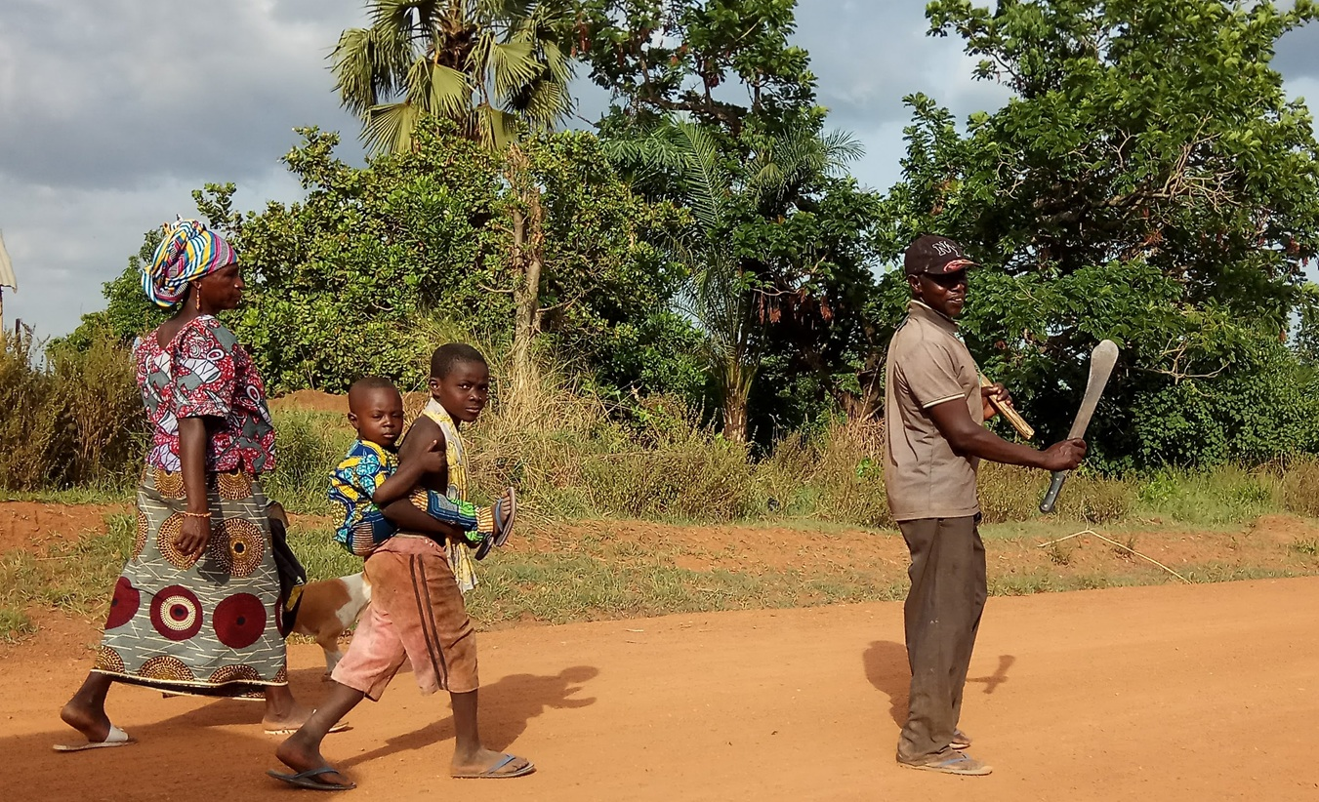

The Structure of Prosperity: Mechanism
“What repeats across systems reveals what lies beneath them.”

Pattern
In the previous column, we traced a trajectory that appeared across domains, geographies, and time, in which human societies evolved from small bands to tribes, from tribes to villages, and from villages to more complex forms such as cities. These transitions did not occur as isolated events but repeated across independent histories, suggesting a consistent direction of development rather than a sequence of unrelated changes. A similar pattern can be observed in other systems: in agricultural value chains, production expands through improved inputs and increased activity, yet income does not consistently improve; and in organizational systems, structures that initially enable strong performance gradually weaken as conditions change, even when effort and capability continue to increase. Although these systems differ in purpose, scale, and context, they display a common direction of change that cannot be explained by chance alone. What we observe is not a collection of isolated cases but a recurring pattern that reflects how systems develop as their level of activity increases.
In this column, we shift from observing the pattern to understanding the mechanism that drives it, because observation is not explanation. Recognizing that systems move in a similar direction is only the beginning, since a pattern can describe what happens without revealing the structure that produces it. It is therefore not enough to attribute these trajectories to luck, historical coincidence, or isolated advantages such as knowledge, capital, or effort. If different systems operating under different conditions repeatedly produce similar outcomes, then the source of that consistency must lie deeper than the visible factors that distinguish them.
This limitation becomes evident when we move from observation to application, because each system reveals a different aspect of the same underlying problem. In agricultural value chains, farmers increase yields, adopt improved inputs, and expand their activities, yet income often remains constrained, showing that improving individual components does not guarantee system-level improvement. In human societies, communities grow and expand their activities, yet encounter increasing difficulty in maintaining coherence and performance as their scale increases, indicating that growth itself creates new demands that existing structures cannot always sustain. Organizational systems display the same dynamic: structures that once enabled strong performance become less effective as conditions change, not because effort declines, but because the structure is no longer aligned with the level of activity and interdependence it must support. In each case, effort increases, knowledge improves, and activity expands, yet outcomes diverge in ways that cannot be attributed to intention, effort, or fairness alone. These are not separate problems but different expressions of the same structural condition.
This realization forces a shift in perspective. Instead of asking why particular systems succeed or fail based on what they have, we must ask what governs how systems change as they grow. The question is no longer whether change occurs, since it is evident in every system we observe, but rather what mechanism determines the direction of that change and why that direction appears so stable across otherwise unrelated contexts. If a pattern repeats across systems that differ in every visible way, then the mechanism that produces it must operate at a deeper structural level than those differences. The trajectory is therefore not random but directional, shaped by how systems structurally respond to increasing activity and complexity.
What we observed in the trajectory is that systems change in a consistent direction. This matters because it suggests that change itself is structured. Systems are shaped by structural dynamics that guide their evolution as activity and complexity increase. If we can identify these dynamics, we can move from describing outcomes to understanding the forces that produce them, allowing us to predict and influence how systems develop rather than relying on trial and error. To do this, we must identify the elements that produce change and the conditions that allow it to unfold. These elements form a mechanism composed of drivers, which push systems to expand and evolve; enablers, which determine whether that expansion can be sustained; and constraints, which define the limits beyond which existing structures can no longer support the complexity they carry.
To reach that level of understanding, we must move beyond the system's surface to its internal organization. Rather than focusing only on what is added, whether more resources, more people, or more activity, we must examine what happens within the system as these additions take place. Only by understanding how growth alters the internal structure of relationships can we uncover the mechanism behind the trajectory we have observed.

Growth
When we observe systems growing, our attention is often drawn to what is being added, whether more people, more resources, or more activity. Yet this perspective obscures the most important transformation that growth produces. Growth does not simply increase the size of a system but changes how it is organized, as every addition alters the relationships between its parts and reshapes how those parts interact with one another. This process originates in activity, the volume and intensity of actions undertaken by the system as it expands what it does. Activity is the primary driver, increasing the demands placed on the structure and initiating the sequence that follows.
This becomes clear when we consider even the simplest examples. Adding one more person to a group not only increases the number of individuals but also the number of relationships that must be maintained. Expanding an agricultural value chain increases production while connecting more actors across inputs, cultivation, logistics, and markets. Adding another function to a farm not only expands its activity but also creates new task dependencies that must be managed over time. In each of these cases, growth introduces new connections, and those connections transform the system from within, so that what changes is not only the number of elements but the structure of the relationships between them, which becomes the primary determinant of how the system behaves. This increase in interactions is not optional; it is an inherent consequence of growth. As elements are added, the number of relationships between them grows faster than the number of elements themselves, making complexity an unavoidable outcome of expansion. This is not only a quantitative increase but a qualitative transformation in how the system behaves. What begins as a manageable set of relationships gradually becomes a dense, interconnected network in which each part depends on many others, and in which changes in one part propagate through the system, becoming increasingly difficult to predict and control.
As this process unfolds, systems differentiate their functions. Roles that were once combined begin to separate, tasks that were once performed together become specialized, and responsibilities that were once shared are redistributed across distinct components. Differentiation is therefore not a matter of preference but a structural response to increasing complexity, because without it the system would not be able to manage the growing number of interactions it has created. Increasing complexity makes differentiation necessary, and increasing differentiation, in turn, produces interdependence. Yet differentiation introduces a new condition: as roles specialize, they become increasingly interdependent. No single component retains the full set of capabilities required to operate independently, which means that while the system becomes more capable as a whole, each part becomes less self-sufficient. This creates a web of interdependence that binds the system together while simultaneously increasing its exposure to disruption, as failure in one part can propagate across the entire system.
This transformation is often invisible at first because growth appears as progress while the underlying rise in complexity and interdependence goes largely unnoticed. Yet what has taken place is fundamental: the system has shifted from a collection of relatively independent elements to a network of specialized components whose performance depends on their ability to work together. At this stage, the nature of the problem changes; if growth inevitably produces interdependence and interdependence binds the system into a network of relationships, then the central challenge is no longer how to expand the system but how to coordinate it as interdependence increases.

Interdependence
Once this transformation has taken place, the system can no longer be understood solely in terms of its individual parts. This is evident in expanding organizations or agricultural value chains, where specialized roles must work together to produce a coherent outcome. As systems grow and differentiate, the web of relationships that binds their components together becomes increasingly dense, and what began as a manageable set of interactions gradually becomes a structure in which each component depends on many others to function. Interdependence is therefore not merely a consequence of growth but the condition that determines how the system operates. This transformation fundamentally alters the nature of the system. Once specialization has taken place and roles have been distributed across distinct components, no part of the system retains the capacity to operate independently. The performance of the system depends not only on the capabilities of its parts but on the quality of the relationships between them. This condition is not optional, because once interdependence reaches a certain level, coordination becomes unavoidable as the only way to sustain system performance.
At this stage, coordination emerges as the central challenge because the system must ensure that interdependent components act coherently over time, despite the growing number of interactions that must be synchronized. Coordination is not a technical detail but a structural necessity; without it, the very interdependence that enables higher capability becomes a source of instability, as mismatches between components propagate through the system and disrupt its performance. The problem is therefore no longer how to expand the system or improve individual components, but how to organize the relationships between them so that their combined activity produces a coherent outcome. As coordination becomes more demanding, it must rely not only on the presence of structure but also on the system’s ability to generate, transmit, and interpret information across its components, enabling each part to respond appropriately to the actions of others. At the same time, the system must maintain coherence across its growing interdependencies, even as direct familiarity and simple forms of synchronization become insufficient. The transition from small groups to larger forms of organization, such as the movement from bands to tribes, provides an early signal of this shift, in which coordination can no longer rely on direct relationships alone and must be supported by new mechanisms that allow interdependent actors to coordinate without continuous direct interaction. Similar transitions appear repeatedly across independent human histories, reinforcing that this shift is structural rather than cultural.
The implications of this transformation are often misunderstood. Systems at this stage may appear to have all the necessary components for success, including capable individuals, advanced tools, and increased activity, yet still fail to deliver the expected outcomes. This is because failure at this level is not a failure of components but a failure of the relationships among them. The system can no longer coordinate the interactions it has created, and the limitation reflects the structure rather than the individuals within it. This distinction shifts the focus from improving parts to understanding how those parts are connected, and from increasing inputs to organizing the structure within which those inputs operate. This marks a fundamental shift in how systems must be understood: the primary unit of analysis is no longer the component alone but the relationship between components, and it is at this level that both capability and failure are determined. At this stage, systems may still appear to function, yet their coordination capacity is already under strain, and attempts to improve performance by adding more effort or components begin to yield diminishing returns.
This leads to a structural threshold beyond which the existing structure can no longer manage the level of interdependence it has generated, making further growth within the same structure ineffective and even counterproductive. Additional elements increase the number of interactions that must be coordinated without increasing the system’s ability to manage them, resulting in a decline in overall capability despite continued expansion. Once this threshold is crossed, the system enters a different phase of its evolution, where the central question is no longer how to continue expanding within the existing structure, but how to reorganize it so it can sustain the level of interdependence it has already created.

Limits
Once a system approaches the limits of its ability to coordinate the interdependencies it has created, the logic that governed its earlier success begins to change. Actions that once improved performance now yield weaker results and, in some cases, even undermine the system itself. At earlier stages, adding more effort, resources, or activity tends to improve outcomes because the system still has the capacity to absorb and organize these additions. As the density of relationships increases and coordination becomes more demanding, this capacity is gradually exhausted, and the limiting factor shifts from what the system can access to what it can organize. What initially appears as a slowdown in progress is not a temporary fluctuation but a structural signal. The system is no longer constrained by the availability of inputs but by its ability to organize them. Additional effort increases the number of interactions that must be coordinated, additional resources introduce new dependencies, and additional activity amplifies the flow of information that must be processed, all of which place further strain on a structure that is already operating near its limit. As a result, the system begins to experience diminishing returns, where each additional unit of effort produces less improvement than the previous one, because the structure within which it operates cannot effectively integrate it.
This change is often hard to recognize because visible signs of progress may still improve even as the system's underlying effectiveness begins to decline. In agricultural systems, yields may continue to rise while income stagnates, highlighting a widening gap between activity and outcome. In many cases, farmers invest in better inputs, expand production, and connect to more markets, yet find that their income remains constrained or even declines because the increasing complexity of the value chain is not matched by a structure that can translate activity into sustained value. In organizations, teams may work harder and produce more, yet efficiency declines and friction increases as coordination becomes more complex than the existing structure can sustain. Organizations often respond to declining performance by adding more processes, more reporting, and more layers of coordination, which increases activity but further strains the structure that must organize it. In social systems, communities may expand and diversify, yet struggle to maintain coherence and shared direction as the mechanisms that once supported coordination no longer scale. In each case, the system appears to improve when viewed through inputs and outputs, yet its ability to translate those inputs into coherent performance is weakening. At this stage, attempts to solve the problem by intensifying the same actions that previously worked tend to backfire. Adding more effort to a system that cannot coordinate it increases pressure; introducing more resources into a structure that cannot integrate them creates additional friction; and expanding activity without restructuring the relationships that support it amplifies instability. Improvement becomes self-defeating, as the system’s response to declining performance reinforces the very conditions that produce it. This is the point at which the system reaches its structural ceiling, not in the sense that it can no longer function, but in the sense that it can no longer improve within its existing form. Declining performance is therefore a signal that the system has reached the boundary of its current structure.
Beyond this boundary, further progress cannot be achieved solely through optimization. Optimization refines performance within a structure, whereas transformation changes the structure itself. Once the coordination limit is reached, the two are no longer interchangeable. The system must either reorganize to sustain its level of complexity or accept a decline in performance as the cost of maintaining its current form. This is why systems that follow similar trajectories can produce very different outcomes, not because of differences in effort or resources, but because of their ability, or inability, to reorganize when their existing structure reaches its limit.

Transformation
Once a system reaches the limits of its ability to improve within its existing structure, the path forward cannot be found in continuing the same processes. The constraint it faces is no longer a shortage of inputs but a limitation in how those inputs are organized. The system cannot return to a simpler form without losing the capabilities it has already developed, because the complexity it has created is embedded in the relationships among its components. As a result, the viable direction is forward through reorganization that can sustain the level of interdependence that has already emerged. At this stage, continuation without transformation is not a stable option, because the structure that once enabled growth has become the constraint that prevents it. This reveals a fundamental property of how systems evolve: growth is not an open-ended process that can continue indefinitely within a fixed structure, but a sequence that produces its own constraints. As differentiation and interdependence increase, they generate demands that can only be resolved by introducing a new form of organization. Once these demands arise, the system must either reorganize itself to sustain them, or experience a decline in its ability to function effectively. Thus, transformation is not a matter of preference but a structural necessity that follows from the dynamics of growth itself.
This pattern can be observed across domains. In human societies, small bands that coordinated through direct familiarity eventually could not sustain larger populations, leading to the emergence of tribes that relied on shared language and identity, and later to territorial systems such as villages and early settlements that organized coordination through spatial proximity and shared activity. In economic and organizational systems, simple forms of production evolve into more complex arrangements as activity expands, and the emergence of firms reflects a response to the limitations of market-based coordination in organizing interdependent production. In each case, the system does not abandon what came before but reorganizes it into a new form that can support the increasing complexity it has generated.
What unites these examples is a recurring sequence in which growth produces increasing complexity, complexity produces differentiation, differentiation produces interdependence, and interdependence produces coordination constraints that eventually exceed the capacity of the existing structure. At that point, the system reaches a breakpoint, and the only way to continue developing is to introduce a new structure that can organize the relationships that the previous one could no longer sustain. This process does not eliminate the earlier structure but builds upon it, preserving its functions while reorganizing them into a more capable configuration. This recurring sequence, in which systems organize increasing complexity until their existing structure reaches its limit and a new structure becomes necessary, is what we define as the Universal Law of Increasing Complexity.
This continuity explains why development appears directional rather than random, as each transformation retains and integrates what came before, enabling systems to accumulate capability rather than starting from scratch each time. At the same time, this process introduces a critical source of divergence. While systems tend to follow a similar trajectory as they grow, they do not all reorganize when their existing structures reach their limits. Some systems introduce new forms of coordination that allow them to sustain higher levels of complexity, while others remain constrained by their existing structure, experiencing stagnation or decline despite continued effort.

The mechanism can be summarized as a simple structural sequence:
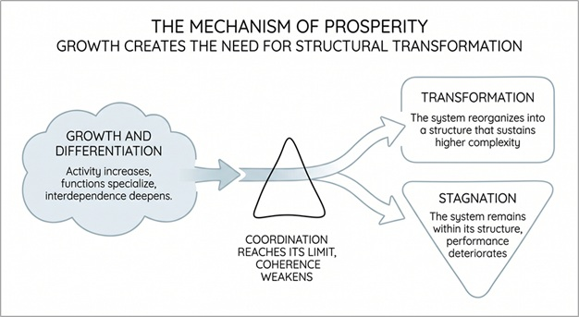
Systems evolve by organizing increasing complexity until their structure reaches its limit, where transformation becomes the only path to continued development.

=-=-=-=-=-=-=-=-=-=-=-==-=-=

* I strive to stay true to the facts and the reality they reveal. If you find an error or see a need for clarification, your insights are welcome.

Press to subscribe


Dr. Nimrod Israely writes on the structural foundations of prosperity and human systems, and is the CEO and Founder of Dream Valley and Biofeed.

Previous column: The Structure of Prosperity: The Trajectory

LinkedIn

