

View Online and Translate
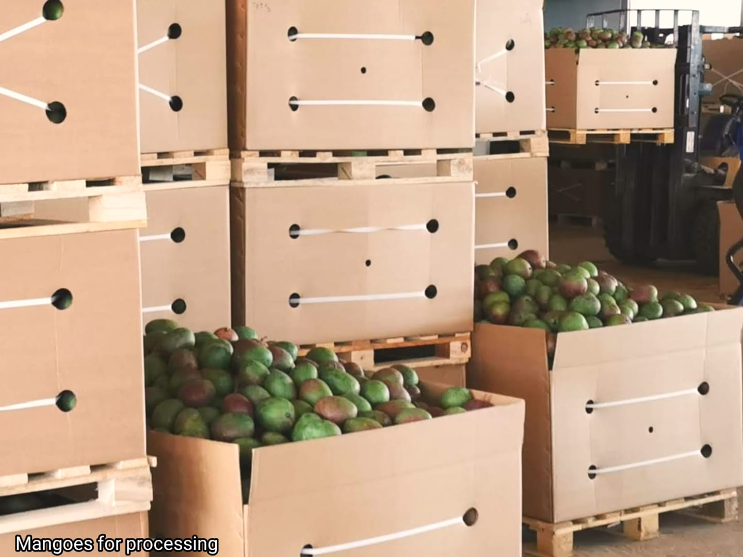

Critical Field Notes: Beyond the Processing Trap
“For the farmer, added value is the difference between revenue and cost, and the best channel is the one that widens that gap.”

From Volume to Value
I remember that after each apple harvest, there were always fruits that did not meet fresh-market standards. Some had fallen to the ground, while others were infested, too small, bruised, or visually imperfect. Whatever the reason, it was our task, as children, to follow the pickers and collect these second-grade fruits into large wooden boxes, each holding four hundred kilograms, and send them to an apple-processing factory.
For many years, this arrangement appeared efficient and rational: first-grade apples were sold directly to fresh markets, while lower-grade fruit was diverted to processing. Nothing appeared wasted, and the system functioned smoothly as long as both channels absorbed their respective volumes.
Over time, however, two changes occurred simultaneously. The widening price gap between the fresh and processing markets encouraged growers to improve cultivation practices, thereby reducing the proportion of fruit that failed to meet fresh-market standards. At the same time, access to premium fresh markets expanded and became more rewarding. As growers calculated more carefully, the price difference became decisive. Once the full costs associated with processing sales were accounted for, the same hectare required nearly the same effort yet generated only a fraction of the income compared with fresh-market sales.
When I started working in developing economies, I discovered that the dilemma between processing and fresh products remains relevant in many countries. In some situations, access to high-quality fresh markets is limited or nonexistent, making processing seem more appealing. When verified fresh-market channels are unavailable, setting up processing capacity often appears to be a logical solution. While in my childhood processing represented the lowest-value outlet, in many developing economies it is now seen as a form of value addition, and over time, processing has come to be viewed as synonymous with added value.
In countries where agriculture has long been shaped by commodities such as cocoa, coffee, and tea, the raw material is often perceived as the least valuable stage in the supply chain, and processing is considered the main way to create value. The conclusion therefore seems obvious: if processing adds value to commodities that must be transformed before reaching the consumer, then the same logic should apply to fruits and vegetables. The analogy is convincing because it applies a familiar development narrative from one product category to another without checking if their economic systems are similar.
This argument also seems to solve practical challenges. Building a competitive fresh produce value chain is difficult, expensive, and relies on strict standards, disciplined logistics, and skills that cannot be set up instantly. Processing facilities, on the other hand, provide visible infrastructure and measurable industrial output that can be planned, funded, and implemented in stages. In such situations, processing seems not only financially sensible but also administratively manageable.
This approach, often described as the industrialization of the agro-sector in developing economies, is based on a clear internal logic. Its appeal to governments, growers’ organizations, development banks, philanthropies, and non-governmental organizations is therefore understandable. When challenges in the fresh-market sector seem hard to overcome, industrial processing offers a visible and administratively actionable pathway for intervention and coordination.
The key question, however, is not whether this logic is coherent, but whether its underlying assumptions remain valid when viewed from the perspective of the production unit. Addressing this requires a clear definition of value at the hectare level.

What Determines Value?
To determine whether processing genuinely adds value, we must evaluate value on a per-hectare basis. From the farmer’s perspective, value is not measured by activity, transformation, or final retail price, but by net income after all related costs are deducted. The relevant unit of analysis is thus income per hectare, calculated as the quantity of saleable output multiplied by the price transmitted back to the production level, minus the full cost required to produce and deliver that output.
Value is only created when the final consumer is willing to pay a price that exceeds the total cost of delivering the product in its chosen form. Transformation alone does not ensure this. If processing increases costs without generating a proportional increase in the price transmitted back to the hectare, net income per hectare decreases even as industrial activity expands. Added value exists only when the gap between revenue and costs widens.
Income per hectare depends on two factors: the amount of output available for sale and the price received per kilogram in the chosen market channel. Any structural change, whether in agronomy, pest control, logistics, certification, branding, export access, or processing, must pass a single economic test. Does it increase the saleable volume, raise the price passed back to the production unit, or reduce total costs in a way that widens the revenue-to-cost gap? If it does not, it changes activity but does not increase value per hectare.
The distinction becomes clearer when we compare products that require processing before consumption with those that are ready to eat at harvest. Tea leaves, coffee beans, cocoa, and rice need transformation before they can be used, and in these cases, processing is structurally necessary for consumption to occur. Fresh fruits and vegetables, on the other hand, are already edible at harvest. When processing is done to these items, it is no longer a structural requirement but a strategic choice that must be justified by a measurable increase in net income per hectare.
The main question is therefore not whether processing is inherently good or bad, but whether it increases net income per hectare compared to available alternatives. When transformation raises retail prices without passing a proportional increase back to the production base, structural complexity may grow while income potential stays limited. Therefore, assessing added value must rely on disciplined accounting at the hectare level.

Accounting at the Orchard Gate
The implications of this framework become clear when we examine realistic orchard-gate prices, which represent the income the farmer receives before the product moves on to further handling or retail distribution. Consider a hectare producing five thousand kilograms of mangoes, a typical yield in many developing economies. The physical output remains the same; what changes is the market channel selected and the price received at the orchard.
Consider two export-oriented market channels. If mangoes are sold fresh into verified export markets at $0.4 per kilogram at the orchard gate, the hectare generates two thousand dollars in gross revenue. If the same mangoes are sold to processing markets at $0.2 per kilogram, the hectare yields one thousand dollars in gross revenue. The agronomic effort remains constant, yet gross revenue is halved.
This difference exists before accounting for any additional transformation costs. When fruit is directed toward lower-priced processing markets, the hectare must sustain the same agronomic effort, input costs, and labor investment with a smaller revenue base. If processing incurs extra costs for transportation, energy, labor, equipment depreciation, and coordination, the profit margin at the production level decreases unless the final consumer pays proportionally more and this increase is transmitted back to the orchard gate. Otherwise, industrial activity may grow, but the hectare's income capacity remains unchanged.
In developed economies, large-scale processing operations operate under different economic conditions. Industrial processing is often characterized by narrow per-hectare margins, high levels of mechanization, and extensive land area. Profitability relies on scale and operational efficiency because orchard-gate income per unit of land remains relatively low. Mechanization helps offset narrow margins, and economies of scale spread fixed costs over large volumes.
Most smallholders in developing economies face significantly different conditions. Their land is limited, mechanization options are restricted, and access to capital is often scarce. Replicating a processing model that relies on large land parcels, heavy equipment, and continuous throughput can increase operational burdens without proportionally boosting orchard-gate income per hectare. In these contexts, processing does not add value at the production level; instead, it shifts revenue among additional layers while the hectare remains economically constrained.
The disciplined economic test remains the same. The key question is whether the chosen market channel increases net income per hectare compared to available alternatives. Such comparisons must be made using equivalent market assumptions, meaning that fresh and processed products are evaluated based on their best possible premium markets rather than by comparing premium channels in one case with lower-value outlets in another. When additional processing increases costs without raising net income at the production base, the hectare bears higher expenses without boosting its earning potential. Ultimately, orchard gate accounting determines whether processing adds value or simply reallocates existing revenue.

Two Paths on the Ladder of Value
Once orchard-gate income per hectare is established as the main measure, strategic options appear as different levels on a ladder of value realization. Processing is one possible route, but it is not necessarily better. Each higher step needs more coordination and economic effort to maintain. The key question is therefore not which option seems more industrial or technologically advanced, but which pathway boosts net income per hectare relative to the effort it requires.
Consider the example of drying mangoes. Producing one kilogram of dried mango slices requires about ten kilograms of fresh mango. If that amount is sold fresh at forty cents per kilogram at the orchard gate, it generates four dollars in gross revenue. If instead it is processed into dried product that gives the orchard gate the equivalent of two dollars for the same original ten kilograms, gross revenue decreases before subtracting any additional labor, energy, or processing costs.
Drying involves peeling, pitting, slicing, dehydration, and packaging, each step adding more labor, energy, equipment, and coordination. A large part of the original mass does not translate into saleable dried product. Therefore, the process increases operational demands while decreasing physical yield. Although the retail price of dried mango may seem high, much of that price covers the processor's costs for capital, energy, branding, distribution, and risk, and is not transmitted proportionally back to the orchard gate.
Now compare this with the alternative pathway of improving access to premium fresh export markets. In this case, the fruit remains in its natural form and the entire harvest weight is preserved for sale. The focus shifts toward phytosanitary compliance, residue management, fruit fly control, varietal alignment, cold chain integrity, and disciplined logistics. These measures enhance value chain rather than physical transformation, and when successful, they increase the price received at the orchard gate without reducing the physical yield.
Certification systems like organic production can further raise the orchard-gate price without significantly altering the physical structure of the supply chain. When the base price per kilogram is higher, any additional premium is based on a larger revenue base. As a result, small improvements lead to proportionally larger increases in income per hectare than when the same premium is applied to a lower base price.
In many producing countries, focusing on drying or juicing reflects structural limitations that limit access to top-quality fresh markets. Under such conditions, processing becomes a rational adaptation rather than the economically highest position on the ladder of value. Processing becomes economically justified only when it clearly increases net income at the production level.
The decisive question is therefore not whether drying is better or worse, but whether the chosen path boosts sustainable net income per hectare relative to alternatives. When costs and coordination needs grow faster than income at the production level, the hectare is burdened with obligations it cannot finance. When income increases first, more demanding standards, logistics, and compliance requirements become economically viable. The value ladder is determined not by industrial intensity, but by whether each extra layer clearly widens the gap between revenue and costs per hectare.

Income Determines Strategy
The implications of this arithmetic extend beyond individual farms. When income per hectare differs by thousands of dollars, the choice of market channel shapes the trajectory of the entire agricultural sector.
Imagine a production region growing tens of thousands of hectares of mangoes. A one-thousand-dollar difference per hectare can mean tens of millions of dollars in annual farm income. At that scale, deciding whether fruit mainly goes to processing or premium fresh markets is no longer just a technical choice, but a strategic decision that shapes the economic strength of the agricultural system.
Income at the production base ultimately determines what the system can support. Higher income per hectare increases financial capacity and allows reinvestment in irrigation systems, pest control protocols, residue compliance, certification, cold chain logistics, and market development. These improvements bring stricter standards and more complex coordination across the supply chain, but they only become economically feasible when the production unit generates enough revenue to cover them.
When income stays limited at the source, these investments become difficult to sustain and often rely on external support rather than internal capacity. Over time, this difference shapes the direction of the development path. Systems that direct production mainly toward lower-value markets tend to settle at lower income levels, reducing reinvestment and slowing technological progress. Systems that secure consistent access to premium markets generate higher income at the production level, enabling producers to finance the standards and coordination that those markets demand.
The arithmetic that caused farmers in my childhood to cut back deliveries to the cider factory was therefore not based on ideology. It was a simple comparison of net returns per hectare. The same calculation still guides agricultural decisions today.
Farmers’ prosperity doesn't depend on how much processing occurs after harvest or on how prominent the industrial infrastructure is. It depends on how much income actually makes it back to the hectare after subtracting costs. When strategy aligns with that discipline, reinvestment becomes sustainable and higher standards become long-lasting. When it doesn't, activity grows, but income capacity stays limited. Ultimately, added value is not measured by processing but by the income returned per hectare.

=-==-=-=-=-=-=-=

Subscribe here, free!
"Mental and Economic Freedom Are Interconnected."

See you soon,
Nimrod


Dr. Nimrod Israely is the CEO and Founder of Dream Valley and Biofeed companies and the Chairman and Co-founder of the IBMA conference. +972-54-2523425 (WhatsApp), or email nisraely@biofeed.co.il

P.S.

If you missed it, here is a link to last week's blog, “When a Ballistic Missile Lands Outside Your Living Room: How Community Structure Determines Recovery “.
P.P.S.
Here are ways we can work together to help your agro sector and rural communities step forward and shift from poverty into ongoing prosperity:
* Nova Kibbutz and consultancy on rural communities' models.

* Local & National programs related to agro-produce export models - Dream Valley global vertical value and supply chain business model and concept connects (a) input suppliers with farmers in developing economies and (b) those farmers with consumers in premium markets.

* Crop protection: Biofeed, an eco-friendly zero-spray control technology and protocol.

You can follow me on LinkedIn, YouTube, and Facebook.
*This article addresses general phenomena. The mention of a country/continent is used for illustration purposes only.

