

View Online and Translate
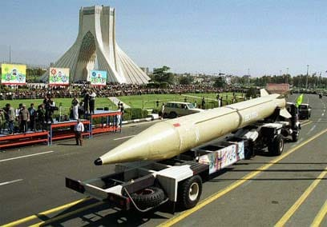
When a Ballistic Missile Lands Outside Your Living Room: How Community Structure Determines Recovery

“When the unexpected strikes, a community’s structure determines how quickly it recovers.”

Editor’s Note. This week I had planned to publish the second column in the series Critical Field Notes. However, events in Israel during the past week made it difficult to continue as intended. A personal family experience revealed something striking about how communities respond to sudden shocks, and I felt it was important to share this observation now, because it also speaks to broader questions we often discuss here about resilience, poverty, and the structure of human systems.

When War Becomes Routine
War is not supposed to become routine, yet after months of conflict, routines slowly form even under conditions that once seemed unimaginable. People check alert applications every few minutes, families remain closer to home, and even the most ordinary trip, including a short visit to the supermarket, begins with the simple question: where is the nearest safe room?
During the past week, that uncertainty became even more personal for my family.
The moment arrived through a short message in our family WhatsApp group sent by my sister in law, the wife of my brother Avner, who lives in the small urban kibbutz community of Tamuz in the city of Bet Shemesh, informing us that a ballistic missile had landed roughly fifty meters from their home while assuring us, almost immediately afterward, that everyone in the family was safe.

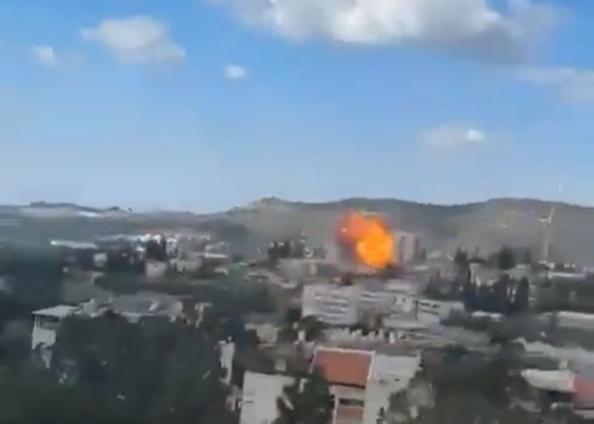
The moment of impact; Bet Shemesh 1.3.2026. Image source unknown.

When Disaster Does Not Distinguish
Ballistic missiles, much like natural disasters, do not distinguish between people, opinions, professions, or neighborhoods, and when one lands inside a city, it strikes everything within its reach with the same indifference. The missile that landed near my brother’s home carried a warhead containing five hundred kilograms of TNT, an explosive force capable of destroying buildings and causing devastating loss of life.
The explosion occurred in a dense urban neighborhood surrounding the small kibbutz community of Tamuz, where thousands of residents live in nearby apartment buildings and houses, while the kibbutz itself consists of 22 members. Within the same physical space, therefore, existed two structurally distinctive communities, exposed to the same explosion and the same immediate consequences.
The missile, therefore, struck two communities situated side by side, creating a rare situation in which the same shock affected two distinct social structures simultaneously. This unusual situation created something close to what scientists describe as a natural experiment, revealing how communities with different structures respond when confronted with the same sudden shock.

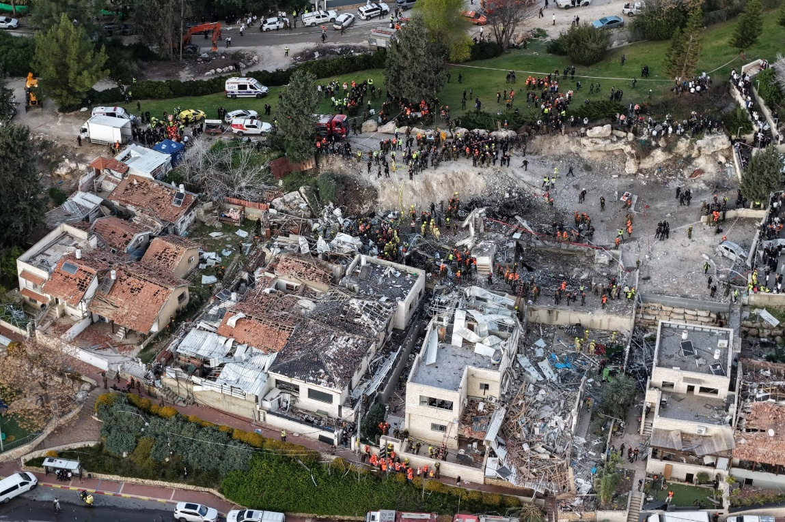
The crater caused by the missile hit obscured the synagogue that stood there and the shelter beneath it. Image source unknown.

Walking the Scene
My brother Avner holds a Ph.D. in biochemistry, yet his true passion lies in education and human well-being, and he founded a network of daycare centers for children in Israel’s social and geographic periphery. When the missile struck on Sunday around 13:45, he was working in his office inside the kibbutz when the sirens sounded. He immediately entered the nearby safe room. Moments later, a powerful explosion shook the neighborhood, and as soon as the immediate danger passed, he stepped outside and saw a column of smoke rising from a nearby location, which he quickly understood to be the impact site. Without stopping to check on his own family, whose home was located roughly midway between his office and the impact site, he ran directly toward the source of the smoke, assuming that was where people would need help most. Seconds later, as he moved closer, he could hear shouting and screaming, saw people fleeing the scene, and encountered other sights that I will not describe here.
Several days later, on Wednesday afternoon, I came to meet Avner at the kibbutz to hear the story directly from him and to understand more precisely what had happened in those first minutes, hours, and days after the explosion. As part of our conversation, we walked together along the same route he had taken on Sunday, allowing him to reconstruct the sequence of events step by step and minute by minute as we moved from his office to the safe room toward the place where the missile had landed.
As we walked on Wednesday toward the place where the missile had landed, I began to notice something I had never noticed before during the many times I had visited Avner. Between the kibbutz and the location of the impact, there were no buildings at all, only a few trees and a small hill that we were now climbing, with the missile having struck on the other side of that hill. From the kibbutz side, the hill played a critical role in shielding the community from the direct blast wave of the explosion.
Only when we reached the top of the hill and looked sharply down about ten meters below us could we see the place where the missile had struck. A building that had once stood there had almost entirely disappeared, leaving behind a field of debris, while several nearby buildings showed severe structural damage. Residents in buildings located hundreds of meters away, particularly on the side of the neighborhood that was not protected by the small hill, later reported significant damage as well, most commonly shattered windows extending as far as seven hundred meters from the point of impact.
On Sunday afternoon, in the minutes immediately following the explosion, the scene in the surrounding streets had been very different. Residents who had been inside their apartments when the missile struck began to emerge cautiously from buildings and shelters, many of them still trying to understand what had just happened. Some spoke with neighbors and family members, others searched for relatives or checked on elderly residents, while the sound of sirens and emergency vehicles soon began to fill the area.
Events of this magnitude create not only physical destruction but also a powerful psychological shock. The sudden combination of noise, danger, and uncertainty, along with the possibility that friends or family members may have been injured, often overwhelms individuals' normal capacity to process information and act calmly. In the first moments after such an event, many people move between confusion, fear, and the instinct to search for loved ones, while clear decision-making and organized action become difficult without external support. Even three days later, as I interviewed Avner and his wife, they kept laughing about how they still felt a bit confused, how their thoughts weren’t always clear, and how they sometimes forgot things that usually would have been obvious to them.

When Structure Begins to Replace Confusion
In the minutes following the explosion, the entire neighborhood was gripped by confusion and shock, yet within a short time, two different social dynamics began to appear side by side: one within the small, organized community of Kibbutz Tamuz, and another among the much larger surrounding neighborhood of city residents.
After helping as much as he could at the impact site and checking on a few nearby houses where he knew elderly residents lived, Avner returned to Kibbutz Tamuz. There, he found the other members and their families gathering on the central lawn of the kibbutz, sharing what each had experienced during the strike and making sure everyone was safe. For about twenty minutes the conversations were emotional and spontaneous, allowing people to exchange information, fears, and relief that no one inside the kibbutz had been seriously injured. Then the tone of the gathering began to change. The members decided to appoint three people to lead and coordinate the next steps, including communication with external organizations, organizing assistance where needed, and guiding the community through the immediate aftermath of the attack.
From that moment, the kibbutz's response began to take a different character. With a small number of people responsible for coordination, tasks could be divided and carried out in an orderly way. Some members focused on assessing damage within the community, others organized assistance for residents whose homes had been affected, and others communicated with the police, emergency medical services, and external volunteer groups that were already gathering nearby. Within a little more than twenty-four hours after the strike, the community had largely regained control of its immediate situation and was able to continue daily life while gradually repairing the remaining damage.
On Monday morning, the process continued in an equally organized manner. Representatives of the property tax authority, engineers from the army national emergency unit, and municipal officials arrived to inspect the damaged buildings and begin the formal procedures required after such an attack. The kibbutz had already appointed one member to accompany the officials and coordinate all matters related to the shared buildings, moving with them from apartment to apartment while documenting the damage and preparing the necessary claims. Families were instructed on how to file separate claims for damaged personal belongings. As Avner explained to me, working in this coordinated way created a natural learning curve: what the representative learned during the first inspection helped streamline the process for the second, third, and subsequent families. At the same time, other members led the practical work to restore the community's physical environment, including removing broken glass, repairing warped doors, and examining cracks in walls, often with the help of volunteers who had arrived from nearby communities.

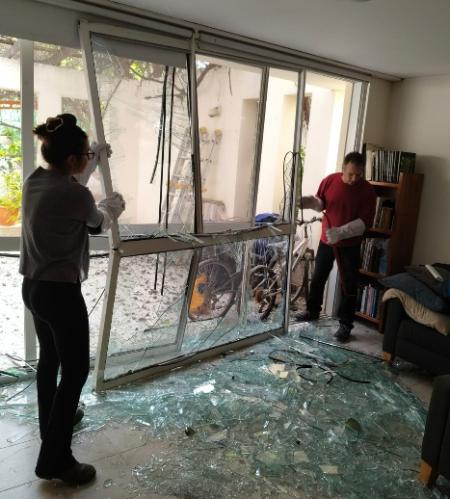
Avner and his daughter Tahir removing the broken window in their living room shortly after the attack (March 1, 2026). Image by Dganit Israely Levi.

By Monday, less than twenty-four hours after the strike, the internal organization of the kibbutz had already restored a surprising degree of normality. Responsibilities had been divided, practical work was underway, and communication with external authorities was being handled in an orderly manner. Even Avner, who was among those coordinating the recovery effort, found time to sit down and prepare his employees' salaries. This small administrative task might appear ordinary, yet in the context of the events less than twenty-four hours earlier, it marked something important: the moment when the community had regained enough control of its situation to resume responsibility for normal life.
In the city's surrounding neighborhoods, the initial reactions were very similar to those inside the kibbutz. People emerged from buildings, met neighbors in the streets, and exchanged experiences about what each had seen and felt during the strike. Yet the same shock was now acting on a very different social structure. The urban neighborhood lacked a structural mechanism for cooperation through which these conversations could evolve into coordinated action; therefore, responsibility remained largely at the level of the individual household rather than rising to the level of the neighborhood community. Each family naturally focused on its own members, property, and immediate problems, resulting in hundreds of households confronting nearly identical challenges and performing the same tasks simultaneously, without coordination. This duplication of effort placed heavy demands on both the authorities trying to assist and on the families themselves, with the entire burden of managing inspections, repairs, documentation, and daily survival often falling on one or two family members.
In reality, only a small number of buildings had suffered damage beyond repair. Most apartments required intensive but manageable work, such as clearing shattered glass, temporarily sealing broken windows, repairing doors, and examining cracks in the walls. With coordinated support, many residents could have returned quickly to sleeping in their homes and gradually restored normal life, which is precisely what occurred in Kibbutz Tamuz. Avner, for example, spent the first evening cleaning the damage in his own house with the help of others and temporarily sealing the windows with nylon sheets, allowing his family to sleep in their home that same night. In many surrounding buildings, however, residents were evacuated to hotels. Although this decision appeared helpful, it often separated families from the place where recovery needed to begin. When people are removed from their homes, the practical steps that restore control, such as cleaning, repairing, documenting damage, and gradually rebuilding routine, are delayed, and with them the psychological transition from shock to recovery. The difference that began to appear during those hours was therefore not a difference in the determination of the people involved, but a difference in the structure within which they were trying to respond. Those who lacked an available structure for cooperation could not easily cooperate even when doing so would have benefited everyone. They simply lacked the structural capacity for cooperation.

When Structure Determines Recovery
In the hours and days that followed, two communities exposed to the same catastrophic event responded in ways that, when carefully examined, revealed a critical difference that largely determined their resilience. That difference was not related to courage, wisdom, or determination, but to the structure through which people were connected to one another and therefore to their capacity to transform moments of confusion and uncertainty into coordinated action.
Moments of crisis often reveal structures that remain largely invisible in ordinary times. In daily life, people interact through routines, institutions, and habits that make cooperation appear almost effortless, yet these underlying structures are rarely noticed until something unexpected disrupts them. When a sudden shock arrives, whether in the form of a missile strike, a natural disaster, or an economic collapse, the capacity of individuals and communities to respond effectively depends not only on the resources available to them, but on the organizational framework through which people are already connected to one another and therefore on their structural capacity to make effective use of the assistance and resources that become available in moments of crisis.
When such a structure exists, as was the case in Kibbutz Tamuz, cooperation can emerge quickly even in moments of confusion and fear. Responsibilities can be distributed among members of the community so that different individuals focus on specific tasks while others continue to address the needs of their families or neighbors, allowing the community to mobilize its internal capacities far more effectively than isolated households could on their own. Communication with external institutions also becomes more efficient because designated representatives interact with inspectors, engineers, emergency officials, and volunteers, allowing experience to accumulate as the process unfolds. What is learned during the first encounters with external authorities can immediately benefit everyone who follows, enabling the community to make far better use of the assistance and resources that become available. In this way, the community gradually transforms an unexpected shock into a coordinated response that enables recovery to begin.
When such a structure does not exist, the same event can produce a very different experience, even when the people involved are equally determined and equally capable of rebuilding their lives after the shock. Individuals and families may act responsibly and with great dedication, yet their efforts remain largely confined to the household because there is no mechanism for neighbors to translate their shared situation into coordinated action. Tasks that could have been organized collectively across dozens or hundreds of residents are instead repeated separately by each family, often forcing the same individuals to communicate with authorities, organize repairs, address emotional distress within the household, and navigate unfamiliar procedures with little opportunity to benefit from the experience accumulated by others. Under such conditions, the available resources, including assistance from institutions or volunteers, become far more difficult to coordinate and use effectively because each household must largely handle the process on its own.
The importance of this structural difference becomes particularly visible in the interaction between communities and the public institutions that arrive to assist them. In the case of the missile strike near Kibbutz Tamuz, police, emergency medical services, army national emergency units, municipal officials, engineers, and volunteers from nearby communities all arrived quickly and worked with professionalism and dedication. Yet even under such favorable conditions, institutions naturally find it easier to communicate with organized communities than with hundreds of individual households. When a community appoints representatives who coordinate communication with external authorities, learning accumulates quickly, and assistance becomes far more effective because each interaction builds on the experience gained in the previous one. When each family must independently navigate the same procedures, however, even well-functioning institutions face the difficult task of repeating the same explanations and processes again and again with individuals who encounter them only once.
With only 22 members, Kibbutz Tamuz is far smaller than most kibbutzim, which often include several hundred members. Yet despite its small size, it fulfilled all that we expect from a much larger community structure, functioning effectively and able to reorganize itself quickly, divide responsibilities, communicate with authorities, and help its members regain control of their lives. The surrounding urban neighborhoods contained thousands of residents, yet without a structure through which neighbors could coordinate their efforts, each household was largely left to manage the situation on its own, remaining fully dependent on municipal and national authorities, despite many residents being equally determined and capable of rebuilding their lives.
What the events around Kibbutz Tamuz reveal, therefore, extends well beyond this particular incident and illustrates a broader principle that appears repeatedly in human systems: resilience emerges not primarily from individual strength but from the structure through which people are connected.
Communities are often evaluated by their wealth, size, or the strength of their individual members, yet moments of crisis reveal something deeper and far more consequential. The decisive factor is whether the structure of the community allows individuals to combine their efforts, accumulate experience, and make effective use of both the community's internal capacities and the external assistance that becomes available.
When such a structure exists, recovery can begin almost immediately, even after a severe disruption. When it does not, even capable and determined individuals may remain confined largely to the limits of their own households, facing challenges that would have been far easier to overcome through collective action.

When Structure Creates Resilience
The principle revealed by the events in Bet Shemesh extends far beyond this particular missile strike. Disasters, whether caused by war, earthquakes, floods, or economic crises, often occur suddenly and unpredictably, yet the way communities recover from them is rarely random or accidental. Unlike the unexpected event itself, the ability to recover depends largely on whether individuals are already connected through structures that enable cooperation, distribute responsibility, and transform confusion into coordinated action.
In many modern societies, attention is often directed toward resources such as infrastructure, professional emergency services, and financial capacity when discussing resilience. These factors are important and often determine how quickly assistance can arrive and how extensive the available support may be. Yet the events described here reveal that another dimension is equally decisive: the way people are organized within their communities and the extent to which those structures allow neighbors to cooperate and coordinate their response.
When such structures exist, the response to unexpected shocks can quickly exceed the capacity of individual households. Responsibility can be distributed across members of the community, allowing some people to coordinate with authorities, others to organize practical work such as repairs or cleaning, and others to focus on supporting families and vulnerable residents. In this way, the burden of recovery no longer falls on isolated individuals but becomes a shared effort in which experience accumulates and solutions developed in one situation quickly benefit others facing similar challenges.
For this reason, the most important question raised by events such as wars, disasters, and sudden crises may not be how strong individuals are when confronted with them, but how well the structures that connect people enable cooperation to emerge and express itself. Moments of crisis reveal this reality quickly and dramatically, yet the same structural principle operates continuously in everyday life as well, shaping how communities solve problems, share responsibility, and respond to challenges even when no catastrophe is present. The deeper question, therefore, is how well the structures that connect people allow individual strength to become collective capability.

=-==-=-=-=-=-=-=

Subscribe here, free!
"Mental and Economic Freedom Are Interconnected."

See you soon,
Nimrod


Dr. Nimrod Israely is the CEO and Founder of Dream Valley and Biofeed companies and the Chairman and Co-founder of the IBMA conference. +972-54-2523425 (WhatsApp), or email nisraely@biofeed.co.il

P.S.

If you missed it, here is a link to last week's blog, “Critical Field Notes: When the Value Chain Loses Direction“.
P.P.S.
Here are ways we can work together to help your agro sector and rural communities step forward and shift from poverty into ongoing prosperity:
* Nova Kibbutz and consultancy on rural communities' models.

* Local & National programs related to agro-produce export models - Dream Valley global vertical value and supply chain business model and concept connects (a) input suppliers with farmers in developing economies and (b) those farmers with consumers in premium markets.

* Crop protection: Biofeed, an eco-friendly zero-spray control technology and protocol.

You can follow me on LinkedIn, YouTube, and Facebook.
*This article addresses general phenomena. The mention of a country/continent is used for illustration purposes only.

