

View Online and Translate
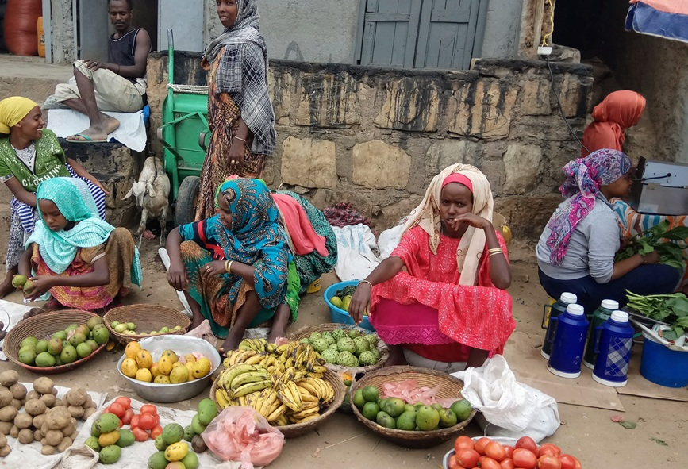
Critical Field Notes: When the Value Chain Loses Direction
“Progress begins not by pouring more effort into the same structure, but by understanding the mechanism that makes it work.”

The Production Machine
After ending a recent video call with an African colleague, I remained seated for several minutes, not because the discussion had been dramatic, but because it brought a structural issue into sharper focus. The colleague on the other side of the screen had spent decades working in agricultural research, international financial programs, and advisory roles across West Africa, and he continues to work on agricultural transformation across the region. What struck me most was not his experience but his willingness to pause when a connection became clear and to acknowledge openly that he had not previously seen it that way. His reaction reflected not an isolated oversight but a broader pattern I have encountered repeatedly, in which complex challenges are examined separately even when they stem from the same structural condition.
Our discussion touched on challenges familiar throughout many developing economies: persistent fruit fly losses, abandoned orchards, limited penetration into export markets, supermarket standards that are difficult to meet, financing constraints, and the recurring call for value addition. None of these issues was new. What shifted during the conversation was the recognition that they were not separate problems but interconnected expressions of a deeper structural reality. Considered individually, each appears technical and potentially solvable through targeted intervention. Considered together, they reveal a pattern that cannot be explained by technology, policy reform, or capital alone.
At one point, we examined the common assumption that value addition means processing. In many development strategies, increasing income is equated with building factories and converting raw produce into processed goods. Yet in fresh produce markets, processing does not automatically translate into higher income for the production base. Without secure access to strong markets and sufficient scale, shifting from fresh to processed output can leave the underlying revenue constraint unchanged. What appears to be value addition may therefore fail to expand the land's income capacity.
From there, our discussion turned to incentives and compensation within the value chain. In many agricultural systems, intermediaries earn by buying from farmers at one price and selling onward at another, so their income depends on the spread between those prices rather than on the total income generated by the hectare. Under such arrangements, participants in the chain are not equally bound to the same revenue event, because their compensation does not rise or fall directly with the final consumer’s purchase. When actors do not share exposure to that common revenue pool, alignment weakens. Activity may expand across the chain, yet the income generated at the production base does not necessarily increase.
What remains most striking is not the existence of these tensions but their persistence. Across West Africa and in many other agricultural economies, fruit fly control technologies are available, financing instruments exist, development programs operate, and policy reforms are repeatedly introduced. Yet orchards are abandoned, mango losses due to fruit fly infestation of 30 to 80 percent are reported in some regions, and national production maintains only a marginal presence in the global fresh market. The land is fertile, farmers are capable, and international demand is strong, yet income per hectare remains low and volatile. The question that therefore emerges is not about one technology or one export initiative, but about the structure that surrounds the source of income itself: how revenue enters the system, how claims on that revenue are organized, and whether the value chain operates within the limits of what the production base can sustainably generate.
To address this question, I will use the term `production machine` to describe the unit that generates income and thereby sustains structure. In manufacturing, a factory serves this role by converting inputs into saleable output, from which salaries, services, and reinvestment are financed. In services, a firm or project performs the same function. In agriculture, the production machine is the hectare of land that produces saleable output season after season, from which the surrounding economic activity derives its justification.
When that machine generates sufficient and stable revenue aligned with validated market demand, differentiated coordination can accumulate around it in a durable way because the economic energy required to sustain complexity originates at the level of the production machine. When revenue is insufficient or unstable, the system cannot maintain higher levels of coordination regardless of ambition or external support, because complexity cannot expand where its sustaining energy does not accumulate. The remainder of this column examines what occurs when the structure surrounding the production machine expands beyond the income it can realistically sustain, and why such expansion produces structural stagnation rather than prosperity.

Design without Constraint
Once the hectare is understood as the farmer’s production machine, and its income is defined as saleable volume multiplied by the price paid by final consumers, the governing constraint of the system becomes clear. The validated purchase by the final consumer is not merely one transaction within the chain but the event that fixes the total revenue available to finance the entire structure. From that single revenue pool, all production costs, services, margins, and reinvestment must ultimately be financed. The willingness of final consumers to pay, therefore, sets the boundary within which the machine must operate and serves as the organizing principle of the entire chain.
All participants in the agro-industrial system ultimately depend on that revenue pool. Input suppliers, service providers, exporters, and retailers each perform necessary functions and pursue rational incentives within their own domains, yet the system as a whole remains bounded by the revenue generated at the point of final purchase. When compensation mechanisms are designed without direct reference to that governing constraint, coordination may expand in visible and measurable ways, while the income capacity of the production machine remains unchanged, and structural strain begins to accumulate at its foundation.
When actors are compensated primarily for activity rather than for revenue validated by the final consumer’s purchase, costs accumulate without a corresponding expansion of validated income. Services are added, coordination becomes more elaborate, and performance is assessed within individual functions, yet the combined structure is not calibrated against the revenue generated by the production machine. The hectare is then expected to carry layers of coordination that its income cannot sustain, and the imbalance becomes structural rather than incidental.
The pattern described above follows a general systems principle: every organized structure is governed by its constraint, and improvements that do not address that constraint cannot improve the system as a whole. In an extended agricultural value chain, the constraint is not the efficiency of irrigation, the sophistication of packaging, or the availability of finance, but the capacity of the final consumer market to absorb produce at a given price. The validated sale, therefore, functions as the structural boundary of the system, because it fixes the total revenue within which all other activities must operate.
When structure is designed without reference to this governing boundary, misallocation does not occur by accident but by design. As additional services and layers of coordination are added without expanding the validated sale, total claims on income rise while the income itself does not. Borrowing, subsidized loans, and philanthropic funding progressively replace internally generated surplus; maintenance is postponed to preserve short-term liquidity; and quality fluctuates as reinvestment becomes irregular. Individual actors may continue to meet local performance metrics, yet the system as a whole operates under mounting strain because the production machine is expected to sustain a level of complexity that its revenue cannot finance.
Injecting capital into a structure that remains misaligned with its governing constraint does not, in itself, generate sustainable income. When additional resources enter a system whose validated revenue has not expanded, they are distributed across existing claims rather than increasing the production machine's income capacity. Temporary improvements may occur, yet without altering how revenue is generated and anchored to the hectare, new funding sustains the existing structure instead of transforming it. Just as a small workshop cannot become a coordinated factory solely through capital infusion, a low-income hectare cannot support higher levels of coordination and, therefore, cannot sustain higher structural complexity unless its validated sale increases in proportion to the demands placed upon it.
Under persistent misalignment between structural ambition and validated sale, systems rarely collapse outright; instead, they stabilize at lower levels of coordination and complexity. Surface expansion may continue, additional hectares may be cultivated, and new programs may be announced, yet the underlying income constraint remains unchanged. Without sufficient revenue per hectare to finance differentiated roles, disciplined logistics, quality systems, and reinvestment across time, structural capacity does not accumulate. The system continues to function, yet it does not deepen in capability, because complexity can expand only when the economic energy required to sustain it grows at the level of the production machine. If that energy originates in the validated purchase by the final consumer, then the decisive question becomes how compensation and incentives are structurally anchored to that revenue.

Anchoring to Revenue
If complexity can expand only when revenue grows at the level of the production machine, then the decisive question becomes how each participant in the chain is tied to that revenue. The persistent strain described above does not arise from coordination being inherently difficult, but rather from whether compensation anchors coordination to validated outcome or separates it into disconnected activities. When participants are rewarded for completing tasks without their returns rising or falling with the revenue generated by the final consumer’s purchase, the system fragments into locally optimized units whose combined demands can exceed the production machine's income capacity.
Some economic structures address this tension by ensuring that all roles remain accountable to the same revenue event.
Consider a limited liability company: designers, engineers, procurement managers, sales teams, and administrative staff perform distinct activities, and salaries may be paid regularly, yet the entire structure's continuation depends on whether the company succeeds in selling its product or service in the market. If validated sales decline persistently, the organization cannot sustain its level of coordination by appealing to the internal importance of each department’s activity, because every function ultimately depends on the revenue generated by the final sale.
A similar principle appears in cooperative models such as the Kibbutz. Members may engage in agriculture, manufacturing, education, or services, yet individual prosperity is not determined by isolated contribution but by the performance of the collective enterprise. Income is realized only when products are sold, and revenue enters the shared pool; until that sale occurs, internal activity does not translate into distributable prosperity. In such systems, individual returns are structurally tied to the total revenue generated by the collective output, so they expand or contract with the enterprise's overall success.
In both examples, the sale to the market is not an external detail but the organizing event that governs the entire structure. Compensation is tied, directly or indirectly, to the revenue generated by that sale, and all roles remain accountable to the same revenue boundary that defines the system’s capacity.
In many agricultural value chains, however, this anchoring remains incomplete. Input suppliers may be paid upon delivery regardless of whether the crop ultimately reaches a remunerative market. Service providers may receive fees even when final prices fall short of expectations. Exporters may earn a margin on shipment volume without fully exposing themselves to downstream retail realization. Each role may operate rationally within its own domain, yet the structure does not consistently bind compensation to the same revenue event that defines the system’s total income. As a result, participants do not necessarily share exposure to the constraint that governs the production machine.
When compensation and exposure are not aligned with outcome, the hectare continues to function as a production machine, yet the structure surrounding it expands beyond what its validated sale can sustain. Income per hectare then ceases to anchor coordination and becomes one claim among many rather than the constraint that organizes the chain. Effort may intensify, programs may multiply, and activity may increase, yet structural progress remains limited because the system is not anchored to the revenue event that ultimately defines its capacity. Without shared exposure to that constraint, complexity cannot accumulate in a sustained and self-reinforcing way.

Income, Complexity, and Direction
The analysis above converges on a single decisive variable: the level and stability of income generated by the production machine. Income per hectare serves as the economic energy of the agricultural system, financing coordination, reinvestment, specialization, and risk absorption. When that energy accumulates consistently, the system can sustain more differentiated roles and tighter coordination. When it does not, coordination may expand temporarily but cannot endure.
In any organized system, structured differentiation persists only when the resources required to sustain it are available across time; when that flow weakens, systems simplify by reducing complexity. Agricultural systems face the same constraint: when income per hectare is low or unstable, they cannot reliably sustain quality assurance, disciplined logistics, certification, market intelligence, or innovation. Activity may intensify and programs may multiply, yet without sustained revenue at the level of the production machine, higher coordination cannot be maintained.
When income per hectare rises in alignment with validated consumer demand, coordination becomes durable rather than episodic. Differentiated roles can be maintained, investment can be absorbed without disruption, and risk can be managed without destabilizing the production base. Structural capacity deepens because internally generated revenue is sufficient to finance the demands placed upon it. Income per hectare, therefore, determines the level of coordination the system can sustain across time.
When income per hectare remains insufficient relative to the structure built around it, the system contracts toward simpler organization. Services, certification, financing, and margin extraction create revenue claims that exceed the validated sale that that sustains them. The system continues to function, yet it stabilizes at lower coordination levels because revenue does not accumulate to the level required to finance a higher coordination level. Persistent poverty in such systems is therefore not accidental but structural, arising when the demands placed on the production machine consistently exceed the income it generates.
The conversation that inspired this column began with practical concerns about fruit flies, export margins, and market access, yet beneath those concerns lies a structural question that extends beyond any single crop or region. Direction in a value chain becomes visible only when the income generated by the production machine is sufficient to sustain the coordination it carries. Where that alignment is absent, stagnation is not episodic but structural. The remaining question is therefore not whether effort should increase, but how a value chain can be structured so that coordination never exceeds the production base's revenue capacity.
The pattern described here is not confined to agriculture. As systems advance, they become more complex, and greater complexity requires tighter coordination across time. That coordination can endure only when the revenue generated at the base is sufficient to sustain it. When structure expands without increasing the income capacity of the production machine, strain accumulates and stabilization occurs at simpler levels of organization. This dynamic is articulated by the Law of Nested Emergence and the Universal Law of Increasing Complexity: durable complexity emerges only when the demands of coordination grow in proportion to the revenue that sustains them.

=-==-=-=-=-=-=-=

Subscribe here, free!
"Mental and Economic Freedom Are Interconnected."

See you soon,
Nimrod


Dr. Nimrod Israely is the CEO and Founder of Dream Valley and Biofeed companies and the Chairman and Co-founder of the IBMA conference. +972-54-2523425 (WhatsApp), or email nisraely@biofeed.co.il

P.S.

If you missed it, here is a link to last week's blog, “From Societies to Universality: Reverse Engineering the Layers of Existence“.
P.P.S.
Here are ways we can work together to help your agro sector and rural communities step forward and shift from poverty into ongoing prosperity:
* Nova Kibbutz and consultancy on rural communities' models.

* Local & National programs related to agro-produce export models - Dream Valley global vertical value and supply chain business model and concept connects (a) input suppliers with farmers in developing economies and (b) those farmers with consumers in premium markets.

* Crop protection: Biofeed, an eco-friendly zero-spray control technology and protocol.

You can follow me on LinkedIn, YouTube, and Facebook.
*This article addresses general phenomena. The mention of a country/continent is used for illustration purposes only.

