

View Online and Translate
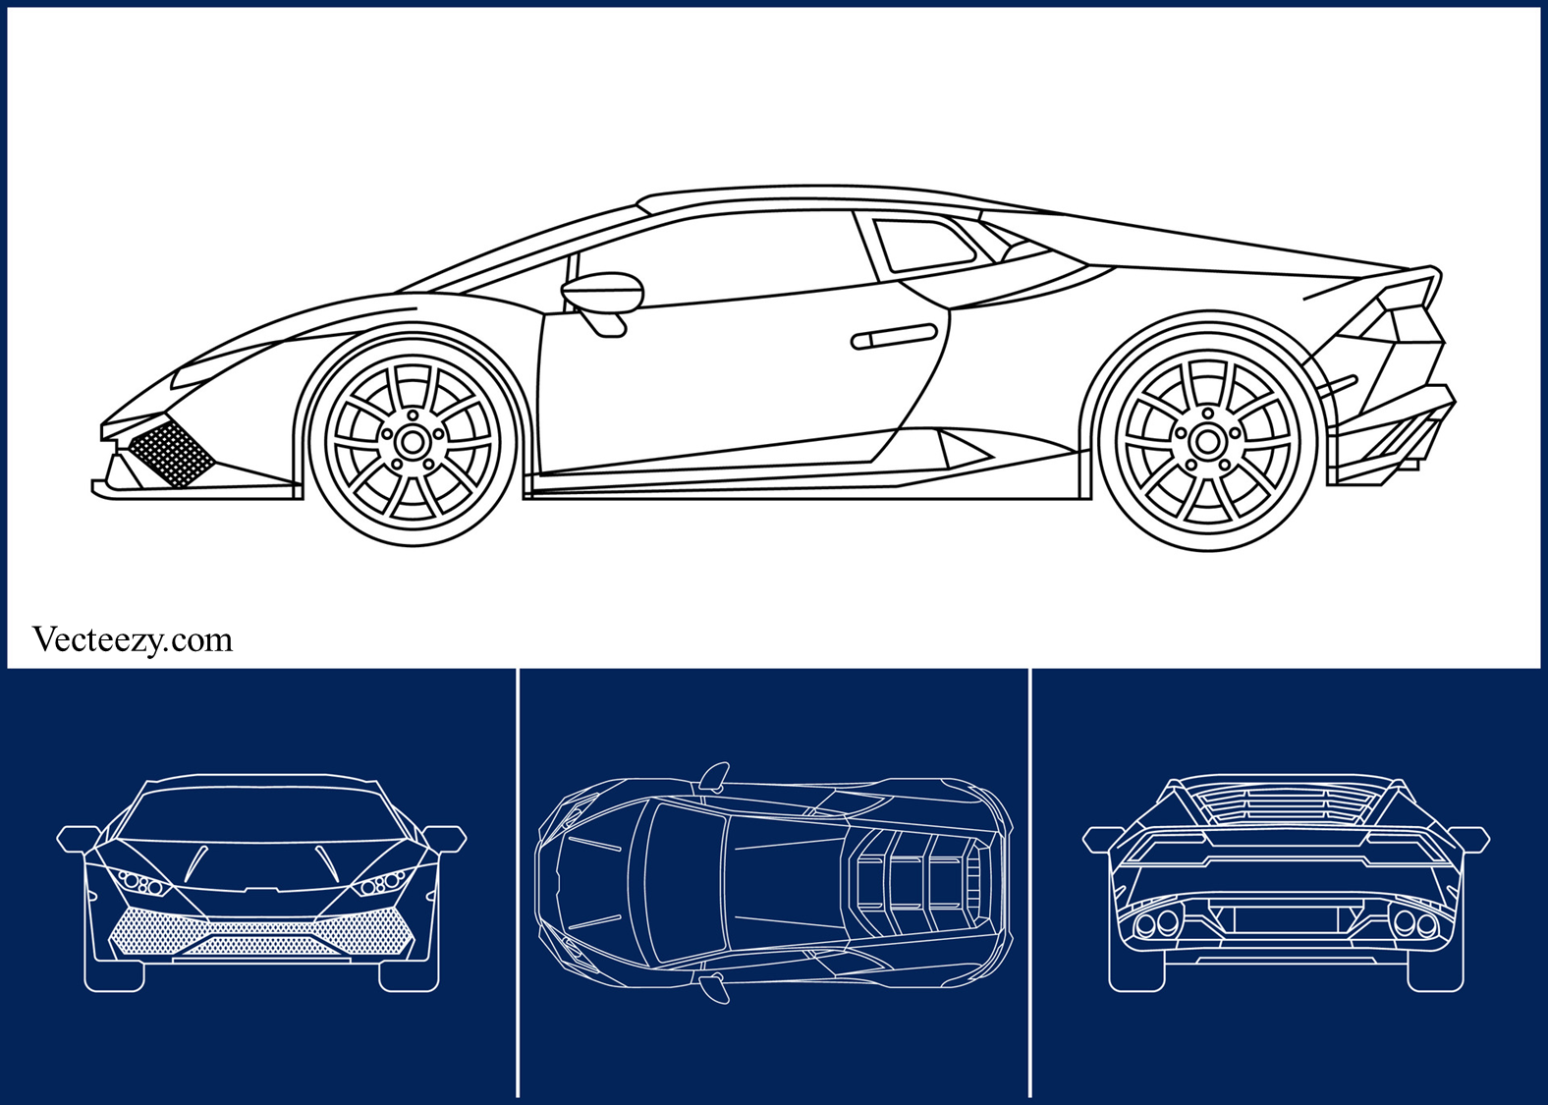

The Search for Missing Universal Laws
“At any point in history, what we don’t know surpasses what we know.”

From humanity’s earliest attempts to make sense of existence, there has been a persistent intuition that reality is not arbitrary but governed by enduring principles that hold even when they are not yet understood. Long before the scientific method, this intuition found expression in myth and narrative, not as fabrication, but as an early recognition that the universe follows rules that can be discovered rather than invented.
Modern science did not replace this belief but disciplined it. It transformed intuition into systematic inquiry while preserving the assumption that coherent laws underlie the world. Seeking universal laws is therefore not to impose order on reality but to uncover it, much like a sculptor who reveals a form already present in the stone. This search is driven by both human curiosity and the recognition that understanding the structures governing the universe often deepens our ability to act within it.

How a Gap in Understanding Led to a Universal Law
We do not discover universal laws by anticipating them in advance but rather when reality resists our explanations. A pattern falters, a theory fails, or a system continues to function without a clear reason, and what once appeared sufficient suddenly no longer is. It is in this moment of unease, when explanation falls behind observation, that inquiry is forced to move beyond refinement and toward something deeper.
The Universal Law of Increasing Complexity (ULIC) did not originate in physics or mathematics but in a personal confrontation with realities that existing models could not explain. For years, I worked across agriculture, technology, and rural poverty, convinced that the right tools and strategies could secure prosperity. In many cases, the evidence initially supported that belief; yields increased, incomes rose, markets opened, and measurable success followed. Yet these achievements proved fragile; prosperity would appear, then collapse, reemerge in fragments, and then vanish again. No technical refinement or strategic adjustment could explain why success, though observable and repeatable in the short term, refused to endure.
What emerged was not a technical failure but a structural one. The outcomes could no longer be explained by farmers' skills or the mechanics of trade alone, because the same pattern persisted even when competence, effort, and resources were present. The underlying problem lay in the system's design. Once this gap became visible, it could not be ignored. What began as an attempt to explain a local difficulty quickly revealed a broader principle. I had no intention of formulating a universal law, only of describing what I observed, yet the same tension appeared in companies, families, political systems, and recurring patterns of social life. The more closely these echoes were examined, the clearer it became that the problem was not local but structural, recurring across domains and pointing to a universal pattern.
This is what distinguishes a universal law from a useful insight. Theories often address anomalies within limited contexts, offering explanations that remain confined to a specific domain. A universal law emerges when the same contradiction appears across multiple levels of reality, from physics to chemistry, from biology to society, and when in each case the tension is not resolved away but transformed into new forms. At that point, the irregularity is no longer a local exception but a fundamental feature, revealing something about how reality itself evolves.

A Brief History of Missing Laws
History confirms this pattern; major breakthroughs arise not from certainty but from contradiction. Gravity was not discovered because anyone sought it in advance, but because the motion of falling bodies on Earth and the motion of planets in the heavens resisted explanation within separate frameworks. Newton showed that what appeared to be distinct phenomena were governed by a single underlying principle, later understood as a structural relationship among mass, motion, and spacetime. What had seemed fragmented was unified, and through that unification, the world became intelligible in a new, more coherent way.
Biology unfolded similarly; for centuries, farmers and breeders observed inheritance without understanding its mechanism. Mendel’s experiments revealed regular patterns that pointed to a hidden order, yet the underlying structure remained obscure. Only with the discovery of DNA was the gap resolved, transforming biology into a science capable not merely of description but of engineering. What had once been an anomaly became a foundation when the existing theory could no longer contain the evidence.
Physics provides further examples. Maxwell’s unification of electricity and magnetism brought together phenomena once thought separate into a single field. Thermodynamics transformed scattered observations on heat and work into principles that defined the direction of physical processes. In each case, the law emerged not because it had been predicted but because accumulated tension made its absence intolerable.
The same logic shaped society. Before Adam Smith, markets were practiced but not understood as systems. Before the articulation of the social contract, rulers governed without a framework that justified their authority in the eyes of the governed. Once formulated, these structures reshaped economies and institutions so thoroughly that it became impossible to imagine the world without them. Structural contradictions created frameworks that, once established, seemed inevitable.
Two lessons follow: first, the universe does not reveal its laws in advance. They emerge only when anomalies accumulate and contradictions make explanation unavoidable. Second, discovery expands not only knowledge but also capacity. Understanding gravity enabled navigation and engineering; DNA opened the path to biotechnology; and the social contract transformed governance. Each law or structure did more than resolve a puzzle; it broadened the horizon of what could exist.
If this has been true in the past, it must remain so today. The unresolved tensions of our era, between relativity and quantum mechanics, between rising complexity and fragile institutions, and between human knowledge and human conscience, are not failures but signals that our understanding remains incomplete. When new laws emerge, they do not resolve tensions in the universe itself but rather resolve limits in our explanations, opening new domains of possibility for human understanding, coordination, and action within the structures that already exist.

What Makes ULIC Different
The laws and principles we already know, including gravity, thermodynamics, electromagnetism, and natural selection, each describe a distinct layer of reality. They explain how matter moves, how energy flows, how forces and fields interact, and how life adapts through variation and selection. Each offers deep explanatory power within its own domain. Yet none explains why the universe as a whole continues to develop greater capability or how tensions at one layer give rise to transformations at the next.
The ULIC differs because it is a law of structure rather than of substance. It does not describe particle interactions, biological mechanisms, or economic exchanges. Instead, it describes how systems, regardless of domain, can sustain opposing forces within a coherent architecture and, by holding that tension, create the conditions for emergence. In this sense, ULIC does not sit alongside other laws as another domain-specific rule but operates as a meta-level description of how laws, systems, and capabilities relate across layers of reality.
We can use a metaphor to clarify the distinction. If the universe were a car, gravity and thermodynamics would describe how motion is generated and constrained, electromagnetism would describe how energy is transmitted and regulated, and natural selection would explain why certain configurations persist while others disappear. These accounts describe functions within the system. ULIC, by contrast, resembles the blueprint, which describes how the parts are arranged, how tensions are distributed, and how the overall structure makes certain forms of motion and development possible. Holding the blueprint makes it possible not only to understand how the system moves but also to identify where existing components no longer function coherently, as in institutions that lose legitimacy, and where essential components are absent altogether, thereby pointing to principles that have yet to be discovered.
Because it addresses structure rather than behavior, ULIC functions as a guide rather than as a predictive rule. A law such as gravity allows precise calculation of trajectories, but it does not indicate where undiscovered principles might lie. ULIC reframes persistent contradiction as information. In some cases, contradiction signals the absence of a law that could reconcile existing frameworks. In other cases, such as the unresolved tension between relativistic and quantum descriptions of reality, the contradiction itself may be structural, generating possibilities that resolution alone could never produce. In both situations, ULIC helps us distinguish between a missing principle and a productive tension that drives emergence.
Seen in this light, ULIC does not compete with existing laws and does not seek to replace relativity, quantum theory, or natural selection. Instead, it situates them within a broader architecture of complexity, interpreting the gaps between physics, chemistry, biology, and society either indicators of missing principles or as tensions whose persistence fuels transformation.
This is what makes ULIC distinctive. It does not merely describe why complexity increases; it offers a way to orient inquiry itself. Just as DNA encodes both the instructions for individual components and the logic that integrates them into a functioning organism, ULIC provides a structural framework that reveals not only how systems hold together but also where new laws are likely still waiting to be uncovered.

Where the Gaps Are: Contradictions Awaiting Laws
Seen through the car metaphor, these contradictions resemble situations in which a machine continues to operate exactly as it was designed to, yet no longer meets the demands now placed upon it. Motion persists, but the gap between capability and requirement widens in ways that no single component can explain. Without access to the underlying structure, this gap appears mysterious or accidental.
ULIC reframes this confusion by making structure visible. It allows us to see whether a system has reached the limits of what it was built to carry, whether forces have outpaced capacity, or whether the environment has evolved beyond what the existing architecture can sustain. In this sense, persistent contradiction is not evidence of failure but evidence that inherited structures no longer match the level of complexity now required.
Because ULIC renders this mismatch legible, it can serve as a compass rather than a rule. Its most reliable role is to orient inquiry toward regions where contradiction persists. These are not places where knowledge is merely incomplete, but where explanations remain coherent within their own domains and fail precisely when they are brought into contact. Such points do not signal missing detail but structural tension, and it is along these tensions that the true frontier of discovery is formed.
Physics offers the clearest example. General relativity describes the fabric of space and time on cosmic scales with remarkable accuracy, while quantum mechanics explains the behavior of particles at the smallest scales with equal success. Yet when the two are combined, incompatibilities arise and the mathematics fails. Some interpret this as evidence of a missing principle, a law still hidden from view. Others believe the contradiction is irreducible, a structural feature that fuels the cosmos's dynamism. In either case, ULIC directs attention here; the persistence of the gap is not a failure but a signal.
The life sciences reveal a similar frontier. We can describe molecular interactions within cells and the evolution of populations through natural selection, yet we cannot fully explain how consciousness arises. Chemistry and biology offer mechanisms, but the emergence of mind resists reduction. This could indicate a missing law that connects matter and meaning, or it could mean that consciousness itself is a structural contradiction, both material and mental, that drives new layers of emergence.
Society reveals contradictions just as striking: markets generate economic abundance yet intensify inequality; democracies depend on freedom yet require constraint; and nations insist on sovereignty yet rely on cooperation. These are not temporary flaws but enduring conditions of collective life. Here too, ULIC suggests that such contradictions are not incidental; they either signal unnamed structural laws of society or serve as engines through which societies evolve toward greater complexity.
Wherever we look, the universe presents contradictions it does not resolve. ULIC teaches us to see them not as irritants to be removed but as markers. They show us where to search, where to design, and where to prepare for discoveries that may redefine what is possible.

Understanding Contradictions: Engines, Gaps, and Absences
Once contradictions are recognized as diagnostic rather than accidental, the next step is to understand their role. Just as a blueprint helps distinguish among a part under strain, a missing connection, and a component that should not be removed because it provides essential tension, ULIC offers a way to classify contradictions rather than treat them as a single phenomenon.
ULIC shows that contradiction is never meaningless, though its significance varies by form. To use ULIC as a compass, we must distinguish three types: those that act as engines, those that reveal explanatory gaps, and those that expose structural absences.
Engines. These are contradictions that must persist if new complexity is to arise. The attraction and repulsion within an atom generate the stability from which molecules form. The tension between individual freedom and collective need creates the pressure from which new institutions emerge. Such contradictions are not meant to be eliminated but sustained, as they provide the conditions under which transformation becomes possible.
Explanatory gaps. These occur when theories succeed within their own domains yet collapse when applied together. Relativity explains the large, and quantum mechanics explains the small, yet when the two meet, the mathematics fails. Here, the contradiction signals that the existing framework is incomplete and that a principle remains undiscovered. The tension does not power emergence directly but points toward a missing unifying structure.
Structural absences. These appear where the architecture of complexity itself seems incomplete, as if a vital connection remains unidentified. We can describe the firing of neurons and the reality of subjective experience, yet the bridge between matter and consciousness remains elusive. Such contradictions do not merely expose the limits of explanation; they suggest that entire domains of law may still be absent.
Seen in this way, contradiction appears in three forms: as the engine of emergence, as the marker of theoretical incompleteness, and as the indicator of structural absence. ULIC enables us to distinguish among them and, in doing so, teaches us when to sustain tension, when to refine explanations, and when to search for principles that have not yet been imagined.

Projected Missing Laws
What follows is not a claim of discovery but an exercise in structural inference. Once contradictions are classified by their function, the compass offered by ULIC can be used not only to interpret existing knowledge but also to anticipate what remains absent. Just as a blueprint allows an engineer to infer which components must exist for a system to function coherently, persistent contradiction allows us to infer the likely presence of laws that have not yet been articulated.
If contradictions can be understood as engines, gaps, or absences, then the task becomes to ask what kinds of universal laws may lie hidden within them. ULIC does not specify these laws in advance, nor does it claim that they must take a particular mathematical or formal shape; instead, it provides a method. Wherever contradictions persist, either as structured tensions that sustain emergence or as missing connections that prevent coherence, new principles should be expected. By following this compass, we can begin to anticipate the contours of future laws even before they are revealed.
ULIC shows that contradiction is the condition of emergence, and the Law of Structured Contradiction expresses the first of these projections. This law refines that insight into a threshold principle: systems evolve in proportion to their capacity to sustain tension without collapsing, because it is precisely this sustained tension that enables new capabilities to form.
Not every contradiction is productive. In physics, the apparent conflict between wave and particle descriptions does not destroy the system because it is contained within a probabilistic framework, allowing quantum behavior to exist. In biology, mutation generates novelty only when balanced by stability, since too much variation leads to chaos while too little leads to stagnation, and it is this balance that enables adaptive evolution. In society, freedom and order can support democratic life only when institutions prevent either extreme from overwhelming the other, creating conditions in which collective coordination becomes possible. Below the threshold, tension destroys. Above it, tension becomes the driver of emergence.
The Law of Emergent Integration describes what follows when novelty appears. If contradiction fuels emergence, integration explains how that novelty stabilizes into enduring form. Systems evolve in proportion to their capacity to integrate new layers of complexity while preserving the integrity of those beneath. Molecules retain atomic identity while forming bonds and acquiring properties; organisms sustain cellular life while coordinating it through regulatory networks; and societies preserve individual identity while establishing institutions that regulate cooperation, foster trust, and ensure continuity. Integration is not passive cohesion but active regulation, requiring continuous energy flow and thermodynamic cost. Where integration fails, complexity fragments and higher forms collapse. Where it succeeds, new wholes arise that are greater than the sum of their parts.
The Law of Directional Emergence completes the projection. If contradiction supplies fuel and integration provides stability, directional emergence explains why some forms of evolution expand possibility rather than returning to prior states. When tension is structured, integration succeeds, and energy is coherently directed, the outcome is not neutral growth but a trajectory toward greater capability and emergence; this is not inevitability. Collapse occurs when preconditions fail, yet when they hold, direction appears. Stable atoms opened the way for chemistry; the evolution of vision expanded ecological horizons; and writing transformed memory and law, reshaping the futures available to human communities. Each step altered the landscape of what could follow. When expansion occurs, it compounds.
Taken together, these projected laws extend what ULIC begins: Structured Contradiction explains how tension becomes fuel, Emergent Integration explains how novelty stabilizes into structure, and Directional Emergence explains why stability, once achieved, opens into new trajectories. Fuel, stability, and trajectory form the triad through which complexity advances.

From Discovery to Design
The history of science shows that universal laws emerge only when contradictions can no longer be ignored. ULIC revealed itself in this way, not as a final explanation but as a compass that orients attention toward structure. It explains why tension fuels transformation and why evolution persists across every domain, even when progress seems fragile or unstable. Where earlier laws described motion, energy, or adaptation within specific layers, ULIC clarifies why systems continue to reorganize rather than settle into equilibrium.
If ULIC provides direction, the projected laws begin to describe the mechanisms that make that direction possible. The Law of Structured Contradiction formalizes the insight that tensions are not failures but sources of fuel, provided they are held within architectures capable of sustaining them. The Law of Emergent Integration explains why new forms endure by regulating coherence across levels, preserving what came before while incorporating what is new. The Law of Directional Emergence explains why this process compounds, why each successful stabilization expands the horizon of what can follow, and why complexity tends toward greater capability rather than mere accumulation.
Taken together, these laws suggest that the universe is not drifting without order but evolving along structural arcs. Those arcs are energized by contradiction, stabilized by integration, and directed by emergence. If confirmed, these laws would not replace the great laws already known; they would stand alongside them, offering a higher-order framework in which space-time dynamics, thermodynamic flow, biological evolution, and human institutions appear as expressions of the same underlying structural logic.
There is no guarantee that these laws, or others like them, will be discovered in the form projected here. History teaches that what is missing is rarely named in advance. No one demanded a theory of gravity before Newton, a molecular basis of heredity before Watson and Crick, or the kibbutz before it reshaped the Promised Land. What can be stated with confidence is that unresolved contradictions and structural absences persist all around us, and ULIC shows they are not random; they are indicators of laws yet to be discovered.
Articulating universal laws is not only to describe reality but also to design how we engage with it. By learning to recognize where contradictions persist, where integration is fragile, and where direction falters, we gain the ability to act with greater alignment with the structure of the world itself. This is the deeper promise of universal laws. They reveal that the same architectures shaping the universe also shape our societies and our lives, enabling us to understand and design what would otherwise remain obscure.

For any matter, contact me at +972-54-2523425

Subscribe here, free!
"Mental and Economic Freedom Are Interconnected."

See you soon,
Nimrod


Dr. Nimrod Israely is the CEO and Founder of Dream Valley and Biofeed companies and the Chairman and Co-founder of the IBMA conference. +972-54-2523425 (WhatsApp), or email nisraely@biofeed.co.il

P.S.

If you missed it, here is a link to last week's blog, “Does the Universe Have a Direction“.
P.P.S.
Here are ways we can work together to help your agro sector and rural communities step forward and shift from poverty into ongoing prosperity:
* Nova Kibbutz and consultancy on rural communities' models.

* Local & National programs related to agro-produce export models - Dream Valley global vertical value and supply chain business model and concept connects (a) input suppliers with farmers in developing economies and (b) those farmers with consumers in premium markets.

* Crop protection: Biofeed, an eco-friendly zero-spray control technology and protocol.

You can follow me on LinkedIn, YouTube, and Facebook.
*This article addresses general phenomena. The mention of a country/continent is used for illustration purposes only.

