

View Online and Translate
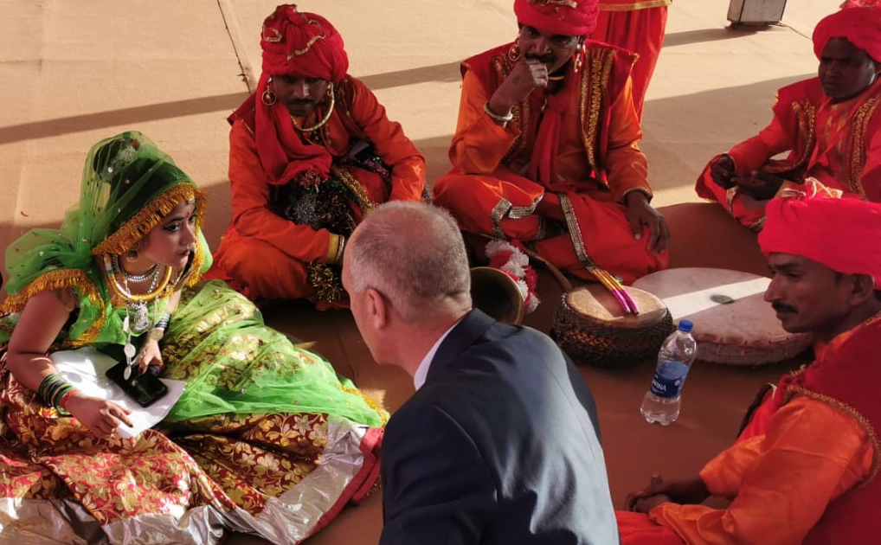
Why Societies Need Both: Stories That Give Us Direction and Methods That Question Them

“Progress doesn’t emerge from eliminating contradiction, but from learning to live with it.”

I entered the world naked, without religion, without a moral framework, without a mission or a vision, and without any understanding of how the universe works, and although I cannot remember that beginning, I have come to see it not as a personal anomaly but as a universal human condition. Every human begins life radically open, equipped with potential but without direction, yet that openness is immediately shaped by circumstances decided long before we are capable of consent or choice, including the stories we inherit and the questions we learn, often implicitly, to permit or suppress.
The family into which we are born, the culture and religion that surround us, the country and historical era we enter, the socioeconomic conditions we inherit, the color of our skin, our gender and appearance, and the opportunities or risks embedded in our environment all shape us in different ways and to varying degrees even before we take our first conscious step. None of these conditions result from later decisions, yet they profoundly influence how we perceive the world, the obstacles we are likely to face, how others will treat us, and which futures appear imaginable or remain out of reach.
This starting point is crucial, because much of the tension between science and religion later in life emerges from overlooking how deeply these earliest conditions shape both belief and openness to inquiry. The religion a person follows is usually inherited from the family and culture into which they are born, while openness to scientific inquiry depends largely on surrounding values that determine whether questioning is encouraged or restrained, values that are themselves shaped by religious, cultural, and historical traditions.
What is truly within our control is far less than we often like to imagine, yet it is not nothing. Within these inherited constraints, we still construct a story, an explanation of purpose that guides our choices, about why we are here, whom we place at the center of our existence, and whether we see ourselves primarily as beneficiaries of the world or as those fortunate enough to serve others. These stories do not free us from constraint, but they shape how we move within it, and that difference is often decisive.

What We Receive Before We Choose
Within days of my birth, decisions were made on my behalf that would shape the values I still carry today, including the decision that I would grow up as a Jewish boy, immersed in a moral tradition shaped both by Jewish heritage and by life on the Kibbutz. As I grew, I absorbed from my parents, from the Kibbutz, and from the broader social environment a set of values that were rarely articulated as formal doctrine, yet were deeply embedded in daily life, including the importance of equality, the dignity of labor, the value of human life, the pursuit of justice, and the obligation to contribute meaningfully to the society in which one lives.
These values were not presented as conclusions derived from scientific evidence, nor as hypotheses to be tested and revised, but as moral anchors that defined what was admirable, what was unacceptable, and what could not be justified even when it was efficient, fashionable, or profitable. At the same time, while values were transmitted with clarity and conviction, no clear personal purpose was assigned to me, and no explicit vision or mission was handed down beyond the expectation that I would live responsibly within the moral boundaries I had inherited.
Only later did I come to understand how important this separation was, because values tend to remain relatively stable across a lifetime, while purpose, mission, and vision must evolve as reality reveals new constraints, new knowledge, and new responsibilities. Values are deeply connected to culture, religion, national history, and family memory, while the ways individuals choose to express those values vary widely, shaped by temperament, opportunity, and the particular problems they feel compelled to address.

The First Encounter With Freedom
For many years, this distinction remained largely invisible to me, because my life was guided by systems that provided direction without requiring self-definition, first through school, then through a volunteer service year in a young Kibbutz, and later through the army. Each of these frameworks offered structure, discipline, and a sense of contribution, allowing me to act meaningfully without having to articulate my own purpose or choose my own direction.
Only after completing my military service, when I returned to the Kibbutz and to the orchards I loved, did I encounter freedom in its most demanding form, which is the freedom that emerges when no one is waiting to assign you your next task. At that moment, I stood before a choice that would quietly shape everything that followed, because there was a paved highway already waiting for me, offering a life I knew, loved, and was good at, continuing to work in agriculture within the familiar and meaningful structure of the Kibbutz.
Yet I chose not to take that path for granted, and instead to explore the side roads of life, asking where and how I could contribute to others, and how I might find a purpose and a mission that served something larger than my own comfort. This decision was not a rejection of the values I had inherited, but an attempt to honor them more fully, guided by the example my parents and community had set, which taught that serving the greater good creates a meaningful life even when the path is more demanding. From that moment on, responsibility replaced obedience, because once you choose your own story, you must also accept responsibility for revising it when reality disagrees, a lesson that would later become central to how I came to understand science itself.

When Values Require Method
The values I carried with me pointed toward action rather than abstraction, because caring about people’s health and about the environment inevitably leads to concrete questions about how food is grown, and agriculture was the domain I knew well enough to test whether values could survive contact with reality. I wanted to grow fruit with fewer chemicals, and if possible without sprays at all, not as a moral declaration, but as a practical expression of responsibility toward consumers, farmers, and the ecosystems that silently absorb the cost of our decisions.
Very quickly, those values encountered their limits, because agriculture does not yield to intention alone, and the moment sprays are reduced, problems emerge that do not respond to ethics by themselves. Fruit flies became the defining challenge, not because they were philosophically interesting, but because without controlling them one loses yield, quality, market access, and trust, and when trust collapses, every higher aspiration collapses with it.
My religion, culture, history, and values offered no solution to that problem, because they were never meant to explain chemistry, physiology, or biological mechanisms. Science, by contrast, provided the only viable path forward, through hypothesis, testing, and iteration, which, if followed with rigor, could lead to an effective and environmentally responsible solution. This was the moment when science entered my story not as ideology, but as necessity, because if values are to matter beyond words, they must be translated into mechanisms that function under pressure.
Out of this tension, a clear mission emerged, one that would guide me through the next twenty-five years of work, which was to develop an effective zero-spray fruit fly control technology that remained faithful to the values that had brought me there in the first place. Looking back, I can now see how the story I carried at that stage, like many stories held by technological entrepreneurs, was naive, not because it was careless or detached from reality, but because it assumed that a single good solution, pursued with integrity and persistence, could correct a deeply layered human problem shaped by markets and institutions.
That naivety was not a flaw, but a phase, because it allowed me to commit fully to the work and to persist through years of uncertainty and failure. Yet it also delayed a deeper realization, which was that improving lives requires not only better tools, but structures capable of carrying those tools all the way from intention to outcome.

Drawing the Boundary Without Choosing Sides
Some readers may expect this column to choose between science and religious stories, to affirm one and discard the other, yet that expectation itself reveals the confusion this column seeks to address, because the tension at stake is not a competition to be won but a structure to be understood. What often appears as a conflict between science and religion is, at a deeper level, a tension between story and method, between the human need for meaning and direction and the equally human need for verification, revision, and accountability to reality.
Religion, at its best, offers enduring stories that orient human life by providing purpose, responsibility, and moral boundaries capable of holding societies together across generations. Science, by contrast, offers a disciplined method for questioning assumptions, testing claims against evidence, and revising understanding when reality contradicts expectation. These two domains address fundamentally different kinds of questions and operate according to different logics, yet both are essential, and the problem arises only when either is asked to perform the role of the other.
There is, however, a third element without which neither religion nor science has any effect on the world at all, and that element is human choice. Stories do not act, and methods do not decide. Only people do. It is human judgment that determines whether values remain abstract or become operative, and whether knowledge is applied, restrained, or ignored. This point of choice is where direction and structure either align or fracture, and it is here that responsibility truly resides.
This distinction becomes clearer when we recognize that there are many religions, each carrying its own stories, symbols, and moral traditions, while there is a shared scientific method that allows humans across cultures to test claims against reality using common standards of evidence and reasoning. For this reason, pluralism in meaning can coexist with convergence in method without contradiction, because they occupy different explanatory domains rather than competing for the same one.
Seen through this lens, the relationship between religion, science, and responsibility can be described structurally rather than ideologically, not as competing worldviews but as distinct functions that together shape human action. The table below summarizes how story, method, and human choice each play a different role in translating meaning and knowledge into real world consequences.
Table: The Interplay of Story and Science in Shaping Human Choice

Domain | Primary Function | What It Answers | ULIC Role
Religion | Story, values, moral orientation | Why we are here, what matters, how we should live | Direction
Science | Method, evidence, mechanism | How the world works and why one outcome occurs instead of another | Structure
Human choice  (what we actually do) | Decision, action, responsibility | How values and knowledge are translated into real-world consequences | Alignment

Attempts to resolve this tension by removing one side repeatedly fail because when belief is erased, societies lose shared orientation and moral coherence, and when inquiry is suppressed, they lose the capacity to learn, adapt, and respond to a changing reality. Progress does not come from eliminating contradiction but from holding it within a structure capable of managing tension through human choice, because it is human judgment that determines whether stories guide action responsibly and whether methods remain accountable for their consequences. This pattern aligns directly with the Universal Law of Increasing Complexity rather than opposing it.

Power, Trust, and Living With the Tension
Once knowledge is translated into capability, the central question shifts from what is true to what will be done with what we now know, because power does not arise from equations alone but from the human decision to act on them.
The Manhattan Project, in which the first atomic bomb was developed in the 1940s in the United States, illustrates this structure with unusual clarity. Scientists working at the frontier of method and technology created an unprecedented capability, yet neither the decision to initiate the project nor the decision to use its outcome belonged to the scientific method itself. Those decisions were made within a broader human narrative shaped by war, fear, historical memory, and moral frameworks that defined survival, responsibility, and necessity at that specific moment.
Science made the bomb possible, but it did not decide whether it should be built, when it should be used, how it should be deployed, or against whom. Once those decisions were taken, they required explanation, justification, and meaning, tasks that belonged to narrative rather than method. Equations could not perform that work.
This pattern is not unique to that moment in history. It reflects a recurring structure in which scientific knowledge expands what humans are capable of doing, while shared narratives determine how that capability is directed, restrained, or released. Power is never self-directing; it always operates within frameworks that define what is permissible, what is justified, and what costs are acceptable.
This is also where responsibility becomes visible. When destructive outcomes occur, the failure is rarely that scientific understanding existed. More often, the failure lies in the guiding narratives, which narrowed, hardened, or lost their capacity to keep human dignity at the center.
For me, this is not an abstract observation. Members of my family on my mother’s side were taken from their village in Hungary to Auschwitz, where they were murdered by gas and burned to ashes, not because of anything they had done, but because a narrative had been constructed in which their existence was defined as a problem to be removed. The machinery that enabled that crime was technical, but the decision to deploy it was moral, shaped long before action by stories that stripped people of dignity and justified annihilation.
The lesson is not to fear knowledge, but to insist that knowledge remain embedded within narratives capable of restraining power and affirming human worth.
Science can tell us how to separate atoms, alter genes, or model behavior. It cannot tell us whether doing so serves life or undermines it, because such judgments do not arise from method. Responsibility emerges only when method is allowed to question narrative and narrative is allowed to restrain method, so that increasing capability remains accountable rather than absolute.
This is why I choose to share knowledge openly, including frameworks such as the Universal Law of Increasing Complexity. I do so not out of naivety, but out of trust that understanding is more likely to cultivate responsibility than ignorance ever could. Over time, withholding insight tends to concentrate power rather than contain it.
Living with this tension does not offer certainty or comfort; it offers something more durable, a way to advance without losing ourselves.
A meaningful life, like a resilient society, is built not by choosing between story and method, but by practicing the ongoing discipline of holding both in dialogue. Narrative provides direction, method corrects illusion, and responsibility resides in human choice, where values and knowledge must be aligned before power is released into the world.

* I strive to stay true to the facts and the reality they reveal. If you find an error or see a need for clarification, your insights are welcome.
Press to subscribe https://bit.ly/WeekendColumn free of fees.
"Mental and Economic Freedom Are Interconnected."

See you soon,
Nimrod

Dr. Nimrod Israely is the CEO and Founder of Dream Valley and Biofeed companies and the Chairman and Co-founder of the IBMA conference. +972-54-2523425 (WhatsApp), or email nisraely@biofeed.co.il

P.S.
If you missed it, here is a link to last week's blog, “Gravity, Temperature, and Prosperity: The Architecture of Emergence“.
P.P.S.
Here are ways we can work together to help your agro sector and rural communities step forward and shift from poverty into ongoing prosperity:
* Nova Kibbutz and consultancy on rural communities' models.
* Local & National programs related to agro-produce export models - Dream Valley global vertical value and supply chain business model and concept connects (a) input suppliers with farmers in developing economies and (b) those farmers with consumers in premium markets.
* Crop protection: Biofeed, an eco-friendly zero-spray control technology and protocol.
You can follow me on LinkedIn, YouTube, and Facebook.
*This article addresses general phenomena. The mention of a country/continent is used for illustration purposes only.

