

View Online and Translate
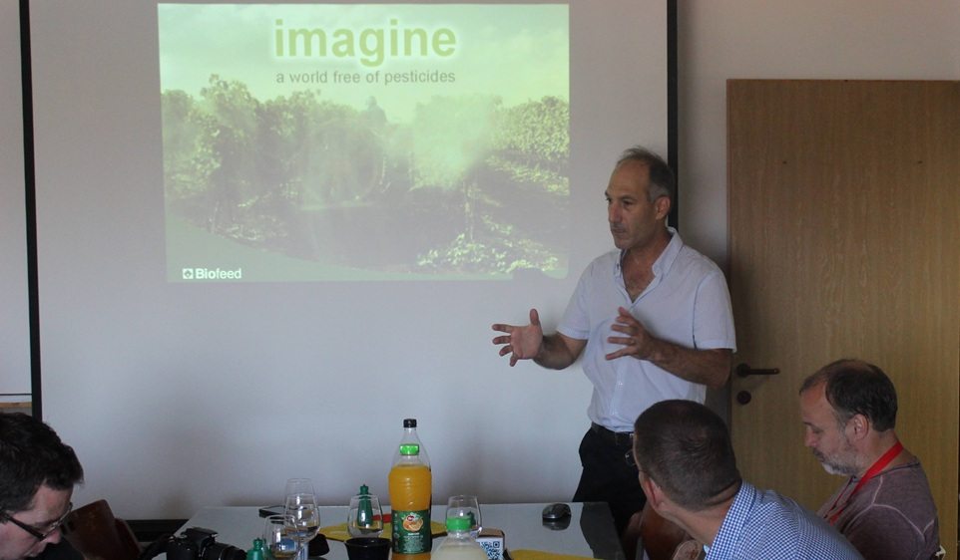

The Power of the Unseen: How Imagined Forces Shape Our World

“The universe has rules, and it rewards those who follow them.”

The most powerful structures in our lives, such as nations, currencies, and laws, are not built from matter but from meaning, and this is why they endure.

Big Question
I have a confession to make: until I reached university, I was afraid of physics. I first encountered it in high school, where it was a subject reserved for students who excelled in mathematics, something I most certainly did not. To me, physics belonged to the world of geniuses, a realm filled with cryptic equations, abstract theories, and distant problems that seemed to have no relevance to the world I lived in. It felt foreign, intimidating, and disconnected from the practical, human-scale challenges I cared about. I saw no reason for our paths, mine and physics, to ever cross, and truthfully, I believed neither of us would lose much if they never did.
But then something shifted. As I immersed myself in the urgent challenges of poverty, agriculture, and the survival of communities and nations, I began to confront questions that could not be resolved solely through policy prescriptions or technological fixes. Again and again, I found myself circling back, not to the equations of physics, but to its deeper philosophical roots, to the kind of questions it dares to ask with clarity and courage: What holds things together? What makes transformation possible? Where does power truly come from?
To my surprise, concepts I once dismissed as science fiction, black holes, dark matter, and dark energy, began to feel strangely relevant. They no longer appeared as distant curiosities from the realm of cosmology. Instead, they echoed something I had witnessed in society itself: the undeniable influence of forces we cannot see, touch, or measure directly, yet whose impact is deeply felt.
The more I explored, the more I came to recognize a strange but compelling truth: the most powerful forces shaping human life are invisible.
A company may lose its employees, its revenue, even its products, yet it can continue to exist if its legal registration remains intact. A nation may come into being not through conquest or revolution, but through a formal vote in the United Nations. Money retains value not because of its paper or metal, but because we collectively agree to treat it as valuable. A constitution, printed in black ink on white paper, governs millions of people over generations, not because of its physical form, but because people believe in the framework it represents.
These are not illusions. They are imagined constructs, yes, but once imagined, they become real. They coordinate human energy, shape behavior, and lay the structural foundations upon which large-scale cooperation becomes possible, far beyond what biological instinct alone could achieve. They form the invisible scaffolding of civilizations, enabling societies to endure, expand, and evolve through shared meaning held not in the hands but in the mind. And perhaps this understanding, the elusive boundary between imagination and reality, is not new at all. In its opening lines, the Bible offers a vision of creation that begins not with matter, but with words: “Let there be light.” No atoms, no tools, only a single act of speech, pure intention given form, animated by belief in the power of words to summon reality into being. With that declaration, the world is born.
The question I wish to explore is not merely philosophical, nor confined to science; it is, in many ways, existential. If the structures that shape our human experience, nations, currencies, constitutions, shared missions, are largely imagined yet exert real and enduring influence, and if we accept that humans and all they build remain governed by the laws of physics, then a deeper inquiry emerges: can we find this same paradox, imagined yet real, reflected in the very fabric of the universe?
What if reality, both social and cosmic, is held together not only by what we can observe, but by deeper structures that cannot be seen, touched, or measured, yet that persist because they allow energy to flow, direction to emerge, and complexity to build?

The Invisible Structures of Society
We often assume that what matters most in life must have physical weight, a building we can enter, a product we can hold, a currency we can spend. Yet the closer we look, the clearer it becomes that the most powerful architecture of human civilization is constructed not from materials, but from shared agreements, collective beliefs, and invisible frameworks. These structures, though intangible, govern nearly every aspect of our lives, and their strength lies not in what they are made of, but in what they enable us to do together.
Consider the lasting impact of figures like Gandhi, Mandela, and Martin Luther King Jr., individuals who, long after their passing, continue to shape the world. Was their influence the result of vast fortunes or physical assets? Or did it stem from the power of their words, their ideas, their visions, and the mission they inspired in others to carry forward?
It is not the physical presence of a corporation that makes it powerful, but rather the way its legal form enables capital to flow, contracts to be enforced, and responsibility to be distributed. With just a few lines of legal text and the imprint of a government seal, an entirely new entity is brought into existence, imagined, yet undeniably real. This structure, the company, can own property, invest capital, enter into contracts, sue and be sued, and continue to operate long after its founders have departed. It may lack a building, inventory, or employees, yet it exists and exerts real influence. Its power lies not in physical presence, but in the clarity of its structure, one that transcends geography, endures across time, and scales without regard to physical limits.
The same principle shapes our highest institutions. A constitution is not just a document, but a shared agreement on how people choose to live together. Its power does not come from paper and ink, but from the belief it inspires and the boundaries it sets. It shapes what is legal, what is possible, and what is worth striving for. When we say a nation is “held together by the rule of law,” we are referring to an invisible structure that channels millions of separate actions into a single, functioning society.
Even our economic lives run on invisible tracks. The value of a currency is not stored in the coins or printed bills we may carry; it is stored in the trust we extend to institutions, markets, and one another. That trust, though intangible, moves ships, builds cities, and determines who eats and who goes hungry. Its absence, conversely, can bring entire systems to collapse.
These structures, corporations, constitutions, and currencies have no weight, no scent, and cast no shadow, yet they move armies, shape markets, and govern lives. They are not fantasies but imagination structured into form, collective beliefs embedded in rituals and rules, made durable through institutions and powerful enough to organize human effort across time and space.
To grasp why this matters, we must recognize a deeper pattern: these invisible systems do not merely govern our lives; they channel energy, transform chaos into order, and align billions of actions without requiring central command. Their power does not come despite their intangibility, but because of it. And once we understand that human society is structured in this way, we are prepared to ask a far more daring question: could the universe itself be governed by the same logic?
President John F. Kennedy’s 1962 speech committing the United States to land a man on the Moon illustrates how energy, structure, and direction converge to generate emergence. It was not simply a bold political statement but the ignition of a structural process. The government mobilized immense energy through billions of dollars and hundreds of thousands of professionals, created a new organizational structure in NASA, and gave clear direction through a national mission to attempt the seemingly impossible. From this convergence emerged far more than a lunar landing, including advances in computing, systems engineering, telecommunications, and satellite infrastructure, which eventually laid the foundations of the internet itself. The World Wide Web was not part of the mission, but it became one of its most transformative outcomes. This is the nature of emergence: when energy and purpose flow through coherent structure, the results often exceed the original intent.
Can we imagine the world today without the internet? I suspect that if Kennedy were alive to witness what truly emerged from the Moon program, he might say, “We never imagined it would be this good,” just as my mother once said when looking back on the Kibbutz she and her friends built from scratch. When we align with the Universal Law of Increasing Complexity, the unimaginable does not just become possible; it becomes the natural outcome.

The Emergence of Complexity and the Hidden Logic Beneath
Long before cities rose, currencies circulated, or constitutions were drafted, our ancestors lived in small, close-knit groups governed by what the senses could grasp: what was seen, heard, touched, or smelled. Their world revolved around the immediate: a lion by the river, ripe fruit on a branch, the rustle of danger in the dark. Reality was what could be pointed to, confirmed, and shared. Concepts like justice, law, or a God watching from above belonged to a future they could not yet imagine, let alone coordinate around.
That changed with the Linguistic Revolution. Language evolved from signaling immediate threats or desires into a structural tool that allowed humans to speak not only of what was, but of what could be, of ancestors long gone, gods who watched from afar, laws not yet written, and futures not yet born. This leap introduced a new internal architecture built on grammar, syntax, and narrative form. With it came the power to transport meaning across space and time, across minds and generations.
It was far more than a communication upgrade; it was the ignition point of emergence. Language allowed knowledge to escape the confines of the moment and the individual, enabling it to be externalized through stories, speech, and symbols, and in turn, preserved, replicated, and scaled. What had once lived only within a single mind could now become part of a shared, intergenerational memory. Meaning was no longer anchored to a single place or person, but could travel across time and space. Purpose, once bound to immediate needs, became something collective and enduring, allowing cooperation to expand far beyond the limits of the visible or the present.
From this structural breakthrough emerged an entirely new class of human systems: myths, laws, taboos, prophecies, ideologies, and shared identities. These were not just fleeting beliefs, but enduring frameworks that shaped structure, not only sentiment. Once institutionalized through rituals, customs, and codes, they acquired the binding force of infrastructure, aligning behavior, assigning roles, and enabling a scale of coordination that no biological mechanism had ever achieved.
To grasp the magnitude of this shift, consider a simple contrast: a bowl of porridge can nourish one person once, and then it is gone. But a story, a shared mission, or a guiding principle can nourish a society for generations, without being depleted. Language gave rise not just to imagination, but to structural imagination, the capacity to generate and preserve abstract concepts that shape human action across vast distances and long durations.
What began as spoken language gradually evolved into law; what started as fiction matured into function. Words once exchanged around the fire became the invisible scaffolding for institutions, cities, and civilizations. Out of this structural imagination emerged religion, commerce, governance, education, and science; all built on the architecture of shared meaning.
This transformation did not arise from randomness, but from the consistent emergence of systems following a deeper pattern. They were not illusions or improvisations, but vessels; structures designed to contain, channel, and amplify energy in service of shared direction. A constitution is not merely an agreement; it is a framework that aligns the life of a nation. A currency is not just a medium of exchange; it is a belief system stabilized by trust and reinforced by law. A shared value is not simply an emotion; it is a structuring force that guides decisions and shapes behavior across generations.
To make this pattern clearer, consider the architecture of emergence itself. Energy flows are not sufficient unless they are contained by structure and oriented by direction, and only when all three are present within one coherent system can something new arise.

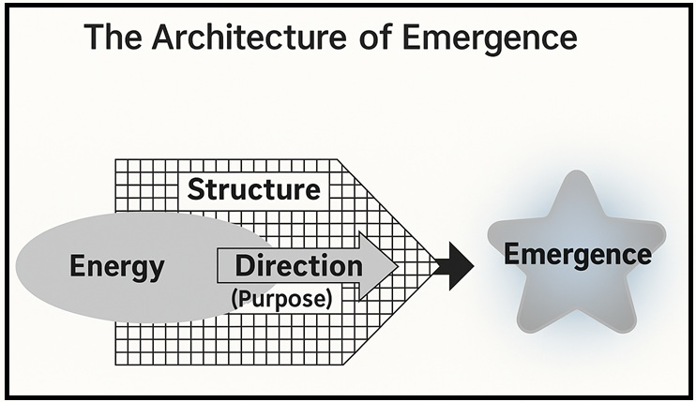

Table: The Four Elements of Emergence
Every system that grows in complexity shares the same architecture. Energy provides the raw potential, structure organizes it, and direction channels it toward purpose. When these three align, emergence occurs, giving rise to new forms such as life, stars, or civilizations.
Element | Example
Energy | Sunlight, capital, hydrogen
Direction | Mission, DNA, gravity
Structure | Membrane, legal system, platform
Emergence | Life, star, civilization

The Power of the Unseen
We often regard imagination as something secondary, abstract, and distant from the solid structures we call real, as if it stood in contrast to reality itself. Yet when imagination is stabilized, when it takes the form of a constitution, a company, a currency, or a shared cause, it no longer floats as an idea; it becomes a framework that channels energy, aligns actions, and enables entire societies to hold together and move forward.
This is not the work of magic but of structure, which when guided by purpose and powered by energy, becomes the engine through which complexity grows, whether in physics, biology, or human life.
What we observe in society is not a departure from natural law, but its continuation. The formation of governments, markets, and belief systems follows the same principles that govern stars and cells. Constitutions and companies, like molecules and galaxies, are shaped by a deeper pattern: energy flowing through form, directed by meaning.
At its core, the Universal Law of Increasing Complexity reveals that wherever energy is channeled through coherent structure and purposeful direction, new capabilities arise, explaining why stars ignite, why life unfolds, and why human civilizations take shape.
To recognize this pattern is to gain more than a deeper understanding of human affairs; it is to glimpse a principle that connects the workings of the cosmos with the choices we make as societies. The same law that shapes matter into stars also shapes shared beliefs into enduring institutions. And if we learn to work with this law, rather than against it, we can design systems, economic, political, and cultural, that are not only more resilient and just, but also more aligned with the deep architecture of reality itself.
Perhaps now you see why I could no longer ignore physics. In the next column, we will take this inquiry deeper, not as a metaphor, but as a continuation of the same underlying logic. If galaxies and governments both obey hidden structures, then perhaps what we call the “invisible” is not mysterious at all, but the architecture we are only beginning to recognize and learn to use with intention.

==> Seeking a speaker to present innovative ideas in agriculture, economics, history, complexity, organizational structures, and the science of prosperity? WhatsApp me at +972-54-2523425

Subscribe here, free of charge!
"Mental and Economic Freedom Are Interconnected."

See you soon,
Nimrod


Dr. Nimrod Israely is the CEO and Founder of Dream Valley and Biofeed companies and the Chairman and Co-founder of the IBMA conference. +972-54-2523425 (WhatsApp), or email nisraely@biofeed.co.il

P.S.

If you missed it, here is a link to last week's blog, “Between Two Theories (Part 2): What the Universe Teaches Us About Society, Structure, and Survival“.
P.P.S.
Here are ways we can work together to help your agro sector and rural communities step forward and shift from poverty into ongoing prosperity:
* Nova Kibbutz and consultancy on rural communities' models.

* Local & National programs related to agro-produce export models - Dream Valley global vertical value and supply chain business model and concept connects (a) input suppliers with farmers in developing economies and (b) those farmers with consumers in premium markets.

* Crop protection: Biofeed, an eco-friendly zero-spray control technology and protocol.

You can follow me on LinkedIn, YouTube, and Facebook.
*This article addresses general phenomena. The mention of a country/continent is used for illustration purposes only.

