

View Online and Translate
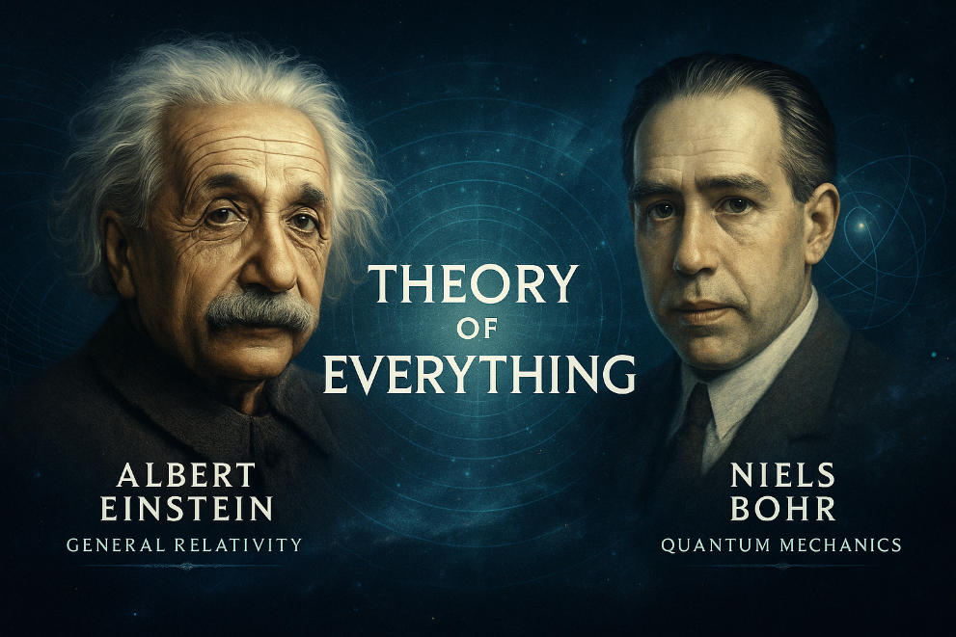

Between Two Theories (Part 1): How Physics Reveals the Engine of Emergence

“Dig deep into any problem, and eventually you will reach physics, mathematics, and philosophy.”

Why Poverty Demands a Theory of Everything
Most weeks, I write about poverty, not as an abstract concept, but as a daily reality that defines the lives of farmers, families, and entire communities too often forgotten. I explore how dignity is either protected or eroded by the structures within which people live. Again and again, I return to the same question: why do some communities rise, while others remain poor?
In seeking answers, I have turned to what I call the Universal Law of Increasing Complexity (ULIC). This law explains how emergent capabilities, which underpin prosperity, resilience, and survival, arise from the alignment of three essential forces: energy, structure, and direction. What makes this law remarkable is that it appears to apply across all levels of existence, whether we are examining a fruit fly trap, a village, or an entire nation.
However, if I am to claim this is a universal law, I must be prepared to test it beyond the familiar domains of agriculture, economics, and social systems. A law cannot be considered universal if it explains only why the Kibbutz model succeeded where others failed, or why solonist farmers remain poor. It must also hold true in physics, chemistry, and biology, and it must describe not only how people live, but how the universe itself evolves.
You might ask why it matters whether this law applies to distant galaxies or atomic particles, as long as it helps us improve life on Earth. The answer is that we are not projecting human needs onto the cosmos. Instead, we are asking the opposite: whether the cosmos operates according to principles that also apply to us. If such a law exists and governs all systems, physical, chemical, biological, and social, then it offers more than insight; it becomes a practical blueprint for transformation.
By revealing how the same forces that shape stars also guide human development, we move from understanding to agency. We gain tools to design systems that are not only more complex but also more capable, more resilient, and better aligned with long-term prosperity.
This is not merely a pattern of increasing complexity; it is a directional process. Systems that successfully hold contradiction do not simply survive; they evolve. They develop new capabilities, increase their coherence, and expand their functional range. This directionality, visible across biology and society, is precisely what the ULIC seeks to explain.
And suppose we can demonstrate that this law governs both living organisms and inanimate matter. In that case, we hold in our hands a powerful tool, one grounded in a universal, pre-existing blueprint that can guide the transformation and advancement of any society or organization, no matter its current state.
That is why, if you find yourself wondering why this column sometimes delves into topics such as the Big Bang, quantum theory, or black holes, which seem distant from farming, hunger, or poverty, it is worth remembering that for 2.5 million years, no hominid ever flew. But once we uncovered the laws of flight, even children and elders could soar through the sky.
Solving hunger, poverty, and ecological collapse will follow a similar path. We will not succeed through charity, improvisation, or fragmented effort alone, but only by uncovering the laws that govern emergence, transformation, and resilience. Only then can prosperity become not an exception, but the natural result of living in alignment with the deeper order of the universe.
That is why I turn to physics; not because I am a physicist, but because I believe that the same patterns that govern our social systems may also be at work in the deepest structures of the cosmos. If the ULIC can offer clarity where even physicists have struggled for a century, then it has earned its name. If not, then I must revise my claims.
In the previous column, we explored how the survival of institutions and nations depends on their ability to hold internal contradictions without disintegration. But this is not a challenge exclusive to human systems. The Universal Law of Increasing Complexity suggests that wherever emergence occurs, whether in biology, technology, or civilization, it emerges from the containment and structuring of contradiction. Nowhere is this more visible than in the heart of modern physics, where the unresolved tension between its two leading theories has persisted for over a century.
Nowhere is the test more demanding than in the unresolved tension between the two most successful scientific theories of the modern era: Quantum Mechanics and General Relativity. One governs the smallest scales, the other the largest. Each has proven astonishingly accurate within its own domain, and yet they do not agree; when scientists attempt to combine them, whether in the heart of a black hole or the first moment of the Big Bang, their mathematics breaks down.
This conflict has given rise to a monumental scientific effort: the search for a theory of everything. What could reconcile these contradictory yet independently verified frameworks? What deeper structure could explain them both?
Here is where the Universal Law of Increasing Complexity may offer a new perspective on the challenge. The contradiction between quantum theory and relativity may not be a flaw in need of resolution, but rather a structured tension that is essential for the emergence of something greater. Perhaps the universe does not begin in harmony, but in conflict. And maybe it is precisely this friction, this dynamic disagreement, which fuels the growth of complexity.
If so, then the conflict between quantum mechanics and relativity is not a barrier, but a doorway, inviting us to explore the deeper principles from which complexity arises.

The Two Great Theories of Physics and Their Conflict
To understand the scale of the challenge, we must briefly revisit the two grand frameworks that underpin modern physics. Each of them is a towering success within its own domain, yet they remain fundamentally incompatible with one another.
Quantum mechanics governs the smallest known scales of existence. It describes the behavior of particles, atoms, and the fields that operate between them. In this microscopic domain, certainty gives way to probability, and outcomes are described not through deterministic causality but through likelihood. Particles may exist in multiple potential states until one is measured. Even what we call empty space is filled with fluctuations and hidden forces. Though abstract and often counterintuitive, quantum theory has been confirmed through decades of rigorous experimentation and forms the foundation of much of the modern world, from electronics to medicine.
General relativity, by contrast, explains the behavior of the massive and the vast. Introduced by Einstein, it redefined gravity as the curvature of space and time itself, shaped by the presence of energy and mass. According to this framework, objects move not because they are pulled, but because they follow the bending of the geometry around them. This theory explains the expansion of the universe, the orbits of planets, the bending of light near stars, and the behavior of black holes. Like quantum mechanics, general relativity has been repeatedly tested and has consistently proven accurate.
Yet when scientists attempt to combine these two theories, when they try to describe phenomena in which both quantum effects and gravitational forces are strong, their assumptions begin to collapse into contradiction. Quantum mechanics assumes a fixed and continuous background of space and time, while general relativity treats space and time as dynamic and shaped by the matter within them. One theory views reality as discrete and probabilistic, while the other sees it as continuous and geometric; their languages are incompatible, and their mathematics do not align.
This conflict becomes inescapable under the extreme conditions that existed in the earliest moments of the universe or within the core of black holes, where quantum fluctuation and intense gravitational curvature coexist. These are precisely the environments in which we would expect our most fundamental theories to work together. Instead, they break down, and the equations produce infinities or contradictions that offer no physical meaning.
Over the past several decades, some of the most ambitious efforts in theoretical physics have aimed to bridge this divide. Proposals such as string theory, loop quantum gravity, and holographic models aim to establish a more comprehensive framework that encompasses both quantum and relativistic behavior. Some suggest that space and time themselves are not fundamental but are emergent from a deeper order, possibly built from information. Although these ideas have inspired rich mathematical development and continue to evolve, none has yet delivered conclusive experimental evidence or achieved widespread consensus.
What we are left with is not a lack of knowledge, but a fracture in coherence. We have two powerful theories, both verified by experiment and internally consistent, yet no shared foundation that brings them together. The result is a divide at the heart of physics, not between observations, but between worldviews.
If the Universal Law of Increasing Complexity is to be taken seriously as a foundational principle, it must speak to this contradiction, because any true universal law must have emerged with the universe itself. It must not only help us understand how societies and organizations evolve, but also whether the universe itself grows through structured opposition. The question is whether this contradiction marks the limit of current science or signals the beginning of a deeper process of emergence. If we apply the law carefully, we may discover that progress lies not in erasing contradictions, but in holding them long enough for something new to emerge and take shape.

ULIC’s Perspective – Complexity Emerges from Tension
When we examine the longstanding contradiction between quantum mechanics and general relativity through the lens of the Universal Law of Increasing Complexity, we begin to see that the two theories may not need to be forced into agreement. Instead, it becomes possible to understand the tension between them not as a flaw in the structure of the universe, but as a foundational condition from which emergence becomes possible.
Let us return to the foundation of the Universal Law of Increasing Complexity and how it operates. This law describes how new capabilities emerge when energy flows through a system that offers both structure and direction. Complexity does not grow from balance or simplicity alone. Instead, it requires sustained interaction among elements that are not naturally aligned or immediately compatible.
For a system to evolve into something more capable, three core elements must be present. First, there must be a continuous inflow of energy. Second, this energy must be oriented by a sense of direction, whether explicit, such as a mission, or implicit, such as evolutionary pressure. Third, the system must contain a structure capable of stabilizing and organizing the energy over time.
When these conditions are fulfilled, the result is not mere growth but the emergence of new capabilities, properties, and behaviors that cannot be predicted or reduced to the sum of the system’s parts.
This framework invites us to reconsider the relationship between the two dominant theories of physics. Quantum mechanics reveals a universe fundamentally saturated with energy. Even the vacuum, far from being empty, is alive with fluctuations, probabilities, and transient expressions of potential. This domain is governed by uncertainty and driven by continuous change. It injects energy into the systems it touches, keeping them in a state of dynamic possibility.
General relativity, in contrast, provides the structure. It describes the geometry of space and time and explains how mass and energy curve that geometry. This theory brings continuity, coherence, and predictability across vast distances and timescales. Without such a structure, the boundless energy revealed by quantum theory would remain unstable, lacking form or endurance. Relativity gives shape to the cosmos and allows systems to persist long enough for complexity to arise.
Direction, the third essential element, can arise from multiple sources. It may emerge from the boundary conditions established in the early universe, from the irreversible flow of time, or from entropy gradients, which we call Genordo, the force that drives order through transformation, compelling systems toward continuous change. Direction may also be shaped by the large-scale expansion of the universe, which imparts motion with a preferred trajectory. And perhaps most intriguingly, it may arise from the ongoing tension between quantum mechanics and general relativity. Though these two theories resist unification, they remain fundamentally interdependent. The contradiction between them creates a kind of internal pressure, not only for the scientists who seek to resolve it, but perhaps within the very fabric of the universe itself.
Even before we achieve a fully unified theory of physics, we can already observe the astonishing result of this cosmic interplay: the universe has unfolded through a continuous and traceable sequence of emergent complexity, in which each stage gave rise to new forms that could not be anticipated by examining the previous one alone. From subatomic particles emerged atoms, which combined to form molecules, setting the stage for the rich domain of chemistry; chemistry, in turn, gave rise to biological systems, leading to life, which eventually developed the capacities for awareness, consciousness, and culture.
With each transition, a new level of organization emerged, more capable, coherent, and purposeful than what preceded it. These stages did not merely add complexity; they introduced entirely new capabilities, allowing the universe to grow not just in scale, but in its ability to generate meaning, resilience, and direction.
Everything is connected to everything. Each emergent level builds upon and reshapes what came before. The cosmos is not a sequence of isolated layers, but a nested system in which every layer, from atoms to awareness, depends on and contributes to the whole.
Although the universe is not uniformly biological, its overall trajectory reveals an unmistakable increase in complexity and capability. The emergence of Homo sapiens and human society is not an exception to this pattern, but part of it. We are the result of a system that has evolved to the point where it can reflect on its own conditions. We are able to study the very laws that gave rise to us, and in doing so, shape the direction of what comes next through us.
From this perspective, the contradiction between quantum mechanics and general relativity is not an obstacle to progress, but part of its generative structure. The friction between these two frameworks may be precisely what drives the ongoing emergence of scientific understanding and structural complexity. The beauty of the Universal Law of Increasing Complexity lies in the fact that it does not require harmony or agreement for growth to occur. On the contrary, it depends on tension; tension that is held, guided, and stabilized, until something new can emerge.
What we observe in the history of matter, life, and society may also apply to the foundations of physics. The most profound contradictions, when placed within a structure that can contain them, may become the sources of our most tremendous advances. The task, then, is not necessarily to unify our theories by force, but to build a framework that allows them to coexist in productive tension, long enough for the next layer of understanding to take shape.

==> Seeking a speaker to present innovative ideas in agriculture, economics, history, complexity, organizational structures, and the science of prosperity? WhatsApp me at +972-54-2523425

Subscribe here, free of charge!
"Mental and Economic Freedom Are Interconnected."

See you soon,
Nimrod


Dr. Nimrod Israely is the CEO and Founder of Dream Valley and Biofeed companies and the Chairman and Co-founder of the IBMA conference. +972-54-2523425 (WhatsApp), or email nisraely@biofeed.co.il

P.S.

If you missed it, here is a link to last week's blog, “The Missing Law of Creation (Part 3)“.
P.P.S.
Here are ways we can work together to help your agro sector and rural communities step forward and shift from poverty into ongoing prosperity:
* Nova Kibbutz and consultancy on rural communities' models.

* Local & National programs related to agro-produce export models - Dream Valley global vertical value and supply chain business model and concept connects (a) input suppliers with farmers in developing economies and (b) those farmers with consumers in premium markets.

* Crop protection: Biofeed, an eco-friendly zero-spray control technology and protocol.

You can follow me on LinkedIn, YouTube, and Facebook.
*This article addresses general phenomena. The mention of a country/continent is used for illustration purposes only.

