

View Online and Translate
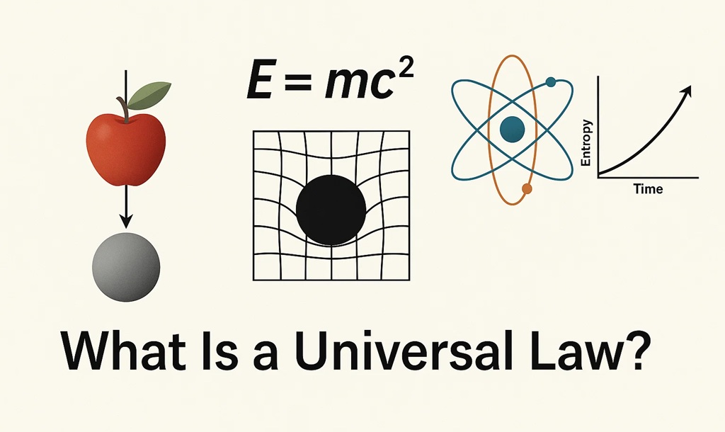

What Is a Universal Law, and Why Most “Laws” Aren’t (part 1)
“What makes a law truly universal?”
In science, words do more than describe. They shape how we understand the world and how we act within it. A single term can separate what is observed from what is explained, what happens often from what must happen always. In an era of accelerating discovery and global interconnection, such distinctions carry growing weight. To call something a principle suggests that it often holds true. To call it a law implies necessity. And when we speak of universal laws, we make an even stronger claim, a statement about patterns that endure across time, space, and scale. This column begins by asking what that claim truly means, and why it matters for how we understand nature, shape society, and pursue lasting prosperity.
Scientific laws are often presented as the bedrock of our understanding of the universe. Gravity draws masses together. Entropy increases in isolated systems. Energy is neither created nor destroyed. These are not merely useful principles; they are understood to describe the deepest architecture of nature, shaping the universe from galaxies to engines, and from chemical reactions to living systems.
Yet despite their foundational status, not all scientific laws are equally universal. Some apply everywhere and at all times. Others, though widely taught and useful, hold true only under specific conditions, within certain domains, or across limited scales. The higher we move through the layers of nature, from atoms to molecules, from cells to ecosystems, and finally to societies, their clarity and universality tend to weaken. What begins as necessity in physics often becomes probability in biology, and then mere tendency in the social realm. As a result, the idea of a “law” becomes less consistent the further we rise from the fundamental layers of matter and energy.
This column does not question the value of scientific knowledge. Instead, it aims to clarify its foundation by asking what qualifies a rule as truly universal. Without a sharp distinction between universal laws and domain-specific patterns, we risk missing something essential. In the physical sciences, this clarity has enabled rapid progress. Fields like electronics, energy, and medicine have advanced on stable ground because they rest on laws that are deeply predictive and universally valid. In contrast, the social sciences lack a comparable foundation. We do not have a single agreed-upon law that explains how communities, companies, institutions, or entire societies operate, or, more broadly, how complexity arises, persists, and why it collapses. As a result, our attempts to solve poverty, design better institutions, or stabilize societies often rely on models that are contextual and fragile. Before proposing a new law to address this gap, we must first understand what it means for any law to be truly universal.

What Defines a Universal Law?
Not all scientific rules are created equal. A universal law must describe a structural regularity that holds across all time periods, geographies, and layers of reality. It cannot depend on a particular chemical environment, a specific biological process, or a narrow range of physical conditions. Instead, it must define invariant relationships, principles that determine what is possible, what is constrained, and what is prohibited, regardless of context.
To meet this standard, a scientific law must exhibit four core properties:
Timelessness: It holds from the earliest moments of the universe to the present and is expected to remain valid into the future.
Spatial Generality: It applies not only on Earth or in laboratories but throughout the observable and theoretical universe.
Cross-Domain Validity: It operates across different layers of nature, physics, chemistry, biology, and society, rather than being confined to one domain.
Structural Necessity: It defines the outer boundaries of possibility. It does not merely describe what tends to happen, but reveals what must happen or cannot happen under defined conditions.
As the physicist Richard Feynman explained, the search for a new law begins with a hypothesis. We propose an idea, deduce its implications, and then test those implications against observation. If the predictions do not match what nature reveals, the law is wrong, no matter how elegant or convincing the idea may seem. Any claim to a universal law must meet this same standard. It must not only sound plausible but also produce predictions that can be observed and verified across physics, chemistry, biology, and human societies alike.
Only a few scientific principles satisfy all four criteria of universality. Newton’s Law of Universal Gravitation describes the attraction between any two masses, operating from the scale of falling apples to entire galaxies. Einstein extended and deepened this universality: his equation E = mc² revealed the fundamental equivalence of mass and energy, and his theory of General Relativity redefined gravity as the curvature of spacetime, governing motion from planets to black holes. Quantum Mechanics introduced equally universal laws at the atomic and subatomic levels, defining how matter and energy behave in the smallest known structures of reality. The Second Law of Thermodynamics shows that entropy increases in closed systems, driving them toward disorder unless energy is introduced and organized. None of these principles is bound to a specific material, environment, or moment in time. They are woven into the fundamental structure of reality itself.
Many other so-called “laws,” though useful within their domains, do not meet this standard.

Most “Laws” Are Contextual Rules
Consider Mendel’s Laws of Inheritance, which describe genetic transmission in sexually reproducing organisms. While foundational, they do not apply to bacteria, viruses, or more complex genetic systems. Boyle’s Law works under ideal conditions but fails in extreme environments or at molecular scales. Kepler’s Laws held for planetary motion until general relativity reframed gravity as the curvature of spacetime. Ohm’s Law breaks down in high-frequency or nonlinear materials. And even in economics, the so-called Law of Supply and Demand often collapses in real-world markets shaped by monopolies, emotional behavior, or policy distortions.
These examples do not reflect flaws in scientific reasoning. Rather, they reveal that many widely accepted laws are not universally applicable. They are conditional, accurate within specific domains, but not beyond them. They describe patterns that often hold, but not always, and not under all conditions. They help us organize knowledge, but they do not define the structural boundaries of what is possible.
We have no widely recognized scientific law that explains how complexity emerges, how it is sustained, or why it collapses. In sociology, for example, we have theories that describe institutions, norms, or group behavior, but none that predict the structural rise or collapse of societies with the consistency we find in the physical sciences. This is not a minor omission; it reveals a missing pillar at the heart of scientific understanding. If we can describe how an object falls or how molecules behave, but not why a society fails or a system unravels, then we lack the law that could unify our understanding of both nature and human organization.

The Continuity of Law Across Layers
Scientific knowledge unfolds in layers, each one emerging from and constrained by the principles established in the preceding layers. At the foundation lies physics, the most universal and mathematically complete of all the sciences. Here we find laws that govern motion, mass, energy, and thermodynamics, principles that apply whether we are analyzing the orbit of a planet or the structure of an atom.
From this foundation arises chemistry, where atoms interact to form molecules, reactions, and materials. Chemistry remains fully governed by physical laws, yet introduces new dependencies on temperature, bonding conditions, and the distinct behaviors of specific elements. Its patterns emerge from physical constraints, but they take on new forms as atomic complexity increases.
Biology emerges next, shaped and bounded by both physics and chemistry. Within this layer, structure and function evolve together in living systems. Evolution by natural selection explains how traits adapt over time, but it requires specific conditions, variation, inheritance, selection, and time, and does not generalize to non-living systems or explain how ordered structures arise in the first place.
Later, societies, cultures, and technological systems emerge. These layers, though often treated as separate from the natural sciences, are fully constrained by the laws of the layers that came before them. Yet their behaviors are richer, more variable, and more challenging to model. In these domains, we rarely speak of laws at all. Instead, we rely on models, tendencies, or cycles. We can observe the collapse of governments or the instability of markets, but we cannot predict them with the precision we apply to gravitational motion or thermodynamic decay.
This absence of predictive laws does not mean that universal principles no longer apply. On the contrary, the same foundational laws persist, but they are expressed differently at each level of complexity. Every emergent layer carries forward the constraints and possibilities of its predecessors, while introducing new forms of organization made possible by greater structural depth. What is missing is not order, but a unifying principle that explains how structure accumulates, how coherence is preserved, and why complex systems sometimes unravel.

The Missing Frame: A Law of Complexity?
What unites all complex systems, from galaxies to living organisms, and from ecosystems to civilizations, is not only that they are governed by gravity or thermodynamics, but that they seem to follow a consistent process of emergence. These systems form, organize, expand, specialize, and, under certain conditions, collapse.
What if there exists a law that governs this process, not as a metaphor or analogy, but as a structural necessity? A principle that operates wherever systems are open to energy, capable of retaining structure, and oriented by a shared direction or function?
Such a law would not contradict the physical or biological laws we already know. Rather, it would clarify their implications. It would explain the structural logic that determines why some systems endure while others dissolve. It would identify the conditions that make complexity possible, and the thresholds beyond which it becomes unstable or unsustainable. It would help us understand not only how a star forms or how a market expands, but also why both eventually reach a limit that leads to disintegration, unless the system’s energy input, structured containment, purposeful direction, and outward flow are realigned.
The layers of reality do not stand isolated from one another. Each is supported by and continuous with the one that preceded it. To understand a molecule, one must understand the atom. To understand a living cell, one must understand molecular systems. And to understand societies, one must begin with the structural principles of biology, chemistry, and physics. Societies do not replace these layers; they extend from them. They represent a higher level of complexity built on the same foundational rules.
This continuity allows us to trace the influence of physical laws across all layers of emergence, from atoms to economies. The laws that govern matter and energy do not vanish as complexity increases. They remain active, even as their effects are expressed in more intricate and adaptive forms. Any pattern that shapes society must, by necessity, conform to the universal laws that govern all systems beneath it
Poverty is not simply a social or economic problem. It is a structural outcome, shaped by the availability of energy, the strength of internal organization, the clarity of shared direction, and the ability of communities to engage with the world beyond themselves through outward flow. These are not metaphors borrowed from physics or biology. They are structural realities that govern molecules, ecosystems, and societies alike. When we overlook them, we fail to address the deeper causes of collapse and end up treating symptoms instead of systems.

What Comes Next
In the next column, we will introduce this emerging law, a principle that explains how complexity arises, stabilizes, and ultimately fails when key structural conditions are not maintained. This law rests on four essential components: a sustained input of energy, the presence of coherent internal structure, the clarity of shared direction, and the capacity to release surplus or disorder through outward flow. These are not abstract ideals. They are observable, repeatable, and measurable across both scientific and social domains.
This new law does not replace the laws of gravity, entropy, or evolution. It integrates them into a broader understanding of how emergence arises from energy and how capability arises from coherence. We already have laws that describe how objects fall, how heat disperses, and how traits are selected. Perhaps it is time to ask a different question: what causes complexity to rise, and under what conditions does it begin to unravel?
That question may lead us toward the next great law, not a law of motion, but a law of emergence.

==> Seeking a speaker to present innovative ideas in agriculture, economics, history, complexity, organizational structures, and the science of prosperity? WhatsApp me at +972-54-2523425

Subscribe here, free of charge!
"Mental and Economic Freedom Are Interconnected."

See you soon,
Nimrod


Dr. Nimrod Israely is the CEO and Founder of Dream Valley and Biofeed companies and the Chairman and Co-founder of the IBMA conference. +972-54-2523425 (WhatsApp), or email nisraely@biofeed.co.il

P.S.
If you missed it, here is a link to last week's blog, “Why Some Leaders Turn to Conflict as a Method of Governance“.

“.
P.P.S.
Here are ways we can work together to help your agro sector and rural communities step forward and shift from poverty into ongoing prosperity:
* Nova Kibbutz and consultancy on rural communities' models.

* Local & National programs related to agro-produce export models - Dream Valley global vertical value and supply chain business model and concept connects (a) input suppliers with farmers in developing economies and (b) those farmers with consumers in premium markets.

* Crop protection: Biofeed, an eco-friendly zero-spray control technology and protocol.

You can follow me on LinkedIn, YouTube, and Facebook.
*This article addresses general phenomena. The mention of a country/continent is used for illustration purposes only.

