Online link
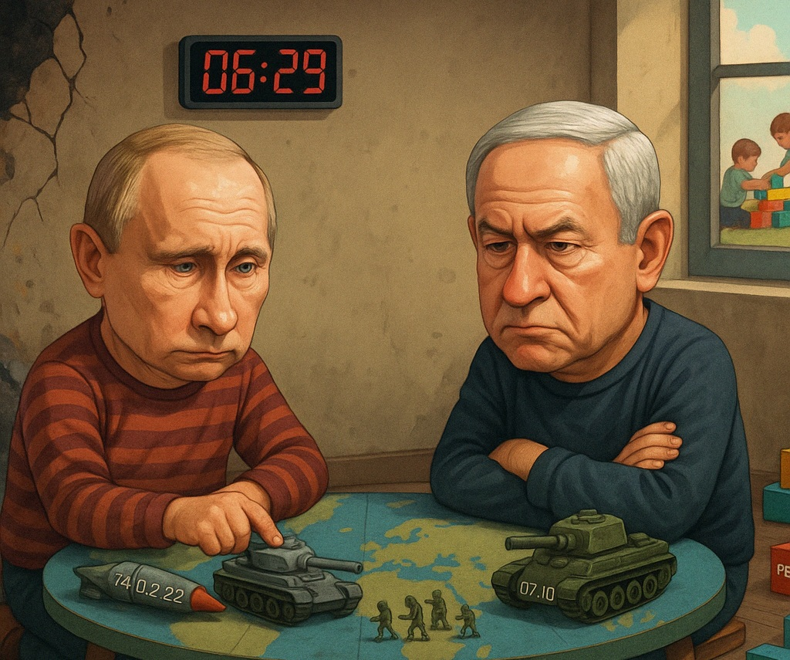

Why Some Leaders Turn to Conflict as a Method of Governance
“The universe offers endless energy. Whether it becomes destruction or creation depends on the direction we choose.”

A quiet thought before we begin: Every successful human endeavor contains three essential elements: energy, structure, and direction. Together, they form what I call Genordo. As you read, notice how these elements rise, collapse, or change. They help explain not just this column, but the deeper mechanics of our past, present, and future.
The column “Seven Revolutions: The Structural Journey of Humanity from Tribes to Corporations” ended with the question: Can we move beyond systems that maximize economic output while weakening social bonds, and instead build ones that support both prosperity and human well-being?
A natural, perhaps inevitable, follow-up question is: What happens if we fail to combine economic and social complexities?
The answer, I’m afraid, is unfolding before our eyes: poverty, hunger, persistent stagnation of developing countries, and, perhaps most visibly, war. These are not isolated crises; they all stem from the same underlying failure to align our economic and social complexities.
But before we examine wars between nations, let’s start with something more intimate: children.

Frustration and Incapability
We’ve all witnessed it: a child, overwhelmed by frustration, loses their temper and lashes out, not necessarily at the true source of their pain, but at whatever is nearest at hand, and if nothing is there, even at themselves. For a fleeting moment, the outburst brings relief. But as the moment passes, the child realizes that nothing has changed; no solution has emerged, and the unresolved frustration remains, possibly even deepening.
Our technological development depends on cultural complexity, which allows for flexibility and rapid advancement. However, developments rooted in biology, that is, changes in our DNA, unfold over thousands or even millions of years. This means that a leader today, with their finger on the nuclear button and the power to erase countries from the map, is emotionally not so different from a tribal chief leading a band of 30 Homo sapiens on a mammoth hunt 30,000 years ago. In other words, Homo sapiens are emotionally underdeveloped for the level of technological and economic complexity we now control.
This helps us understand why leaders and nations often behave much like children. When internal tensions mount and social cohesion frays, frustration builds within a society like steam trapped in a sealed chamber. Without a constructive outlet, that pressure eventually bursts forth violently. Sometimes it erupts outward, directed by a failing government against foreign adversaries. Sometimes, tragically, it turns inward, consuming the nation’s own citizens.
But why does this happen? Why do struggling societies, instead of turning their frustration into fuel for renewal and improvement, seem doomed to repeat cycles of destruction? Can this destructive impulse be interrupted? And, perhaps unexpectedly, what does this have to do with solonist farmers and how we grow our food?
Frustration itself is not the problem; it is a natural signal, a sign of imbalance, unmet needs, and energy building up inside the system, seeking release. In children, frustration arises when their desires exceed their abilities. In nations, it emerges when leadership and society’s ambitions outpace the system’s capacity to deliver prosperity, justice, or security. What matters is what happens next.
Some children learn to manage frustration constructively: They channel their energy into sports, innovation, or helping others, turning restless energy into growth rather than destruction.
Others lash out, not because it solves anything, but because they have yet to learn a better way, and because, for a brief moment, it feels powerful.

The Illusion of Power in War
Leaders and nations are no different from the children we described earlier. Throughout history, countries have gone to war for many reasons. Some wars, of course, are calculated efforts to expand territory, seize resources, or gain economic or political advantage. Such campaigns require clear direction and a coherent structure to sustain them.
But there is a darker category of war, one born not of strength but of weakness and unraveling cohesion. Like frustrated children, when a nation’s unity frays and frustration swells, its leaders may reach for war not in pursuit of victory but as a desperate means of political survival. Increasingly, war is not used to win but to govern; a tool to buy time, freeze elections, silence dissent, and hold fractured coalitions together under the illusion of national purpose.
War becomes a crude yet familiar tool reminiscent of ancient hunting expeditions. However, this time, it diverts the restless energy of a fragmented society away from its crumbling leadership and toward a convenient enemy, whether foreign or domestic.
This diversion takes many familiar forms: wars of conquest, grasping for tangible spoils; wars of distraction, elevating external enemies to unify a divided public; and wars of scapegoating, vilifying internal groups to absorb the blame for systemic failures, or, all too often, a toxic mix of those and more.
What unites these tactics is the use of war as a ready-made structure, a crude yet powerful mechanism to channel restless energy away from failing leadership, all while sustaining the illusion of positive, purposeful action.
But it is only an illusion. The energy, including valuable, limited resources that could have built prosperity, is instead consumed by destruction. What begins as a controlled release of pressure becomes a wildfire of entropy, consuming not only the intended target but the nation itself.
This reveals a harsh truth: leaders and the people they govern do not always share the same interests. In fragile or failing states, leaders fighting for their own survival may provoke or prolong conflict, not to serve the nation, but to protect themselves and their personal interests.
As Samuel Johnson famously observed in 1775, "Patriotism is the last refuge of a scoundrel", a reminder that leaders often cloak self-interest in the guise of national loyalty.

A Word Before We Look at Examples
Before we explore specific cases, let me clarify: this is not a political commentary. I am not endorsing or condemning any side. The examples I share, Israel and Russia, are meant purely to illustrate patterns of leadership, frustration, and structure in action. My purpose is not to pass judgment, but to understand the deeper mechanisms at play, which are visible to anyone following public events.

Real-World Patterns of Destructive Energy
Consider Israel. When Hamas attacked on October 7, 2023, it did so sensing Israel’s internal vulnerabilities, and backed by the interests and support of other leaders. Months of protests against judicial overhauls, accusations of a government-engineered coup, and eroded public trust had all weakened social cohesion.
In the immediate aftermath, Israelis rallied in unity. For a moment, war seemed to restore purpose and direction. However, as the conflict dragged on, doubts began to grow. Was the war being prolonged to mask leadership failures? Was it used to delay elections, silence opposition, and deflect public outrage? Increasingly, Israelis suspected troubling entanglements between Hamas’s funders and elements within the Israeli leadership.
What began as a defensive necessity risked becoming a strategy for political survival. Rather than healing internal fractures, the nation’s energy was consumed in an endless cycle of conflict. The release valve had been opened, but the system continued to overheat.
What makes this moment especially volatile is that even societies with democratic traditions are beginning to lose faith in their own institutions. As public trust erodes, leaders increasingly turn to fear, identity, and conflict, rather than unifying society through a shared vision, to survive its disintegration.
This is a historical pattern, and Israel is not alone in it. Russia also walks a similar path, as seen in Putin’s invasion of Ukraine, which followed years of domestic frustration and deepening economic decay. War promised unity, a revival of national pride, and the dream of restoring Russia’s status as a military superpower, fueled by the hope of becoming an economic powerhouse through control of vital resources.
But instead of stabilizing the country, the invasion only deepened Russia’s international isolation and internal hardship. Russia’s attempt to export its people's frustration failed, and the fire returned home fiercer than before. For both Russia and Israel, war has become less a response to external threat than a method for managing internal breakdown, not to achieve victory but to postpone collapse.
What unites these cases, and so many others throughout history, is not geography but mechanism. Leaders, confronted by rising internal entropy, instinctively reach for conflict to divert the energy of frustration away from themselves. However, as the Universal Law of Increasing Complexity teaches us, energy expelled without constructive structure and clear direction does not simply disappear — it rebounds and feeds the very entropy it was meant to escape, spreading destruction not only to others but back to its source.

Packages of Destruction vs. Packages of Creation
Such chains of events, wars initiated or prolonged by the stronger party, are not accidents of history. They result from leaders reaching for familiar packages of power: weapons, tactics, and strategies that they instinctively understand and know how to upgrade. Throughout history, armies with superior military packages have overwhelmed those with outdated ones. When Nazi Germany invaded Poland, it took only days; tanks and airpower crushed cavalry and obsolete defenses. When Spain conquered Latin America, it brought steel, gunpowder, and cavalry against societies with far less developed military packages.
Destructive military packages are deeply embedded in political traditions and military doctrines. Leaders know them by heart; they are passed down through generations, studied, refined, and always at the ready. In contrast, packages of creation remain elusive and challenging to develop.
While destructive packages have been refined over generations, the packages of creation; those essential for building thriving economies and resilient societies, remain neglected, misunderstood, or simply beyond the comprehension and reach of many leaders. Fields like agriculture, for instance, demand a sophisticated blend of knowledge, ecosystem design, and organizational models. Yet, too often, these systems are left outdated and fragile.
Lacking both the tools and understanding to upgrade such vital systems, leaders revert to the playbook they know best: managing conflict and confrontation.
Some leaders possess basic familiarity with industrial LLC structures, public administration, and education systems, usually copied from developed nations. However, when it comes to transforming traditional agriculture into a modern, thriving economic engine, they are often left without the theoretical and practical frameworks or the skills necessary to carry out the transformation required. And so, again and again, they are heading in familiar directions of industrialization or reach again for the tools of destruction, not because they want to destroy, but because they have not learned how to build, they lack the recipe to transform traditional industries, including agriculture, effectively.

The Trap of Relative Decline
Sometimes, a leader’s calculations turn even colder. When they no longer believe they can grow their own capabilities, they may choose a darker path: not to rise themselves, but to destroy the capabilities of others. Their thinking becomes: “If we can’t rise, we’ll drag our rivals down”, hoping they can outlast their rivals’ collapse.
But when the system as a whole degrades, no one escapes the consequences. It is like setting fire to your neighbor’s field, fully aware that the wind is already blowing toward your own. What begins as a seemingly strategic effort to unify the nation ends in deeper social fragmentation, economic devastation, and, all too often, irreversible decay.

The Leadership Choice: War or Renewal
There is another path. Frustration, like all energy, is not inherently destructive. It is raw potential, waiting to be shaped by the structures and purposes we give it. As children mature, they discover this. Instead of lashing out, they channel frustration into curiosity, anger into creativity, and loneliness into connection. Some become entrepreneurs, scientists, businesspeople, or builders, people we admire for turning restless energy into progress.
Nations can do the same. Rather than masking decay with war, societies can confront their fractures honestly. They can rebuild trust, modernize outdated structures, and design systems that channel energy toward growth. Instead of blaming others, they can look inward and choose renewal over resentment.
The formula remains the same: Energy × Structure × Direction = Emergent Capabilities. While war uses this formula for destruction, wise leadership applies the same elements to build. Leaders who understand this do not fear frustration; they recognize it as a signal. Instead of suppressing or weaponizing it, they build systems to metabolize it through open institutions, shared narratives, and real structural reform. Emotional maturity is not just a personal trait; it is a systems capability. And systems that lack it will turn every crack into a collapse. Even in the face of hardship, energy can be channeled toward building capabilities, strengthening the social fabric, and laying the foundations for genuine prosperity.
It is not comfort that drives transformation, but emotion, especially frustration, fear, and hope. These feelings have fueled some of the most significant shifts in human history. By contrast, contentment and hopelessness discourage change, sapping energy and inviting stagnation, which always leads to decline.
The choice is always there: between entropy and creation, between the old reflex of war and the higher path of constructive renewal. And that choice begins, as always, with leadership.

Leadership at Every Level
The choice between entropy and creation is always present. At the heart of this choice lies one decisive factor: leadership, often imagined as the domain of presidents and prime ministers, but in truth, it exists at every level of society. It lives in the heads of state, yes, but also in the heads of villages, businesses, families, and movements. Leadership belongs to anyone bold enough to shape direction and design structure for the future.
Throughout history, it has not always been national governments that have led societies toward prosperity through innovation. Often, innovation begins from the ground up, from individuals and communities that refuse to wait for salvation from above and instead take action to create the needed change themselves.

Lessons from the Kibbutz
One of the clearest examples of this comes from the early 20th century. While the Ottoman Empire crumbled in corruption and decay, a small group of Jewish pioneers in pre-state Israel saw the writing on the wall. They could not depend on the empire or the Jewish leadership to build their future. Instead, they took leadership into their own hands and created their own visionary structure: the Kibbutz.
With shared ownership and a mission greater than any individual, they directed their energy into cultivating the land and building cohesive communities. Through emotional energy, the Kibbutz structure, and a visionary sense of direction, rooted in ideals of equality, justice, and the shared dream of returning to the Promised Land, they transformed frustration into creative action and real prosperity. Without realizing it, they practiced Genordo in its purest form, the universal counterforce to entropy, and in doing so, they defied the poverty, hunger, and despair that ruled the Promised Land during those harsh and uncertain times.
This story carries a lesson far beyond its time: leadership, in its finest form, is not about position but about responsibility.

The Universal Formula
With the same energy that fuels wars, we can ignite prosperity. Whether you lead a nation, a village, a movement, or a single initiative, the universal law remains the same: Energy, Structure, and Direction will shape your destiny.
When we ask, “What happens if we fail to combine economic and social complexities?” the answer is clear: as Genordo declines, disorder spreads, and suffering follows. But this path is not inevitable. The same formula, the Universal Law of Increasing Complexity, shows us how to reverse the decline.
Genordo reaches its peak not in isolation, like the solonist farmer, nor in environments of conflict and war, but in cooperation: when we work, create, and build together. This is the hallmark of excellent leadership: guided by a vivid vision and mission, it steers organizations away from conflict and toward deeper collaboration. Prosperity, in this model, is not the goal; it’s the natural outcome.
This principle holds true whether you draw wisdom from the first chapter of Genesis or scientific models. The universal law rewards those who collaborate while preserving their unique identity.
More importantly, we observe that social systems adhere to the same logic as physical and chemical ones. Energy, structure, and direction are not abstract concepts; they are the very architecture of history.
When we understand this, we realize that we should not be passive observers of entropy, but rather active participants in shaping complexity. In our hands, we hold not only the tools to analyze the past and predict the future, but also the power to build it. Ultimately, it is not circumstances, but our choices of structure, direction, and leadership, that determine whether our energy builds a future of prosperity or burns away in the fires of conflict.
Ultimately, the future belongs not to those who lash out in fear but to those who manage tension and harness it to build, create, and grow.

Strength Isn’t Enough: The Fall of Unbalanced Complexity

