

View Online and Translate
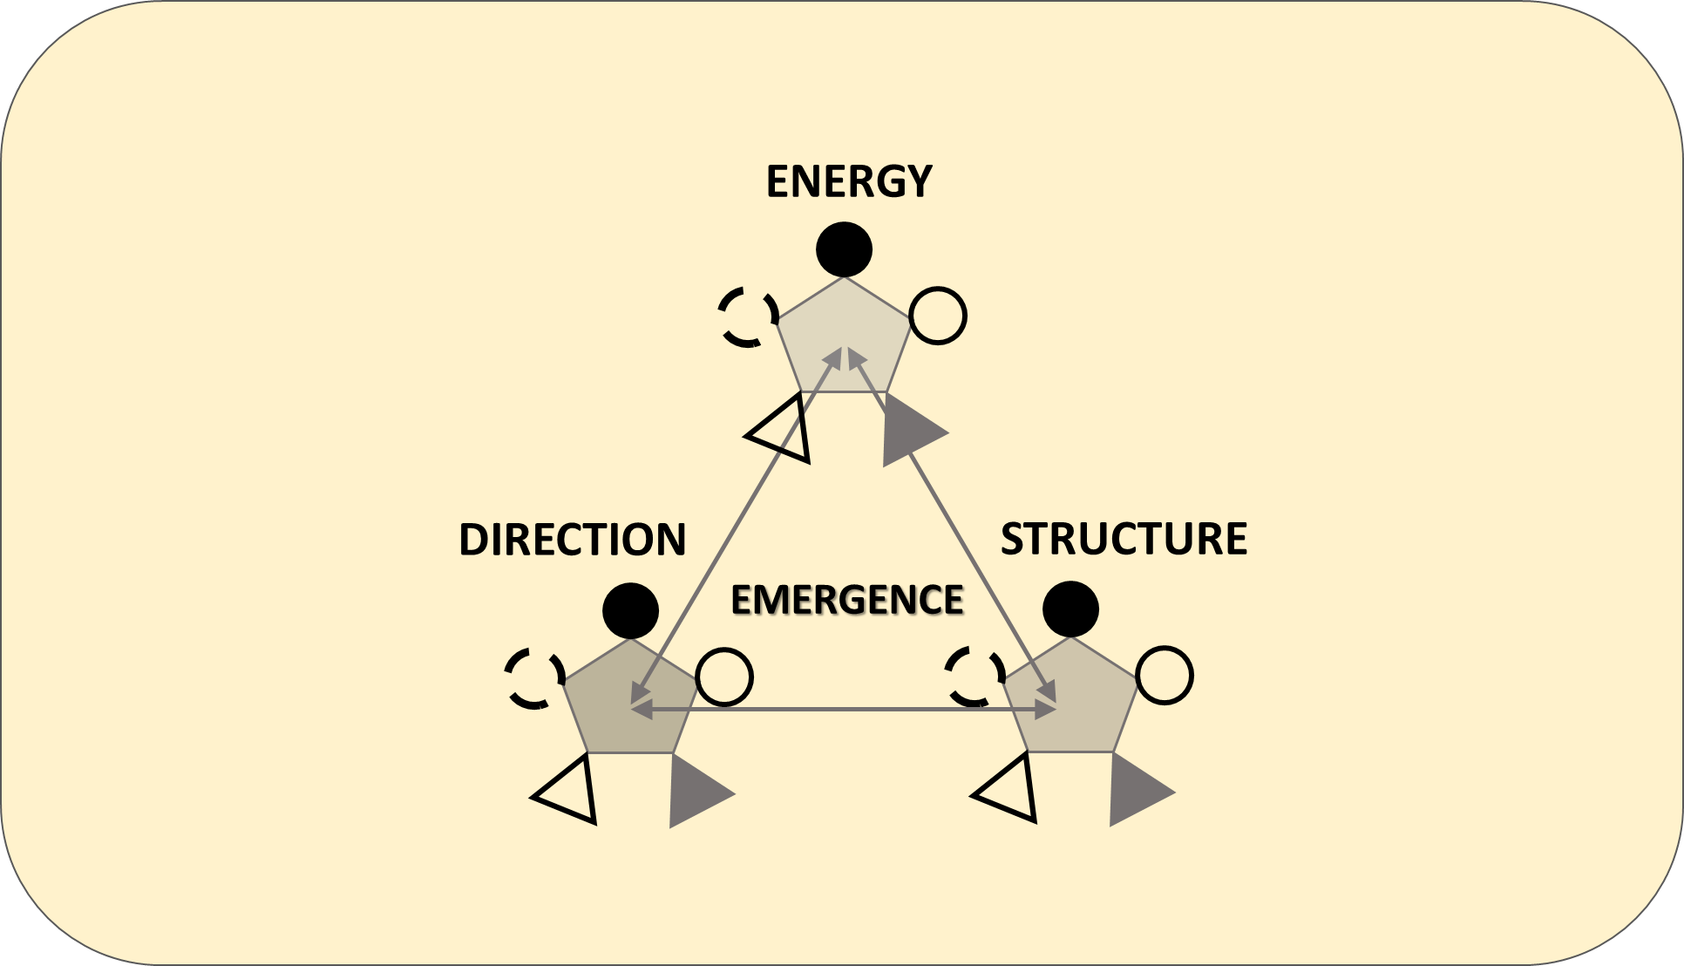

The Complete (3×5 Interactions) Architecture of Complexity
“Since the universe will not learn our laws, we must learn its laws, in detail.”

From Insight to Design
This column continues the exploration from the previous one, The Cascade Universe: Why Complexity Repeats Across All Layers, where we traced how Energy, Structure, and Direction align to create emergence. Here, we shift from principle to practice and expand the framework to show how each of these three elements is supported by five recurring complexities that govern all lasting systems: economic, structural, protective, cultural, and integrative. Together, these form fifteen (3×5) ongoing relationships that illustrate the complete architecture of coherence.
I use two blueprint examples to show how we can translate this structure into human design: one in a company and another in a nation. In the appendix, two additional examples, the traditional village and the Kibbutz, demonstrate the same geometry in community life. Each case is a fractal expression of one universal law. The goal is practical: to provide leaders, managers, and policymakers with a useful tool for diagnosing imbalance and designing systems that can renew themselves under pressure. As you review these examples, think about how this geometry might already be present in your own environment.
Throughout history, every civilization’s progress started with a moment of structural insight, when intuition turned into geometry. From Hammurabi to Drucker, humanity has pursued the formula that transforms effort into order and order into prosperity. That pursuit has never truly ceased. The Universal Law of Increasing Complexity (ULIC) shows that such a formula exists, embedded within the structure of the universe itself. To understand this transformative discovery is to take on responsibility, because knowledge of coherence requires design in harmony with it, a harmony that combines precision with responsibility.
This structure embodies the operational expression of the ULIC, turning its abstract principle into a tangible architecture of coherence, where alignment is its key feature. Next, we will explore this perspective to understand the geometry behind the examples to follow.

The 3×5 Geometry of Alignment
Within this universal law, every enduring system manifests as a triad of Energy, Structure, and Direction. Each plays a specific role within the whole: Energy supplies motion and capacity, Structure provides form and continuity, and Direction offers orientation and meaning. None can exist alone, as each relies on the others to stay coherent through change. Beneath each lies five sustaining complexities that act as its internal scaffolding, allowing it to move, hold, and evolve. These fifteen interactions together form the circulatory network through which coherence flows, keeping every living system stable yet adaptable to transformation.

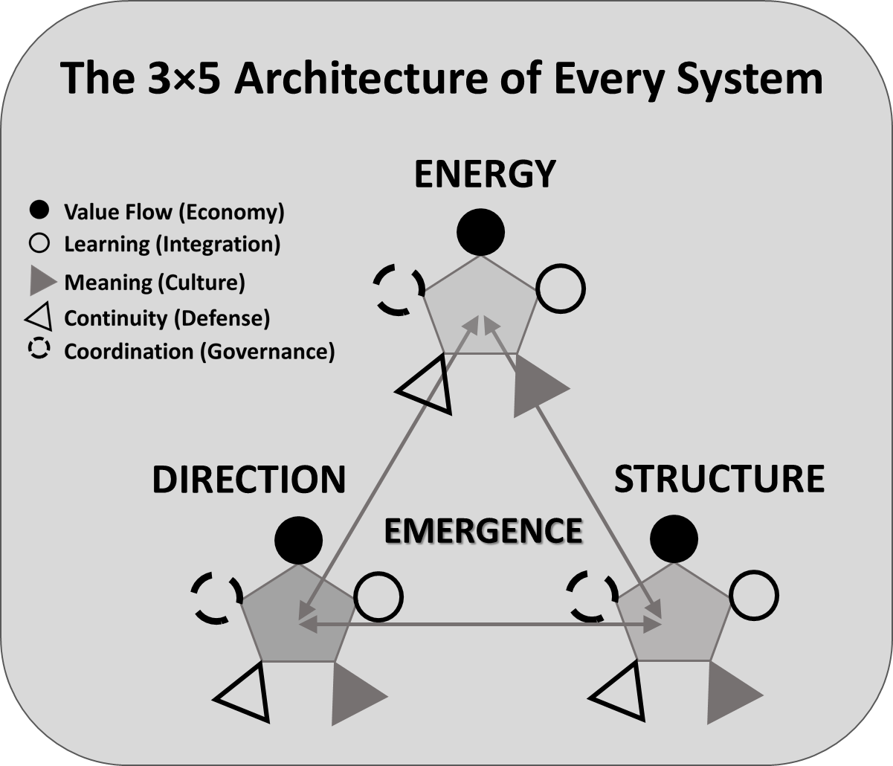
Figure: The 3×5 Geometry of Alignment; The Universal Architecture of Every System. Each element of the triad: Energy, Structure, and Direction, is supported by five universal complexities: Value Flow (Economy), Coordination (Governance), Continuity (Defense), Meaning (Culture), and Learning (Integration). These form fifteen continuous exchanges that maintain system coherence as they evolve. The alignment of these fifteen relationships produces Emergence; the visible result of internal harmony.

Although the five sustaining roles recur within each element, their expression varies: within Energy, they control flow; within Structure, they shape form; and within Direction, they define evolution. Their alignment ensures that a system remains both stable and alive.
Energy’s five complexities govern vitality. They determine how resources are generated through Economy, coordinated through Governance, protected through Defense, inspired through Culture, and renewed through Integration.
Structure’s five complexities ensure stability. They define how value is distributed through Economy, how authority is organized through Governance, how continuity is preserved through Defense, how identity is embedded through Culture, and how design is improved through Integration.
Direction’s five complexities sustain coherence through time. They show how purpose is converted into value through Economy, how intention becomes coordinated action through Governance, how commitment is defended under pressure through Defense, how meaning is transmitted and shared through Culture, and how learning refines vision through Integration.
These fifteen exchanges form the living architecture of persistence and transformation. When they align, energy flows smoothly, structures stay stable without rigidity, and direction develops naturally without confusion. The system becomes capable of renewing itself under pressure and expanding without breaking down. In human systems, this alignment is not by chance but results from the discipline of conscious design.
The 3×5 geometry is not just an abstraction but the fundamental language of existence. It is evident wherever systems flourish – in the rhythmic efficiency of a well-structured enterprise, in the steady renewal of a nation, and in the recursive symmetry of nature itself. To understand how these relationships come alive, we now shift from principle to practice.

Table A: The 3×5 Architecture of Every System.
Triad Element | Value Flow (Economy) – How energy moves and throughput is maintained | Coordination (Governance) – How decisions and responsibilities align | Continuity (Defense) – How stability and resilience are preserved | Meaning (Culture) – Why people care and remain engaged | Learning (Integration) – How adaptation and evolution occur
Energy | Generates and channels resources toward shared goals | Coordinates capacity and effort across roles | Safeguards vitality and trust under pressure | Inspires motivation through shared purpose | Renews capability through reflection and practice
Structure | Distributes and balances value across the system | Organizes authority and flow of communication | Preserves reliability through redundancy and design | Embeds identity and values within procedures | Improves processes through feedback and refinement
Direction | Translates purpose into measurable value | Aligns intention with collective action | Defends commitment through adversity and change | Transmits vision across generations and institutions | Refines understanding and direction through evidence and dialogue
Table A. The Universal 3×5 Architecture reveals the fifteen interactions that keep every system coherent and adaptive. Each element of the triad, Energy, Structure, Direction, expresses the five sustaining complexities in its own function, forming the living geometry of persistence and transformation.

Example 1: The Company as a Living Geometry
When visitors arrive at Daniel Rahman’s company today, they notice not machinery or numbers but a distinctive rhythm, the quiet steadiness of people moving with ease, confidence, and shared purpose. This harmony did not come from charisma or pressure; it resulted from a deliberate transformation that started when Daniel realized that success depends not on intensity but on alignment. For years, the company had been restless and exhausted, overflowing with activity yet lacking coherence. Departments competed for resources, decisions clashed, and energy dispersed in every direction. Each reform created a temporary order that quickly fell apart. What the organization lacked was not intelligence or effort but balance among Energy, Structure, and Direction. (See Table 1B.)
The turning point occurred when Daniel stopped viewing the company as a hierarchy of tasks and instead saw it as a living geometry shaped by the ULIC. Energy represented people's motivation and skills; Structure embodied the systems that coordinated them; Direction expressed the shared purpose that gave meaning to both. None of these could sustain itself without the five sustaining complexities that support every long-lasting system: Value Flow, Coordination, Continuity, Meaning, and Learning. Together, they create fifteen interdependent relationships, the 3×5 architecture, which determines whether an organization stays alive and adaptive or drifts toward entropy.
Daniel began applying these principles systematically, mapping the organization not by departments but by interactions, observing how each of the three elements expressed the five sustaining complexities, and inviting his team to identify where flow was blocked, where coherence could be restored, and how alignment might become visible. Through this mapping, the company shifted from supervision to design, from control to calibration, from effort to coherence. Just as the discovery of aerodynamics transformed flight from myth into engineering, this insight into alignment transformed management from oversight into creation.

Table 1: The 3×5 Alignment Framework for Organizational Design
Triad Element | Value Flow (Economy) – How energy moves and throughput is maintained | Coordination (Governance) – How decisions and responsibilities flow | Continuity (Defense) – How stability and resilience are preserved | Meaning (Culture) –  Why people care and stay engaged | Learning (Integration) – How adaptation and evolution occur
Energy | Ensure that every individual perceives how personal effort creates tangible value and contributes to collective throughput while constraints are identified and resolved. | Clarify authority and decision pathways so that initiative moves without delay or confusion. | Safeguard essential relationships, knowledge, and psychological safety that sustain motivation and trust. | Connect everyday work with a purpose that transcends profit, reinforcing belonging and dignity through shared values. | Encourage curiosity and reflection as continuous habits so that learning renews vitality rather than interrupts it.
Structure | Allocate resources transparently so that processes channel energy toward value rather than bureaucracy. | Design decision systems that are documented, coherent, and responsive to feedback. | Create redundancy where fragility exists and establish mechanisms that preserve reliability through change. | Embed organizational vision and ethos within procedures so that rules express culture rather than suppress it. | Integrate feedback loops into every process to ensure continuous refinement of design and alignment of constraints.
Direction | Translate the company’s mission into measurable outcomes that sustain economic health and coherence across scales. | Align long-term goals with short-term actions through explicit communication channels. | Maintain strategic consistency so that direction survives leadership transitions and external shocks. | Articulate a unifying narrative that gives purpose to growth and connects individual aspiration with collective destiny. | Use evidence and reflection to refine purpose over time, allowing intention to evolve without losing integrity.
Table 1. The 3×5 Alignment Framework translates the universal geometry into organizational design. It allows leaders to diagnose where flow, coordination, continuity, meaning, or learning weaken, and to realign them before imbalance becomes crisis.

Each cell in this table can be examined through the same inner triad of energy, structure, and direction, allowing for recursive analysis across different layers of scale. Every interaction acts as a feedback loop, constantly adjusting the system toward renewed coherence. This rhythm formalizes what the Figure describes in principle and what Table 1 implements in practice.
Daniel viewed the table not as a checklist but as a living map. Each row symbolized one dimension of the triad, and each column one complexity type. By regularly examining these intersections, his management team could identify imbalance before it turned into a crisis. Transparency became the company’s way of showing trust, shifting control into shared responsibility. Value Flow was seen as throughput, the continuous conversion of potential into actual performance, while aligning constraints made sure that local optimization never disrupted the overall global flow.
As coherence grew deeper, Daniel realized that alignment couldn't rely on his constant presence. To maintain continuity, he appointed a Chief Executive of Coherence (CEC), a role meant not to manage departments but to harmonize relationships among them. The CEC’s task was to observe how Energy, Structure, and Direction interacted through the five sustaining complexities, identify early signs of friction, and guide recalibration before strain turned into crisis. This role became the guardian of balance, translating the abstract geometry of the 3×5 framework into everyday practice.
At the same time, Daniel led the development of a Founder Story that highlighted the company’s origin, purpose, and lasting promise. It explained how the company started, what problem it aimed to solve, and why that mission was meaningful beyond just making money. The story wasn’t just branding but a guiding principle: every employee knew it, each new project was evaluated against it, and every decision needed to align with its values, vision, and mission. Over time, this story became the living source of Meaning, the thread linking motivation with identity and strategy with culture.
Quarterly Alignment Reviews followed, using the same framework. Each division evaluated not only outcomes but also the health of its fifteen relationships, pinpointing where Value Flow slowed, where Coordination became tangled, where Continuity weakened, where Meaning drifted, or where Learning had stopped. Through this disciplined reflection, the company learned to evolve while staying true to itself.
Over time, the table became an instrument of leadership. It replaced management through instructions with management through awareness. Conversations about performance shifted to discussions about coherence. Departments started thinking systemically instead of defensively; feedback flowed more openly; and innovation naturally arose from balance. The company’s rhythm changed from acceleration and collapse to steadiness and renewal. Energy circulated; structure adapted without breaking; and direction stayed clear amid uncertainty.
Daniel also learned that alignment depends just as much on fairness as on design. When people saw that effort was recognized, resources were distributed transparently, and values were upheld consistently, motivation rejuvenated itself. Fairness became the emotional counterpart to structural integrity. The company’s shared values provided consistency to judgment, its vision guided growth, and its mission turned aspiration into everyday action. Through these three anchors, meaning evolved from inspiration into discipline.
Leadership, Daniel concluded, is not the art of pushing energy but the discipline of maintaining balance among interdependent relationships. When Energy, Structure, and Direction are harmonized through the five sustaining complexities, emergence happens naturally. Productivity, innovation, and resilience stop being mere goals and become properties of the system itself.
By the end of the second year, growth stabilized and profits increased, but Daniel saw these results as less important. The real change was hidden: a company that can correct itself, renew, and evolve without losing its identity. Energy without Structure causes exhaustion; Structure without Direction becomes rigid; Direction without Energy turns into abstraction. Only when all three exist in constant balance through the five key complexities can an organization be a living system, resilient, adaptable, and cohesive.
Teaching Note – How to Use the Model
Any organization can start this process by mapping its own fifteen relationships. The easiest way is to look at the 3×5 Alignment Table as a reflection of structural health. For each of the three elements, leaders should consider five guiding questions.
1. Where does value flow freely, and where does it stagnate?
2. Where does coordination break down or overlap?
3. Where is continuity threatened by turnover or neglect?
4. Where has meaning weakened or become ambiguous?
5. Where does learning occur naturally, and where is it constrained?
The purpose of these questions is not to evaluate but to increase awareness. By reviewing them regularly, leadership can see how coherence flows through the organization and where it begins to break down. The table becomes a tool for balance instead of control, turning the ULIC into a discipline of structural design. Through it, prosperity appears not as an act of management but as a natural result of systems aligned with the order of the universe itself.

Example 2: Designing National Coherence
The same architecture that restored balance in Daniel Rahman’s company reemerges on a national scale, as every level of existence reflects the same structural law in its own material. When Emmanuel Kato took office as Prime Minister, he inherited a country full of potential but burdened by fragmentation. Energy existed in the people, structure was present in ministries and institutions, and direction appeared in numerous reform slogans, but none of these three elements moved in harmony. What should have been flow had turned into friction. (See Table 2.)
Initially, Kato behaved like most new leaders, believing that control could replace coherence. He reorganized agencies, launched programs, and announced new priorities with confidence, yet results fluctuated unpredictably. The more he pushed, the more the system pushed back, not out of unwillingness but because of misalignment. Over time, he realized that a nation operates not as a machine but as a living organism whose vitality depends on balancing Energy, Structure, and Direction, each maintained by the five recurring complexities of Value Flow, Coordination, Continuity, Meaning, and Learning.
To restore coherence, Kato introduced what he called Alignment Sessions, gatherings where every ministry examined its work through the fifteen relationships of the 3×5 architecture. Economists, educators, engineers, and cultural leaders sat at the same table, learning to see interdependence rather than territory. Each ministry was understood as a smaller triad supported by its own five complexities, mirroring the recursive pattern of the whole. Through this shared language, government stopped being a collection of departments and started to function as a single adaptive structure.
Table 2 – The 3×5 Alignment Framework for National Governance
Triad Element | Value Flow (Economy) – Circulation of resources and productive capacity | Coordination (Governance) – Coherence of decision and execution | Continuity (Defense) – Stability and resilience through time | Meaning (Culture) – Shared identity, values, and purpose | Learning (Integration) – Capacity to adapt and evolve
Energy | Encourage inclusive participation so that labor, creativity, and enterprise transform potential into collective prosperity that endures. | Simplify administrative layers so that initiative moves freely between local and national bodies without delay or distortion. | Strengthen health, food, and safety systems that protect citizens and sustain public confidence. | Cultivate civic pride grounded in shared values, so that motivation arises from belonging rather than fear. | Invest continuously in education, research, and digital literacy that renew national vitality through lifelong learning.
Structure | Build transparent fiscal systems that channel revenue efficiently into public value and prevent corruption. | Clarify mandates among ministries and create cross-sector councils that synchronize policy toward one coherent direction. | Maintain reliable infrastructure and institutions that remain stable through political transitions. | Embed vision and cultural heritage into law and policy so that institutions express national character. | Institutionalize feedback, experimentation, and evaluation so that structure evolves through evidence rather than inertia.
Direction | Translate the national mission into measurable strategies that generate sustainable and equitable growth. | Align regional, national, and international actions within one coherent long-term path. | Preserve constitutional integrity and memory so that purpose survives leadership change. | Articulate a unifying narrative of dignity, progress, and contribution to humanity that inspires lasting commitment. | Refine national purpose through reflection on outcomes and dialogue with citizens and the wider world.

Each intersection in this framework functions as a living conversation among the elements of the nation. When coordination weakens in one area, strain propagates through the others like a misaligned joint in a body. Kato realized that every policy failure was not an isolated event but a symptom of a deeper constraint within these fifteen relationships. He began to treat each constraint not as an obstacle but as a diagnostic signal, a point revealing where the system had lost coherence. By tracing where flow had stopped, whether in finance, communication, or trust, his team learned to realign decisions and restore throughput without adding pressure.
Transparency became the clear symbol of moral trust. Publishing fiscal and development data did more than decrease corruption; it changed perceptions. Citizens started to feel fairness, and that mental clarity turned cynicism into motivation. Alignment succeeded not only in structure but also emotionally. People could see and feel that effort led to results, and that perception turned effort into lasting energy.
Kato also recognized that complexity burdens cognition. When information becomes overwhelming, officials act out of habit, and citizens fall into fatalism. The 3×5 framework became a cognitive tool that reduced mental friction by making interdependence visible. Instead of memorizing hundreds of objectives, ministers could see coherence through fifteen relationships. The map was simple, yet it made complexity understandable.
Meaning then became the true engine of Direction. When policies were framed as expressions of national dignity rather than as performance targets, intrinsic motivation replaced compliance. People no longer worked merely to avoid punishment or to pursue reward; they acted from a sense of belonging. Meaning gained operational depth through its three anchors: shared values, which defined what the society held sacred; a vision, which described what it sought to become; and a mission, which translated both into daily policy and conduct. These three transformed culture from ornament to compass.
To maintain coherence beyond his own tenure, Kato created a Ministry of Coherence, whose purpose was not to govern citizens but to align the internal structure of governance itself. Its focus was on designing governance systems, not on providing services. Its role was to observe the flow of energy, structure, and direction across all ministries, ensuring that every reform supported the national mission rather than competing for attention. The ministry operated under one core principle: when coherence breaks down anywhere, prosperity weakens everywhere. Its analysts, drawn from economics, psychology, and systems science, supervised the fifteen relationships within the 3×5 architecture, identifying where flow was blocked and recommending realignment before strain turned into crisis.
To ensure this structure maintained moral continuity, Kato introduced a Founder Shared Story. It was not propaganda but a unifying narrative explaining why the nation existed, what values it embodied, and what contribution it aimed to make to humanity. Every schoolchild, civil servant, and policymaker studied this story as the source of purpose and the standard of integrity. Within it lay the triad of meaning: values that shaped ethics, vision that guided direction, and mission that translated both into action. Through this shared story, the Ministry of Coherence became not just an administrative office but the guardian of national identity in motion.
Quarterly alignment reviews were held. Each ministry reported not only on outcomes but also on the health of its fifteen relationships, pinpointing where Value Flow stagnated, where Coordination overlapped, where Continuity weakened, where Meaning blurred, and where Learning had stopped. Reflection became a habit; awareness became part of the culture. Coherence shifted from being just a project to becoming everyday practice.
History confirms the wisdom of this design. Civilizations that lasted, from the Nile Valley to post-war Japan, succeeded because their institutions naturally reflected this geometry, balancing energy and structure through shared meaning and disciplined learning. Those that lost that balance decayed despite having power or wealth. The lesson was clear: stability through moral continuity, not control, sustains nations across centuries.
By the end of Kato’s second year, exports increased, foreign investment grew, and youth migration slowed, but he viewed these as consequences, not causes. The deeper success was unseen: citizens started to trust one another again, and government operated as a self-correcting system. “A nation,” he said, “is a geometry of purpose. When Energy, Structure, and Direction stay in balance through the five sustaining complexities, prosperity becomes the natural rhythm of life.”
Teaching Note – From Company to Country
The 3×5 architecture offers leaders a diagnostic mirror rather than a command tool. To use it effectively, they must first identify where national energy gathers and where it drains, where structure has become inflexible, and where direction has fragmented. For each of the fifteen relationships, they can ask: Is flow visible and equitable? Is coordination smooth or burdensome? Is continuity maintained? Do values and vision unify or divide? Is learning active or stagnant? By asking these questions regularly, governance shifts from crisis response to ongoing adjustment.
As we note, alignment does not guarantee prosperity but raises its likelihood, because coherence boosts the efficiency of how value, trust, and knowledge flow through society. When ethical reflection and synchronized constraint management accompany that coherence, development becomes sustainable. Leadership then shifts from authority to stewardship of alignment.

Designing Coherence: From Understanding to Application
Humanity advances when it shifts from guessing and improvisation to design based on knowledge. When we build an airplane, a microchip, a chemical plant, or a nuclear reactor, we depend not on charisma or intuition but on established scientific models that reflect universal laws. However, when we create organizations and nations, the structures that shape every life, we often trust instinct more than understanding. Leaders rise through persuasion or inheritance; management becomes an art of improvisation. The results are clear everywhere: most startups, businesses, and even countries fail not because of a lack of technology or intelligence but because their management structures are misaligned with the laws that support coherence. Engineers have blueprints that guarantee flight; do managers have parallel blueprints that ensure prosperity?
The ULIC suggests that such a blueprint exists. It describes the geometry through which all enduring systems convert energy into coherence: the alignment of Energy, Structure, and Direction through five sustaining complexities: Value Flow, Coordination, Continuity, Meaning, and Learning. Together, these fifteen interdependent relationships form the living mechanism by which stability and creativity coexist. This column expands that framework, demonstrating how design can become a science of coherence instead of a series of trial and error. From this perspective, management is not a struggle for control but a discipline of renewal, involving the continuous calibration of relationships that keep a system alive.
The architecture of complexity reveals not only how systems survive but also how they can be intentionally designed to endure. Every type of organization, from the smallest team to the largest civilization, relies on the same fifteen relationships. When these relationships stay balanced, coherence moves like a living current; when they weaken, the flow of vitality slows down. Decline and renewal are not accidents but signs of how well this circulation is seen and preserved.
Alignment is not a state but a process. No system remains in equilibrium for long; tension is constant, and change is unavoidable. What sustains life and civilization is not resistance to disruption but the ability to transform disturbance into feedback. The organizations Daniel Rahman and Emmanuel Kato built succeeded not because they eliminated friction but because they integrated renewal into their design. Each used the 3×5 framework to identify where flow was restricted and where coherence could be restored. Their success was structural, not circumstantial, because they turned feedback into rhythm.
True coherence cannot be imposed; it must be cultivated through resonance. When the patterns of interaction across scales are aligned with the same rhythm, energy flows freely, structure adapts, and direction becomes meaningful. Resonance and feedback are two aspects of a single mechanism, our self-tuning capacity through which living systems sustain themselves. People perceive this state as fairness, belonging, and trust; perception is not an illusion but feedback, a diagnostic sign of systemic health. When perception diverges from structure, motivation diminishes and fragmentation begins.
Every system thus requires institutional mechanisms for reflection and recalibration. Feedback loops, transparent processes, and shared narratives are not just administrative formalities but the means through which coherence sustains itself. A leader’s role is to uphold these conditions so that alignment can re-emerge naturally. Coherence spreads only as fast as its weakest link; fixing a single weak point can energize the entire system. When design achieves this sensitivity, progress becomes self-sustaining: flow speeds up without burnout, structure adapts without failure, and direction evolves without losing its core identity.
Understanding the 3×5 architecture transforms knowledge into responsibility. It bridges the material and the moral, uniting mechanism and meaning. Once we realize that every act of leadership, governance, and creation participates in the same geometry that governs the universe, the question is no longer whether we can design coherent systems but whether we will choose to. To design for alignment is to act in harmony with reality itself, replacing control with clarity, reaction with rhythm, and isolation with resonance. Through this discipline, prosperity stops being accidental and becomes the natural result of systems built according to the same principles that keep galaxies stable and life ongoing.
For readers interested in seeing this architecture in two real community examples, the annex illustrates the fifteen relationships in a Kibbutz and a traditional village. Since many readers want to understand how these principles work in actual communities, the annex also compares how structure and culture interact to influence whether prosperity grows or diminishes, explaining why one model maintained coherence for decades while the other broke apart under pressure.
The purpose of this section is to make management and governance as scientifically grounded as engineering. The next era of progress will not belong to those who improvise brilliantly but to those who design intentionally, leaders who recognize that every lasting success, from a cell to a civilization, follows the same framework of Energy, Structure, and Direction aligned through five sustaining complexities. When this principle is mastered, prosperity can be built with the same dependability with which we now construct flying machines, allowing humanity to shift confidently from improvisation to design, from uncertainty to understanding, and from reaction to creation.

Annex: The Kibbutz and the Traditional Village through the 3×5 Framework
Both the Kibbutz and the traditional village started as human responses to scarcity, but they developed under very different conditions. The traditional village thrived for thousands of years in a world that changed slowly, where continuity and tradition were enough to maintain stability. Its structure was perfectly suited to an era where survival depended on repetition rather than innovation. The Kibbutz, on the other hand, emerged in a time of acceleration and uncertainty, when prosperity required not only endurance but also renewal. Each community had energy, identity, and purpose, but only one evolved into a system capable of turning scarcity into coherence amidst modern changes. The difference between them is not in values but in organizational design, as shown in the following table.
Communities, like all living systems, survive only when Energy, Structure, and Direction stay balanced and are supported by the five sustaining complexities: Value Flow, Coordination, Continuity, Meaning, and Learning. The difference between the two models is not in geography or morality but in their internal design. Both relied on collective effort and social bonds, yet only one turned those forces into self-reinforcing coherence.
The following table shows how the fifteen relationships of the 3×5 framework appeared in these two community models. Each cell explains how one element of the triad interacted with one sustaining complexity and how its success or failure influenced the overall system.
Table 3 – The 3×5 Architecture in Two Community Models
Triad Element | Value Flow (Economy) | Coordination (Governance) | Continuity (Defense) | Meaning (Culture) | Learning (Integration)
Energy | Kibbutz: Collective labor transformed personal effort into shared output; surplus was reinvested in common assets, keeping motivation linked to visible benefit.  Village: Labor remained individual and fragmented; surplus often hoarded or lost through inefficiency, weakening collective motivation. | Kibbutz: Daily assemblies and rotating roles allowed rapid decision flow and mutual accountability.  Village: Authority concentrated in elders; decisions slow, often contested, discouraging initiative. | Kibbutz: Social cohesion and shared security obligations preserved unity under external pressure.  Village: Protection depended on kinship networks, leaving gaps in collective resilience. | Kibbutz: Ideology of equality and renewal generated emotional energy and belonging.  Village: Tradition maintained identity but resisted adaptation, leading to stagnation. | Kibbutz: Continuous experimentation in work, education, and technology renewed enthusiasm.  Village: Learning informal and limited to imitation, producing gradual decline in vitality.
Structure | Kibbutz: Transparent accounting and central resource management ensured throughput across activities.  Village: Exchange mediated by personal trust, not systems; value leaks common. | Kibbutz: Governance designed as participatory democracy with clear rules for shared property.  Village: Customary hierarchy preserved order but inhibited systemic coordination. | Kibbutz: Redundancy built into social and economic roles; failures absorbed without collapse.  Village: Fragility concentrated; one bad harvest could dismantle entire balance. | Kibbutz: Cultural rituals institutionalized equality and solidarity.  Village: Rituals preserved lineage more than function, reducing adaptability. | Kibbutz: Formal education and communal review embedded learning in structure.  Village: Learning remained personal, with no structural channels for innovation.
Direction | Kibbutz: Vision of building a just society guided economic choices and distribution.  Village: Economic aims remained survival, not transformation. | Kibbutz: Collective goals translated into measurable plans and iterative adjustments.  Village: Direction implicit and inherited, rarely updated. | Kibbutz: Long-term strategy integrated defense, economy, and education, ensuring continuity through crises.  Village: Continuity depended on external protection or chance alliances. | Kibbutz: Founder Story unified generations under a sense of historical mission.  Village: Meaning derived from ancestry, not shared future, limiting aspiration. | Kibbutz: Direction evolved through debate and feedback, refining purpose without losing identity.  Village: Direction static; learning seldom altered the collective path.

Interpretation
The Kibbutz succeeded structurally where the village struggled because it embraced feedback and renewal. Its design ensured each aspect of Energy, Structure, and Direction remained connected through the five sustaining complexities. Economic value circulated openly, coordination aligned decision-making and purpose, continuity went beyond survival into resilience, meaning was shared through narrative rather than lineage, and learning became part of daily routine.
The village, by contrast, maintained energy and identity but lacked systemic coordination and adaptive learning. Its coherence was local and temporary, relying on personalities and customs rather than deliberate design. When external conditions changed, misalignment spread faster than corrections could be made. Energy caused coherence to fade and revert to entropy; structure became rigid, and direction dissolved into nostalgia. The village was a high-fitness design for a slow world; its limits are not failures but a poor fit for an era marked by frequent changes.
These lessons are not exclusive to agrarian communities; they apply to any modern organization that must coordinate energy, structure, and direction under pressure. The same fifteen relationships determine whether a start-up, a ministry, or a nation can turn vitality into lasting prosperity.

Design Insight
A coherent community must institutionalize renewal rather than rely on goodwill. The Kibbutz achieved this by embedding reflection into its structure, with education committees, communal meetings, and shared storytelling serving as continuous adjustment processes. This principle remains universal: whenever reflection becomes part of the structure, alignment becomes self-sustaining.
The same analysis can guide modern development efforts, social enterprises, and countries. By mapping the fifteen relationships and identifying where flow or meaning is blocked, leaders can move management from simple reaction to deliberate design. The 3×5 framework doesn’t romanticize the Kibbutz; it clarifies its structure so future communities can adopt its logic without copying its form.
The lesson from both communities is timeless: prosperity endures not because of wealth or belief, but because of a structure built for renewal. What lasts isn’t the institution but the architecture that allows coherence to exist.

* I strive to stay true to the facts and the reality they reveal. If you find an error or see a need for clarification, your insights are welcome.

Subscribe here, free!
"Mental and Economic Freedom Are Interconnected."

See you soon,
Nimrod


Dr. Nimrod Israely is the CEO and Founder of Dream Valley and Biofeed companies and the Chairman and Co-founder of the IBMA conference. +972-54-2523425 (WhatsApp), or email nisraely@biofeed.co.il

P.S.

If you missed it, here is a link to last week's blog, “The Cascade Universe: Why Complexity Repeats Across All Layers“.
P.P.S.
Here are ways we can work together to help your agro sector and rural communities step forward and shift from poverty into ongoing prosperity:
* Nova Kibbutz and consultancy on rural communities' models.

* Local & National programs related to agro-produce export models - Dream Valley global vertical value and supply chain business model and concept connects (a) input suppliers with farmers in developing economies and (b) those farmers with consumers in premium markets.

* Crop protection: Biofeed, an eco-friendly zero-spray control technology and protocol.

You can follow me on LinkedIn, YouTube, and Facebook.
*This article addresses general phenomena. The mention of a country/continent is used for illustration purposes only.

