

View Online and Translate
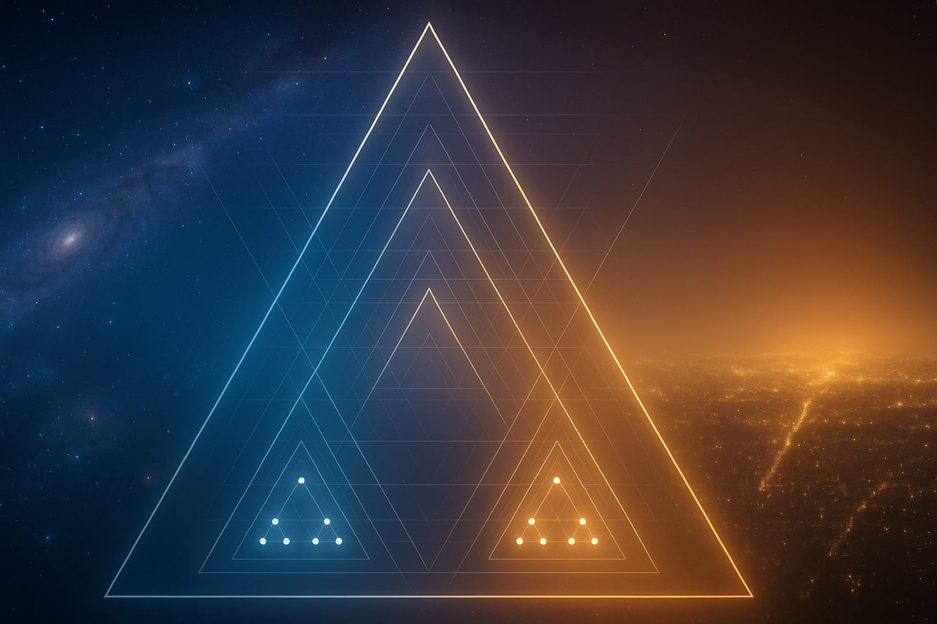
The Cascade Universe: Why Complexity Repeats Across All Layers

“Since the universe will not learn our laws, we must learn its.”

Why We Must Study the Architecture of the Universe
Every generation tries to understand the laws that govern existence, yet much of human knowledge stays within specialized fields. Physicists study energy, biologists study life, economists study growth, and sociologists study cooperation. Each looks at a part of reality, but the full pattern often remains hidden from us. The Universal Law of Increasing Complexity (ULIC) urges us to step back and see how these parts connect, pointing to a single structure beneath them all.
This column continues that search for coherence. Its goal is not to introduce another theory but to uncover the structure that makes theories possible. Beneath every stable order exists the same geometry of Energy, Structure, and Direction. Recognizing this geometry is practical: it explains the conditions under which systems survive or fail. When we see these laws as structural rather than circumstantial, we can design societies, economies, and institutions that promote prosperity.
The method is both structural and cumulative. Every inquiry starts with what is known, then delves one layer deeper into the framework that holds reality together. The goal is not to increase complexity but to simplify until the core pattern becomes clear, the pattern that repeats from atom to nation and from the universe's earliest moments to today. Each insight builds on the previous one until the architecture of creation is fully revealed.
Next, we demonstrate step-by-step how the Triad of Energy, Structure, and Direction is maintained by five complexities, how this pattern repeats itself, how it appears in society, and finally, an example with a real-world simulation of applying those principles.

The Triad: The Architecture of Emergence

Everything that exists, from atoms to civilizations, persists because three elements work together in harmony: Energy, Structure, and Direction. They are universal functions that exist wherever something has form, acts, or changes.
Energy is motion and potential, the flow that enables change and maintains system responsiveness.
Structure is order, the form that directs flow and determines how motion moves. Energy alters structure through feedback, strengthening paths that carry flow and weakening those that resist it. Without structure, energy disperses into noise; when structure dominates, energy becomes trapped and the system stiffens.
Direction is orientation, the meaning that tells energy where to go and what to become. Without direction, systems drift and waste potential.
When Energy, Structure, and Direction are aligned, they create the conditions for emergence, capabilities that did not exist in any element alone. Energy provides the power to act, Structure channels that power, and Direction unites them toward a shared outcome. Alignment transforms parts into a single, organized whole.
Every stable system relies on this Triad. When energy surpasses structure, systems burn out; when structure surpasses energy, they freeze; when direction weakens, coherence breaks apart. Balance among the three is essential for existence. Balance is dynamic, not static.
These three are not separate steps but aspects of a single living pattern. If one weakens, the others can't support it. Having identified each aspect, we can now ask what holds them together.

The Five Complexities: The Scaffolding of Each Element
If the Triad supports every system, what enables the Triad to continue? A deeper foundation appears in five recurring functions—the five complexities—that form the framework giving the Triad its strength. These are Value Flow (Economy), Coordination (Governance), Continuity (Defense), Meaning (Culture), and Learning (Integration). They are universal roles that appear wherever something must persist, adapt, and evolve.
Value Flow (Economy) provides the circulation and transformation of usable resources, ensuring the system stays vital and can renew its work.
Coordination (Governance) provides decision logic and synchronization so that parts act coherently toward a purpose.
Continuity (Defense) provides protection and resilience so that form endures under pressure and change.
Meaning (Culture) offers shared identity and purpose, so energy and structure come together within a common pattern.
Learning (Integration) enables absorption and assimilation of information, fostering ongoing adaptation and improvement.
The five work together beneath the Triad. Energy depends on them to circulate, stabilize, find purpose, and refine flow. Structure depends on them to preserve form while staying responsive. Direction depends on them to maintain coherence over time and renew purpose through learning. When anyone weakens, systems lose alignment; when all five align, emergence expands.
The Triad and the five complexities are co-emergent and interdependent. The Triad explains how emergence happens; the five explain what keeps it stable through time. Acting together, they allow the universe to convert fragility into resilience and repetition into transformation.
Now we look within those supports to see how the same pattern repeats. Each of the five complexities is not a fixed block but a smaller living system composed once again of Energy, Structure, and Direction. The universe builds its cascade by embedding one alignment within another, from the smallest particle to the most complex society.

The Recursive Architecture: How the Pattern Repeats Within Itself

The universe develops through recursion, a pattern that sustains itself by repeating on both smaller and larger scales. Every component within a stable system reflects the form of the system that contains it, maintaining coherence across different levels of complexity. The Triad explains the process of emergence, the five complexities define the conditions for persistence, and recursion unites the two into a single living order.
The relationship is not hierarchical but co-emergent. Each element of the Triad depends on the five for stability, and each of the five is maintained and generated by its own internal Triad. The pattern is circular rather than linear, linking micro and macro into a coherent whole.
Each complexity contains its own Triad: Value Flow holds movement, channels, and priorities; Coordination holds initiative, rules, and shared purpose; Continuity holds effort, protection, and the intent to preserve; Meaning holds emotion, language, and a unifying vision; Learning holds curiosity, knowledge systems, and the aspiration to evolve.
Because each layer contains a smaller version of the same logic, a change in one layer spreads to others without losing its identity. A modification in Value Flow affects Coordination. A shift in Meaning changes Direction. An advance in Learning reshapes Structure. The system remains recognizable even as it evolves.
Recursion enables information and stability to spread together. Each stage inherits structure from what came before while transmitting energy and direction to what follows. This is why a cell can repair itself, a society can reform itself, and a star can sustain its cycle. Renewal in any part can spread coherence through all layers when it follows the universal principles of Energy, Structure, and Direction aligned through the five complexities.
Recap. The Triad shows how emergence occurs; the five complexities describe what maintains its stability; recursion explains why it repeats across different scales.

The Cascade Universe

Examining existence closely shows not chaos but a beautiful order that repeats at every stage of life. The cascade universe reflects that order. It is a continuous structure of connections, each one supporting and growing from the one before. What links atoms, life, and societies isn’t material similarity but structural harmony.
At the physical level, the alignment of energy and structure creates conditions for matter. What moves forward is not matter itself but structural information that controls how matter, energy, and purpose interact. In the chemical stage, this alignment produces molecules that store and release energy. In the biological stage, it shows up as metabolism and adaptation, with flows aligned within bounded structures guided by genetic instructions. In the social stage, it manifests as cooperation, aligning individuals through shared purpose, coordinated governance, and cultural meaning. The architecture stays consistent even as the material changes.
This continuity explains why the universe achieves unity through diversity and permanence through transformation. Physics sets boundaries within which chemistry unfolds; chemistry provides conditions for biology; biology gives rise to consciousness and society. At each stage, the Triad produces emergence, while the five complexities preserve and transmit that emergence through time.
The same pattern governs surplus in human systems. Knowledge gained in schools transforms into structure in companies and guidance in government, while surplus from economic activity returns as resources that support future learning. This cycle only works when Economy, Governance, Defense, Culture, and Integration stay aligned with the Triad at each stage. When education fails, governance loses coherence, or meaning diminishes, the cycle weakens and the cascade becomes fragile.
The cascade also clarifies the direction of time. Each new alignment retains the memory of those before it, turning potential into structure and structure into the foundation for future change. Complexity grows through accumulated alignments that keep coherence while allowing for novelty. Think of it; the same law that shaped the first atoms also guides the design of human institutions.
Enduring forms, whether physical, biological, or social, achieve longevity by embracing change. Alignment enables this integration, and recursion drives it forward. When we see the world this way, leadership and innovation become about maintaining alignment across different stages. A society that manages energy but loses moral direction will struggle. A system rich in structure but poor in learning will stagnate. An economy that emphasizes flow without maintaining continuity will wear out.
This perspective demonstrates that human prosperity aligns with cosmic order. To govern, to teach, to create, or to invent is to engage in alignment. Every improvement in structure, every refinement in purpose, and every increase in understanding enhances coherence. Living in harmony with this order means moving with the flow of evolution and building structures that last.

The Human Application
We have observed how the universe organizes itself through the alignment of Energy, Structure, and Direction, supported by five recurring complexities. To see how this shows up in daily life, imagine walking into two rooms. In one, Daniel Rahman, a manager of a mid-sized company, explains how he redesigned his organization. In the other, Prime Minister Emmanuel Kato discusses how the same principles helped rebuild a nation. Their stories illustrate a pattern that appears wherever people align energy, structure, and direction, from small businesses to entire nations.

Daniel Rahman – The Company Manager
“When visitors come now, they see coordination, trust, and steady progress. That was not always the case. We used to be busy and disorganized. Departments defended their own goals. I tried targets, stricter rules, and bonuses. It worked briefly, but then everything felt heavier. Motivation dropped, deadlines were missed, and ideas dried up. We had energy, but it was scattered.
I learned that prosperity relies on alignment. Every living system operates on Energy, Structure, and Direction. In our case, energy was people’s motivation and skills, structure included workflows and rules, and direction was meant to be our vision. I had mistaken direction for goals. Quarterly sales targets created pressure, not purpose. Direction is a clear vision that people understand, feel connected to, and want to pursue.
I stopped asking how to push harder and instead asked how to align. That was the pivotal moment. One evening, I noticed people smiling while still working late. The pressure was there, but the energy was shared.
Then we adopted the five complexities as design questions:
Value Flow (Economy): Do we all see how our work creates value and moves it forward?
Coordination (Governance): Are decisions moving clearly, or are they bouncing around?
Continuity (Defense): Are we protecting the knowledge and relationships that keep us stable?
Meaning (Culture): Do we remember why we exist beyond the next invoice?
Learning (Integration): Are we improving together, or repeating last year?

We opened financial dashboards so everyone could see where value was created. We shifted weekly meetings from reporting to coordination. We documented key know-how. We clarified our story for every new hire. After each major project, we met briefly to reflect on what we learned.
Initially, people thought this was extra work. Soon they realized the goal was clarity, not control. Once alignment took hold, everyone shared ideas freely, and innovation naturally reemerged. Instead of safeguarding departments, everyone protected coherence. Energy started coming back faster than it was used, deadlines became stable, and profits increased. More importantly, people wanted to stay. Leadership shifted to maintaining Energy, Structure, and Direction in balance through design. When alignment is right, emergence handles the rest.”

Prime Minister Emmanuel Kato
At first, I thought our country’s problem was laziness or lack of funds. Later, I realized it was misalignment. Our energy, structure, and direction were not working together.
When I took office, we had talent and optimism, but ministries were islands. Policies contradicted one another. Success in one area sometimes caused failure in another. I believed leadership meant having a clear vision and exercising control, so we implemented reforms from the top down. It looked impressive, but the results faded over time. The more we worked, the less coherent and unified we became.
It did not change overnight. I made mistakes. Over time, I began to see government as a living system. Our energy was driven by the ambition of our people. Our structure was a web of institutions. Our direction was a shared purpose of building dignity through opportunity. That purpose was not just a slogan or a target; it was a direction people could feel connected to. The three were out of sync. Energy hit dead ends, structure resisted change, and direction shifted with each cycle.
I told the cabinet we were not here to manage programs but to design alignment. We used the five complexities as a diagnostic map:
Economy was the flow of value through society, not just the budget.
Governance was the coherence of decisions, not the count of regulations.
Defense meant resilience in health, food, and security together.
Culture was our shared story, not a ceremonial ministry.
Integration meant our capacity to learn through education, research, and openness.

We conducted alignment sessions. Each ministry presented its work and its impact on the other four complexities. Contradictions emerged immediately. Education trained skills that the industry did not need. Infrastructure overlooked environmental plans. Trade policies conflicted with health goals. Once we identified the fractures, the solutions became clear.
We reorganized budgets, eliminated overlaps, and created joint data platforms. Within two years, our credit rating improved, foreign investment doubled, and youth migration slowed down. When a global downturn hit, we didn’t fall apart; the structure held because alignment provided flexibility. Most importantly, trust was restored. People stopped saying ‘them’ and started saying ‘us’. My role became maintaining coherence across the system, ensuring that Energy, Structure, and Direction remained aligned through the five ongoing complexities. Alignment may never be perfect or permanent, but keeping it alive is the true task of leadership. When alignment is maintained, a nation grows naturally.

Reflection
What Daniel achieved in a company of fifty, Emmanuel achieved in a country of fifty million, using the same principles of alignment. A company and a nation differ in size, not in architecture. Failures come more from misalignment than from actual weaknesses. Prosperity starts when leaders move from commanding to designing.
Energy without structure leads to exhaustion. Structure without direction becomes inflexibility. Direction without energy results in a lifeless plan. When these three elements align through the five core complexities, emergence occurs. Daniel recognizes this in teamwork and innovation. Emmanuel observes it in trust and stability. As scale shifts, the pattern stays the same.
Designing for alignment involves intentionally engaging with the universe’s way of creation, where leadership and law, practice and principle, come together. As coherence is maintained, complexity has room to develop.

Seeing the Universe Through Design
Every universal law provides explanation and invitation. The Universal Law of Increasing Complexity describes how emergence develops and invites us to participate consciously in that process. Once we understand that Energy, Structure, and Direction form a recursive architecture sustained by five interconnected complexities, the world appears as a single continuous process of alignment. Physics, chemistry, biology, and society are successive expressions of one fundamental pattern, each transforming what came before into new capabilities.
The cascade is a living continuity where each alignment supports and refreshes what came before. Every new configuration draws stability from earlier forms while reorganizing them into the foundation for further transformation. Wherever energy is shaped by structure and guided by direction, coherence grows and new capabilities develop. When alignment weakens, systems break apart; when it strengthens, they integrate. This pattern applies across all levels.
To design is to work with the logic of emergence. This is what Daniel practiced within his company and what Emmanuel discovered while leading his nation—design as the discipline of collaborating with complexity. Enduring creations succeed because they align flow, form, and purpose in ways that create tension and transform it. Failures can be traced to structural imbalance where one element dominates and the others become too silent.
No system is self-sufficient. Every capability relies on smaller alignments that came before it, and each action becomes part of the structural continuum through which the universe organizes itself. Leadership and creation are acts of participation. When intention aligns with the deeper architecture of an organization, our designs exhibit the same coherence that sustains life. The principle that governs the formation of galaxies also governs prosperity, because both depend on continuous alignment under pressure and the renewal of order without halting motion.
We've all experienced moments of alignment, a team moving as one, a conversation flowing toward insight, or a design that feels inevitable once seen. These are encounters with structural harmony. To work with that harmony is to design for continuity instead of reaction, for balance instead of control, for systems that can hold tension and turn it into progress. When design reaches this clarity, complexity becomes a way for intelligence to move forward.
The five sustaining complexities persist through every layer, providing tangible substance to the Triad: value through Economy, coordination through Governance, protection through Defense, meaning through Culture, and learning through Integration. Whether in a molecule, a living cell, or a nation, these five enable energy to circulate, structure to endure, and direction to evolve. When one weakens, systems lose coherence; when all align, emergence becomes likely.
Across all domains, three forces remain constant: energy as motion, structure as form, and direction as meaning. Their balance is the bridge between chaos and creation, the pattern that unites matter and mind, nature and society, into a continuous act of transformation. Acting in harmony with this pattern means designing not against the universe but within it, participating in its method of creation.
Every authentic alignment advances that method, carrying the same architecture that shaped the cosmos into the next chapter of human design.

For any matter, contact me at +972-54-2523425

Subscribe here, free!
"Mental and Economic Freedom Are Interconnected."

See you soon,
Nimrod


Dr. Nimrod Israely is the CEO and Founder of Dream Valley and Biofeed companies and the Chairman and Co-founder of the IBMA conference. +972-54-2523425 (WhatsApp), or email nisraely@biofeed.co.il

P.S.
If you missed it, here is a link to last week's blog, “Structure: The Universal Thread From Atoms to Nations“.
P.P.S.
Here are ways we can work together to help your agro sector and rural communities step forward and shift from poverty into ongoing prosperity:
* Nova Kibbutz and consultancy on rural communities' models.

* Local & National programs related to agro-produce export models - Dream Valley global vertical value and supply chain business model and concept connects (a) input suppliers with farmers in developing economies and (b) those farmers with consumers in premium markets.

* Crop protection: Biofeed, an eco-friendly zero-spray control technology and protocol.

You can follow me on LinkedIn, YouTube, and Facebook.
*This article addresses general phenomena. The mention of a country/continent is used for illustration purposes only.

