

View Online and Translate
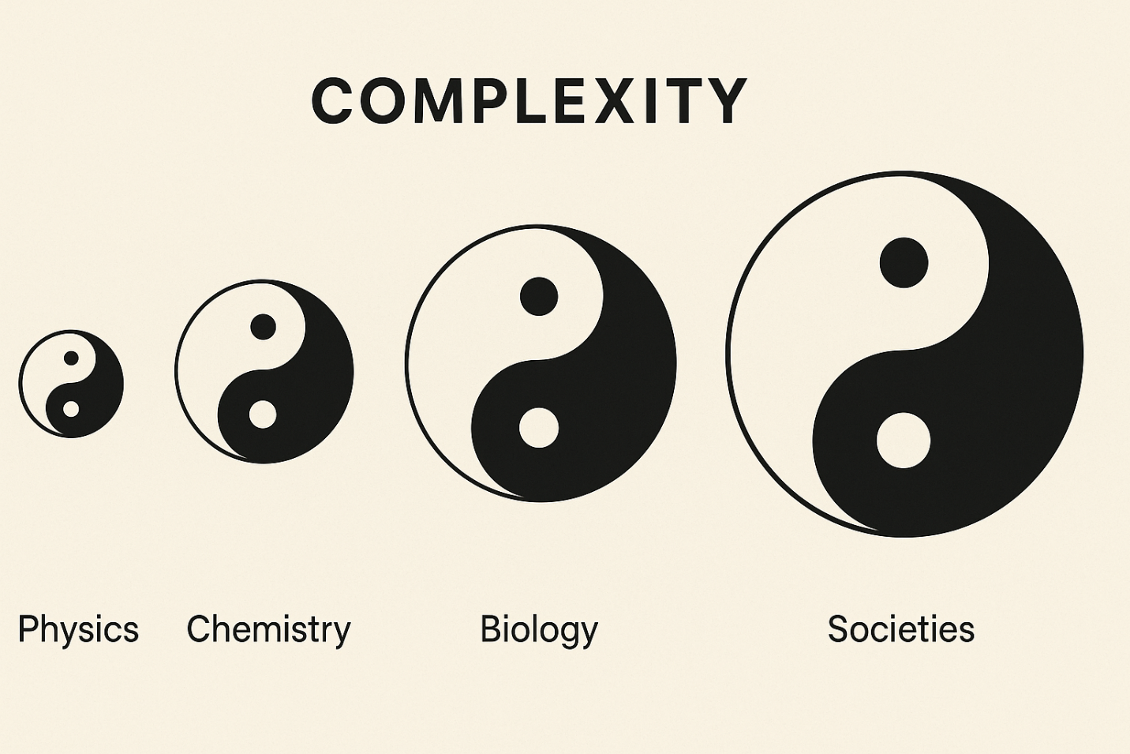

Why Contradiction Is the Beginning of Everything

“We seek independence, yet cannot do without one another; contrast is inherent in everything.”

Born Into Fundamental Contradictions
When I was growing up on the Kibbutz, children did not sleep at home. We lived, studied, played, and spent our nights together in communal children’s houses, separate from our parents, except for a few hours each evening that were reserved for being with our families.
This arrangement did not arise from neglect or indifference, but from a deliberate act of design. The Kibbutz placed the highest value on equality, sharing, and collective responsibility, and communal child-rearing was understood as a natural extension of those values: part of building a more just and cohesive society.
Many parents, however, experienced this arrangement differently. While it reflected the collective ideal, it imposed an emotional strain that became increasingly difficult to ignore. Parents missed their children at night, worried about their well-being, and gradually began to question whether the emotional cost of separation was too high. As this tension grew, the contradiction between the communal vision and the intimate bond of family exceeded what the structure could continue to hold. Eventually, the system adapted, and today, in every Kibbutz, children sleep in their parents’ homes.
At the time, leaders feared that allowing children to sleep at home would fragment the collective and undermine the foundations of the Kibbutz. In retrospect, this fear proved unfounded. The change was absorbed by the structure, which adjusted without collapsing, and the community remained intact.
Yet not all contradictions were removed. Many continued to exist within the system. Kibbutz members were still expected to work daily, contribute equally, and share the community’s income and decisions, even when they did not fully agree with every rule or feel personally inclined to participate on a given day. In these cases, the contradiction between individual preference and collective obligation was held by the structure itself. For decades, the community endured this tension and, in many places, continued to thrive because of it.
But what if the contradiction had been different in nature? What if members had been permitted to stop working, or to abandon the foundational principle of equality? Would the structure have been strong enough to adapt without unraveling?
This story reveals two distinct contradictions between the individual and the system: one that could no longer be sustained, and one that had to be. Not all contradictions carry the same weight or produce the same consequences. The essential question is not whether a contradiction exists, but whether it is required for the system to fulfill the mission it was designed to serve.
The Universal Law of Increasing Complexity (ULIC) teaches that some tensions are not optional. They are fundamental to the vitality of any system and must therefore be held. These tensions support the inflow of energy, the coherence of structure, the clarity of direction, and the emergence of complexity. When sustained within a form capable of containing and channeling them, they strengthen the system and expand its generative potential. But when they are suppressed, avoided, or removed without regard for their structural function, the system begins to lose coherence, adaptability, and resilience.
Other contradictions, by contrast, do not support emergence but instead degrade the system from within. Rather than contributing to the system’s generative flow, they disrupt energy, fragment structure, confuse direction, and diminish complexity. The separation of children from their parents in the Kibbutz was one such contradiction. It could be sustained for a time because the broader structure was strong enough to absorb the emotional costs, but over time, its contribution declined and its harm became more difficult to justify. Once the contradiction no longer served the mission, it was removed, and the system did not collapse. The structure adjusted, and the community continued to function.
The difference lies not in the presence of contradiction itself, but in whether the structure is capable of containing it in a way that advances the system’s purpose. One contradiction dissolved without harm, while another became the foundation of shared life. What does this reveal about the deeper logic of resilience and transformation? And what can the ULIC teach us, not only about the Kibbutz, but about society, nature, and the architecture of existence itself?

Embedded Universal Contradictions
Contradictions exist in everything; sometimes they are obvious, and other times they are hidden deep within structure. What influences a system's fate is not the contradiction itself but whether there is a form capable of containing and guiding it. When contradiction is held within a structure strong enough to withstand its pressure, complexity increases, coherence deepens, and new abilities emerge. Without such a structure, the system unravels, and contradiction leads to collapse rather than creation. This is the difference between being and not being, emergence and decay, prosperity and disintegration. The universe demonstrates this pattern at every level: gravity in tension with motion creates orbits; attraction balanced with repulsion forms molecules; competition, tempered by cooperation, sustains life; and disagreement within trust allows societies to last. In physics, chemistry, biology, and human systems, contradiction is never erased; it is transformed into structure, and through structure, into the capacity for more.

Physics: The Ultimate Contradiction
Why can a particle exist in multiple states at once, while planets follow precise and predictable paths? Why do the laws that govern the smallest building blocks of matter collapse when applied to stars, galaxies, or time itself?
At the foundation of all systems lies a contradiction that no theory has yet resolved. The behavior of the smallest particles in the universe, described by Quantum Mechanics, is probabilistic, discontinuous, and entangled across space. The behavior of the largest structures in the universe, described by General Relativity, is continuous, deterministic, and grounded in the smooth geometry of spacetime. Each theory is internally consistent, experimentally validated, and operationally precise. Yet when we attempt to unify them into a single framework, their contradictions become irreconcilable.
Thanks to this contradiction, not despite it, reality persists. The large; stars, planets, and galaxies, is composed of the small, including atoms and subatomic particles. And as in the Kibbutz, where contradiction creates pressure between the collective system and its individual members, so too in physics, the tension between the laws that govern the parts and those that govern the whole must be held. Stars, planets, and living systems are built from particles whose behavior is defined by quantum mechanics, even as their macroscopic form follows the curvature described by general relativity. The contradiction between these scales remains unresolved, but it has been held. That act of structural containment may be the very reason that anything exists at all.
When contradiction is held within a form capable of coherence, it becomes generative. It enables the emergence of time, energy, gravity, and the layered formation of matter, life, and mind. But when the structure is too weak, or altogether absent, the contradiction collapses inward. The outcome may be the dissipation of energy and the spread of entropy, as in the eventual heat death of the universe, or the total compression of matter and information, as in the gravitational collapse of a black hole. In both cases, complexity does not develop further; it vanishes. Genordo dissolves, and with it, the structural continuity of time and the conditions for emergence.
The origin of the universe may not have been a random explosion or a singular event. It may have marked a structural threshold, a turning point at which contradiction, once held within a coherent form, became capable of generating complexity.

Chemistry: Attraction and Repulsion
From the contradiction held within the laws of motion and matter, something new begins to emerge: a structure that not only stabilizes itself but also enables the formation of new patterns. In chemistry, opposing forces are not eliminated but arranged into configurations capable of coherence.
Matter is built from forces that resist agreement. Within every atom, positively charged protons and negatively charged electrons exert opposing influences. Electromagnetic attraction pulls them together, while repulsion between like charges and the quantum nature of their orbits prevents collapse. Neutrons and nuclear forces stabilize what would otherwise disintegrate. These tensions are not resolved but are held within the structure of the atom.
Molecules form only when the arrangement of atoms allows these contradictions to be balanced and sustained. Bonds are not passive links but structured tensions, where their form is what enables chemical stability and coherence.
This containment of contradiction is what gives rise to material reality. The same atoms, arranged differently, can produce water or fire. Whether the outcome is generative or destructive depends not on the elements themselves, but on the structure that holds them. No material form emerges without both attraction and repulsion, and without a structure that shapes how they interact.
When structure collapses, molecules disintegrate, energy disperses, and chemical potential breaks down into entropy. But when structure holds, complexity advances, from carbon chains to proteins, membranes, and living systems.
It is not energy alone that gives rise to complexity, but the capacity of structure to hold contradiction and transform opposing forces into coherent form.

Biology: Change and Continuity
Once matter becomes capable of forming and sustaining chemical bonds, a deeper threshold is crossed. Structure no longer holds only energy, but the conditions required for life.
At the biological level, life emerges from a core contradiction between the need for continuity and the need for change. A living cell must preserve its identity over time, reproducing its genetic code and maintaining the boundaries that define it. At the same time, it must remain open, responsive, and adaptable to the surrounding environment. Without change, the cell becomes inert and unresponsive, while without stability, it disintegrates and loses coherence.
Like the layers before it, the cell does not resolve contradictions but holds them through structure. A membrane separates the inside from the outside while enabling selective exchange. Genetic systems permit mutation within limits that preserve functionality. Repair mechanisms respond to damage while maintaining internal order. Life endures not by avoiding contradiction, but by containing it within structural form.
As biological systems increase in complexity, the contradictions within them grow more numerous and more interdependent. Organs become highly specialized, yet continue to rely on one another for their function. Physiological systems diverge in their roles while converging toward a shared purpose. The nervous system must both send signals outward and receive input from within and without. The immune system is tasked with the paradox of protecting the body by destroying part of what enters it. The brain holds within its structure both primal instinct and abstract reasoning, allowing life to advance by developing forms capable of holding internal tension through deeper structural coordination.
This same principle governs evolution itself. Random variation introduces the changes required for adaptation, while selective pressure imposes the constraints necessary to preserve coherence. Neither process alone can sustain life across generations. The survival of species depends on a structure capable of holding both forces in an ongoing relationship that maintains internal tension while allowing continuous transformation.
When the structure that holds life’s internal tensions begins to fail, the system does not gradually dissolve but collapses under the weight of contradiction that no longer generates the pressure required to sustain form and direction.
Disease, dysfunction, and death arise when an organism’s structural capacity weakens, unable to contain the opposing forces that once supported its complexity and coherence. Death, in this view, is not simply the absence of life, but the moment when direction is lost, when the system can no longer hold the contradiction that once gave it purpose, continuity, and the ability to evolve.

Society: From Individuals to Collectives
From biology, the pattern continues, but now the structure must contain not the contradictions within a single cell or organism, but those that arise among individuals living together in groups. As societies grow in size and complexity, the challenge shifts from internal biological coordination to the negotiation of shared values, norms, behaviors, and expectations. The same structural principles that stabilize living systems reappear in cultural and institutional forms, where they must hold opposing human needs, goals, and contributions within a common framework capable of coherence and adaptability.
Human beings are born into a structural contradiction. On one side is the desire for autonomy; the wish to act freely, to determine one’s path without interference, and to achieve self-sufficiency. At the same time, there is the unavoidable reality that survival, growth, and prosperity are only made possible through social interdependence. We rely on systems we did not create, on knowledge inherited from generations before us, and on a vast web of unseen connections that enable everything from our daily routines to our most significant accomplishments.
When individuals or families attempt to exist outside the bounds of cooperation, they soon encounter the limits of what can be sustained in isolation. Across history, those who lived without trade, without shared protection, and without the exchange of knowledge rarely endured, and even when they did, their lives remained vulnerable, stagnant, and constrained by scarcity. They could not build cities, advance systems of learning, or create structures of productive organization. Their complexity remained low, their exposure to risk remained high, and the possibilities for transformation were sharply limited.
Societies that prosper do so by developing structures capable of containing the contradiction between personal autonomy and collective obligation. Whether through the bonds of kinship, the customs of tribes, the economies of villages, the institutions of nation-states, or legal frameworks such as the limited liability company, enduring societies do not eliminate contradiction. Instead, they manage it more effectively by containing, aligning, and channeling opposing forces through structures that enable complexity to grow and be sustained. The more advanced the structure, the more contradictions it can hold, and the more contradictions it can hold, the greater the complexity it can support and the more emergent capabilities it can produce.
The Kibbutz offers a particularly clear example. Its early success was not the result of ideals alone, but of a structural design that aligned closely with the ULIC. It combined a shared sense of purpose with deep interdependence, minimized internal disintegration, and enabled distributed productivity through clearly defined roles and collective responsibility. For decades, it held contradiction through an architecture that absorbed pressure and maintained coherence, guided by a unifying mission that gave it clear direction. This allowed it to sustain high complexity and generate emergent capabilities that would have been impossible in a less integrated system, e.g., a village. But as its sense of purpose faded, that direction weakened. Structural coherence unraveled, and the system’s ability to endure and adapt began to decline.
This same structural logic extends beyond the Kibbutz to systems whose foundational designs were never intended to withstand the pressures of modern economic environments. Traditional villages, for example, evolved to meet local subsistence needs, not to absorb the demands of global trade, technological acceleration, or sustained productivity. When exposed to such conditions, they face rising pressure without the structural complexity needed to contain and direct it. Yet rather than encouraging integration, specialization, and coordinated interdependence, prevailing approaches often instruct smallholders to do everything themselves under the banner of “capacity building.” This strategy, instead of increasing viability, hastens collapse. It is like pressing the accelerator while heading toward a wall; the energy is real, but the structure is absent. When contradiction exceeds the system’s capacity to hold and convert it, coherence unravels, direction dissolves, and the path to transformation disappears.

From Structure to Genordo
From the fundamental contradictions of physical law to the tensions within human society, the pattern remains consistent. Contradictions are not flaws to be removed, but the raw material from which emergence is shaped. Whether they lead to collapse or creation depends on the structure that holds them.
At every layer of reality, systems gain capability only when contradiction is held and directed by structure. The outcome is always the same, an increase in Genordo, but we describe it differently depending on the domain: in society, we call it prosperity; in biology, vitality and growth; in chemistry, molecular coherence; and in physics, the continuity of time, space, and motion. Across all layers, the principle holds: when contradiction is contained within a resilient structure, Genordo rises, complexity deepens, and new capabilities may emerge. But where structure fails, contradiction overwhelms, coherence breaks down, and collapse follows.
This is the logic of emergence: it does not begin with harmony or simplicity, but with contradiction, held, shaped, and transformed by structure into a directed flow of energy, purpose, and capability.

The Logic of Existence
To exist is not to eliminate contradiction, but to hold it within structure. To grow is not to escape complexity, but to align it toward coherence. To prosper is not to resolve tension, but to transform it into direction, purpose, and capability.
From the architecture of atoms to the design of societies, from the first instant of time to the present moment, all that endures has emerged not from harmony, but from the structured containment of forces whose interaction generates contradiction and gives rise to tension. In the end, what exists is not the product of agreement, but of contradiction sustained in form and made coherent through structure. This is the foundation of everything.

* I strive to stay true to the facts and the reality they reveal. If you find an error or see a need for clarification, your insights are welcome.

Subscribe here, free!
"Mental and Economic Freedom Are Interconnected."

See you soon,
Nimrod


Dr. Nimrod Israely is the CEO and Founder of Dream Valley and Biofeed companies and the Chairman and Co-founder of the IBMA conference. +972-54-2523425 (WhatsApp), or email nisraely@biofeed.co.il

P.S.

If you missed it, here is a link to last week's blog, “Why the Law That Shapes Galaxies Could Hold the Key to Ending Poverty “.
P.P.S.
Here are ways we can work together to help your agro sector and rural communities step forward and shift from poverty into ongoing prosperity:
* Nova Kibbutz and consultancy on rural communities' models.

* Local & National programs related to agro-produce export models - Dream Valley global vertical value and supply chain business model and concept connects (a) input suppliers with farmers in developing economies and (b) those farmers with consumers in premium markets.

* Crop protection: Biofeed, an eco-friendly zero-spray control technology and protocol.

You can follow me on LinkedIn, YouTube, and Facebook.
*This article addresses general phenomena. The mention of a country/continent is used for illustration purposes only.

