

View Online and Translate
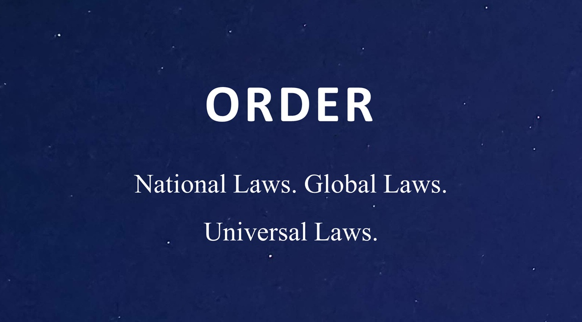

The Reflective Universe – How Societies Inherit Nature’s Design
“The universe has rules, and it rewards those who follow them."

Lasting prosperity cannot be built on markets or policies alone; it must be rooted in the architecture of complexity itself. The universe has already revealed how systems endure, and now it is our turn to design in alignment with its logic.

Society – The Architecture of Human Systems
Human societies do not mark the beginning of complexity, but they do represent its most abstract and consciously directed form. Through human beings, complexity gains the ability to reflect on itself. The structural functions that sustain societies, economic coordination, governance, defense, cultural identity, and integration, were not created by humans from nothing; they have existed in various forms since the earliest stars and molecules. What makes us different is not the emergence of these roles, but our capacity to recognize them, name them, and intentionally reshape them. Where stars maintain equilibrium through physical laws, and organisms coordinate through genetic programming, human societies attempt to design their structure with purpose, using imagination, belief, and foresight.
A society is not simply a gathering of individuals, but a structured and layered system composed of institutions, infrastructure, laws, symbols, markets, language, and shared memory, all of which enable large groups of people to coordinate their actions across space and time. Like galaxies, molecules, and organisms, societies must perform essential structural functions to remain stable, evolve, and thrive. Their survival depends not merely on raw power or cultural richness, but on how well their internal systems are aligned, how effectively they manage energy, organize decision-making, preserve coherence, sustain identity, and respond to change.
Let us revisit these five functions as they manifest within societies:
- Economic Complexity: This is the system’s engine for producing, distributing, and sustaining value. It encompasses markets, supply chains, financial institutions, and systems of labor and exchange. A society’s economic architecture determines how efficiently it mobilizes resources, scales production, and supports livelihoods across time and shifting conditions.
- Governance Complexity: Governance defines how choices are made, how intentions are coordinated, and how collective direction becomes actionable. It includes laws, institutions, leadership frameworks, and decision-making processes that translate vision into policy and policy into organized behavior.
- Defense Complexity: Defense ensures continuity by protecting a society’s structure from collapse. It includes security forces, legal enforcement, health systems, emergency response, and strategic foresight. A system that cannot defend its coherence, whether from external attack or internal decay, cannot survive or evolve.
- Cultural Complexity: Culture provides the connective tissue of meaning. It binds individuals into a shared identity through language, narrative, ritual, values, and memory. Culture defines what matters, who belongs, and why the system exists. Without it, institutions may operate, but they cannot cohere or inspire.
- Integration Complexity: Integration allows a society to learn, adapt, and renew itself. It includes education, science, media, diplomacy, and systems of communication and feedback. Through integration, a society interprets change, absorbs disruption, and evolves without losing its structural integrity.
What sets human societies apart is not the presence of these five functions, but the medium through which they operate. Unlike molecules or living cells, which coordinate through physical forces or biological instinct, human coordination is rooted in shared imagination. A currency holds value not because of any intrinsic property, but because people collectively believe it has value and are willing to act accordingly. Laws function not as natural imperatives, but as agreements that exist only as long as they are upheld. A nation survives not because it occupies space, but because millions act as though it is real. Through this capacity to align around symbols, rules, and stories, we construct orders that do not physically exist, yet shape the behavior and destiny of entire civilizations.
These symbolic systems extend the architecture of complexity, making it more flexible, scalable, and vulnerable simultaneously. They enable human societies to organize on an unprecedented scale, but they also introduce new risks: the fragmentation of belief, the collapse of trust, and the loss of shared direction. The same power that builds civilizations can dissolve them when alignment breaks down.
These five functions do not operate in silos, nor can they be prioritized in isolation. They are interdependent, and their alignment determines whether a society becomes coherent and resilient or fragmented and unstable. A nation may develop a strong economy, but if it lacks cultural cohesion or educational integration, that wealth may not translate into long-term prosperity. Similarly, a state may maintain powerful defense institutions, yet fail to survive if it lacks legitimate governance or a unifying cultural story. Structural imbalance, favoring one function at the expense of others, leads to decay, not strength. Prosperity does not emerge from dominance in a single domain, but from harmony among all five.
Although we often imagine that society stands apart from nature, this perception stems more from perspective than from truth. Human systems are not exceptions to the rules of emergence and alignment. They are extensions of the same principles that shaped galaxies, molecules, and living organisms. What has changed is not the architecture, but the level of abstraction, the scale of cooperation, and the ability to reflect on and reshape our own systems. Where earlier systems followed these functions without awareness, we are the first to study, question, and attempt to redesign them.
Human societies are not separate from nature; they are nature gaining the capacity for reflection. The five families of complexity that organize our economies, institutions, and cultures are not speculative theories; they are grounded in empirical evidence. The five families of complexity are practical tools that enable us to understand where a system is strong, where it is breaking down, and how it might realign itself to endure. To use these tools is not to impose structure on the world from above, but to build in accordance with the logic that shaped the universe from the very beginning.

A Universal Pattern
We often speak as though human society stands apart from nature, as if we are governed by different rules than the ones governing stars, cells, or molecules. We imagine ourselves as exceptional, conscious agents in an unconscious universe, constructing meaning and purpose out of raw material. But this perception arises not from truth, but from scale and perspective. In reality, we are not outside nature’s logic; we are its most recent and reflective expression.
What we have traced throughout this column is not a metaphor loosely applied across disciplines; it is a recurring structural pattern, visible wherever energy flows through a system that is shaped, sustained, and directed. Whether in the formation of galaxies, the chemistry of early Earth, the architecture of living cells, or the design of modern societies, the same five structural functions emerge again and again: the production and exchange of value, the organization of decisions and direction, the protection of coherence, the preservation of shared identity, and the integration of learning and change. These functions are not inventions of the human mind; they are conditions for emergence, roles that must be performed if a system is to hold together, adapt, and grow more capable over time.
At each layer of complexity, the essential functions remain the same, but the medium through which they are expressed evolves. In the realm of physics, complexity is shaped through the interactions of matter and force, where gravitational pulls and quantum fields give rise to structure. In chemistry, the same structural roles are carried out through atomic bonds and cascading reactions, creating networks that can stabilize, replicate, and transform. Biology introduces further intricacy, using metabolism, membranes, and genetic replication to maintain organization, store information, and adapt to environmental change. In human societies, these functions are no less present, but they operate through more abstract means, such as shared beliefs, symbolic systems, institutional design, and intentional coordination. Although the materials and mechanisms differ, the underlying logic of emergence remains consistent across all layers: energy must be harnessed, structure must be maintained, pathways of transformation must be coordinated, continuity must be preserved, and feedback must be integrated. These functions allow complexity not only to endure but to evolve into higher forms.
This is the architecture of complexity; it does not begin with us, but through us, it becomes conscious. While galaxies do not choose their direction and molecules do not revise their bonds, human beings can observe misalignment, imagine alternatives, and redesign their structures in pursuit of a shared purpose. We alone possess the ability to ask whether the systems we inhabit still serve what we value, and to change them if they do not.
When we recognize that our societies are governed by the same principles that organize the stars, we gain not only humility but clarity. Complexity is not a force we control, nor is it a problem we can solve once and for all; it is the terrain we must navigate. Our task is not to escape its logic, but to work with it, to align our structures with the deep patterns that nature has refined over billions of years.
Human societies are not special because we break from nature, but because we reflect it, and in doing so, we gain the capacity to shape it. The five families of complexity, economic, governance, defense, culture, and integration, are not merely tools for analysis. They are instruments of design. When aligned with intention and care, they enable systems to thrive. When neglected or distorted, they lead systems to fragment, stagnate, or collapse. It is through this lens that we can begin to understand why some nations endure while others collapse, why some communities prosper while others stagnate, and how we might build structures that last. This pattern governs galaxies, molecules, cells, and civilizations. It is not a metaphor, but a mechanism. If we learn to recognize it clearly and align our systems with its demands, we may gain the ability to build structures that not only serve us now but also endure across generations.

==> Seeking a speaker to present innovative ideas in agriculture, economics, history, complexity, organizational structures, and the science of prosperity? WhatsApp me at +972-54-2523425

Subscribe here, free of charge!
"Mental and Economic Freedom Are Interconnected."

See you soon,
Nimrod


Dr. Nimrod Israely is the CEO and Founder of Dream Valley and Biofeed companies and the Chairman and Co-founder of the IBMA conference. +972-54-2523425 (WhatsApp), or email nisraely@biofeed.co.il

P.S.

If you missed it, here is a link to last week's blog, “The Architecture of Complexity – From Stars to Cells“.
P.P.S.
Here are ways we can work together to help your agro sector and rural communities step forward and shift from poverty into ongoing prosperity:
* Nova Kibbutz and consultancy on rural communities' models.

* Local & National programs related to agro-produce export models - Dream Valley global vertical value and supply chain business model and concept connects (a) input suppliers with farmers in developing economies and (b) those farmers with consumers in premium markets.

* Crop protection: Biofeed, an eco-friendly zero-spray control technology and protocol.

You can follow me on LinkedIn, YouTube, and Facebook.
*This article addresses general phenomena. The mention of a country/continent is used for illustration purposes only.

