

View Online and Translate


Why Organizational Prosperity Begins With Trust and Interdependency

“Trust is the currency of all lasting prosperity.”

The Hidden Architecture of Trust
When I was a young man working in the orchards of my Kibbutz, I never once questioned whether those around me shared my mission. We labored side by side, sometimes in conversation, often in silence, but always with a quiet certainty that we were striving for the same thing: for the orchard to flourish, for the Kibbutz to prosper, and for our shared future to unfold. That trust was not earned through contracts or performance reviews; it was structural, woven into the very fabric of how our community was designed to function.
Now, decades later, outside the Kibbutz ecosystem, I often find myself in professional settings where suspicion feels like the default. I ask myself whether these partners truly want what I want, whether I can rely on them, whether they will fulfill their part as they should, and whether they will act with integrity even when no one is watching. Too often, after careful thought, I decline opportunities not because they lack merit, but because my honest answer to those questions is uncertain. “I don’t know” or “I am not sure” becomes a quiet, invisible wall. The energy we expend navigating this doubt is unseen, yet it slowly drains our time, blunts our focus, and diminishes our momentum.
And so I find myself asking a deeper question. What is the economic cost of mistrust? And, in its mirror image, can we predict, perhaps even model, the prosperity of an organization based on the level of trust and interdependency it enables?
The cost of mistrust is not merely the time or energy spent on oversight, corrections, or contingency planning. It is far greater. It lives in the opportunities we never explore, the partnerships we never form, and the ideas we never test, not because they lacked potential, but because we could not be certain of others. In these moments, inaction becomes the safer choice. We hold back not out of caution, but out of quiet doubt. These are the costs that never show up in a financial report, yet they shape the boundaries of our ambition and quietly define how far we are willing to go.

The Assembly Line and the Power of Integration
At the turn of the 20th century, American industrialist Henry Ford introduced the assembly line. By aligning tasks in a coordinated, interdependent system, Ford's factories were able to produce cars ten times faster than the British model of individualized craftsmanship. This was not merely a triumph of tools; it was a triumph of structure.
Where the British system relied on highly skilled individuals working independently, the assembly line trusted each worker to perform one focused task, knowing that others down the line would do theirs. This required precision, yes, but also trust in the system and the people within it. The result? A transformation not only in productivity, but in economic accessibility.
And yet, long before Ford’s innovation, a quieter revolution was already underway. In the first Kibbutzim of pre-state Israel, still under Ottoman rule, from 1910, work was not divided informally, but structurally. Agricultural tasks were arranged in coordinated sequences, responsibilities were rotated intentionally, and labor was viewed as a shared endeavor rather than an individual task. In essence, it was an assembly line for agriculture and for life itself, introduced three years before Ford’s factory model. In the Kibbutz, trust was not confined to a single domain; it extended across the entire fabric of daily life, encompassing work, education, housing, healthcare, family, and governance. The system was built for interdependence, and trust was its currency. By contrast, in the LLC model, trust is primarily confined to work-related roles and contractual duties, while in traditional villages, it is often limited to familial bonds.
But unlike Ford, the early Kibbutz pioneers never articulated the structural innovation they had created. They embraced it as natural, even self-evident, replicating it from one community to the next without stopping to ask why it worked, or how it might be adapted, improved, or extended to different contexts. And therein lies a deeper lesson: when we fail to understand the architecture of our own successes, we lose the ability to replicate them, repair them when they falter, evolve them when they stall, or scale them when the world shifts.
This is why modeling is essential. It is not the pursuit of abstraction, but the practice of giving form to insight, transforming lived experience into structure, and structure into something that can be shared, repeated, and scaled. When we model what works, we empower our knowledge to transcend time, bridge cultures, and adapt to new realities. We allow wisdom to travel not as memory, but as design.
What both Ford and the Kibbutz demonstrate, whether by intention or by outcome, is the same structural principle described by the Universal Law of Increasing Complexity: prosperity emerges not from isolation, but from interdependence. As components of a system become more aligned and integrated, their collective capacity expands. Integration multiplies the capabilities of each part when working together. It is not the structure itself that unlocks potential, but rather the right structure; one designed to coordinate complexity, support coherence, and adapt to change.
Now imagine applying this same insight not to factories or fields, but to organizations, communities, and entire nations. What would it mean to design a system not just for output, but for trust, alignment, and interdependency, conditions that enable not only multiple outcomes, but emergent capabilities? What kind of prosperity might become possible if our structures were built not simply to perform, but to foster coherence, shared purpose, and dynamic interconnection, as both the Ford assembly line model and the Kibbutz quietly revealed?

Modeling Organizational Trust
If we accept, based on everything discussed so far and in previous columns, that structure shapes prosperity, then the next question becomes unavoidable: Can we model this? Can we actually demonstrate how trust and interdependency influence economic outcomes over time, not just anecdotally, but structurally?
To explore this question, I developed a simple simulation based on three familiar organizational models: the Traditional Village, the LLC, and the Kibbutz. Each reflects a distinct way of structuring work, trust, and interdependence:
- The Traditional Village has little formal structure. People may work side by side, but not necessarily together. Trust is largely personal, often confined to kinship, and coordination is limited.
- The LLC (Limited Liability Company) introduces defined roles and a shared mission. People operate in structured teams, and while trust exists, it is often mediated through contracts, supervision, and periodic performance measurement.
- The Kibbutz is designed for deep alignment and total interdependence. Members do not merely share work; they share purpose, livelihood, and the whole fabric of daily life. Trust is not maintained through oversight or measurement; it is embedded in the very structure of the community. There are no mechanisms for individual supervision or evaluation, and membership is lifelong, unless broken by a severe breach of trust, such as a criminal act, which is exceedingly rare. The economy, education, healthcare, housing, and governance are all managed collectively, making the Kibbutz a fully integrated model of mutual responsibility that extends far beyond working hours.
To compare these models, I posed a simple question: If every person begins with the same productive potential, how much more, or how much less, value do they generate over time, depending on the level of trust and interdependency embedded in their organizational structure?
Using basic assumptions about how effectively each system coordinates and aligns its members, I projected their growth over time, not only in terms of annual output, but in how that performance compounds across decades.
And then I introduced a twist: what happens when trust begins to erode?
Many organizations, including Kibbutzim and companies like Apple, start strong, with deep alignment and shared purpose, but lose coherence as leadership changes, cultures shift, or foundational values fade. I modeled that scenario too, by reducing their growth rate after year 25, reflecting the subtle but compounding cost of structural mistrust.
The logic behind the model is grounded in historical reality. When Henry Ford introduced the assembly line, productivity rose by nearly ten times compared to the individualized British system. Even if we assume far smaller gains, such as doubling or quadrupling output, the long-term effects are still dramatic. That is the structural power of alignment and interdependency.
The assembly line is not only a breakthrough in efficiency. It is a clear expression of structural interdependency. Each task relies on the next, and no step holds meaning without the sequence as a whole. This logic extends beyond factories. The deeper the interdependency, within work and beyond it, the greater the system’s capacity for emergence. A traditional village offers little interdependence in either domain. An LLC introduces interdependence at work, but often stops at the boundaries of professional roles. The Kibbutz, by contrast, is interdependent by design, both in labor and in life. And it is this all-encompassing alignment that unlocks its exceptional coherence, adaptability, and long-term generativity.
For readers interested in the full model assumptions and historical comparisons, please refer to the Appendix at the end.
And the result?
The difference between high-trust and low-trust organizations is not just seen in what they produce today. It becomes even more pronounced in the futures they unlock, or quietly lose.

Visualizing the Model
The following diagrams bring the model to life, translating the framework described above and detailed in the appendix into visual form. Each chart illustrates how economic output evolves over a 50-year period within one of the three organizational structures, based on their respective levels of trust, interdependency, and structural design.
Each organizational model is shown under two projected scenarios:
1. Sustained Trust – trust and interdependency remain high throughout the entire 50-year period, allowing the structure to maintain its coherence and compounding growth.
2. Trust Decay After Year 25 – alignment begins to erode in the second half, reducing the system’s ability to coordinate and diminishing its long-term growth trajectory.

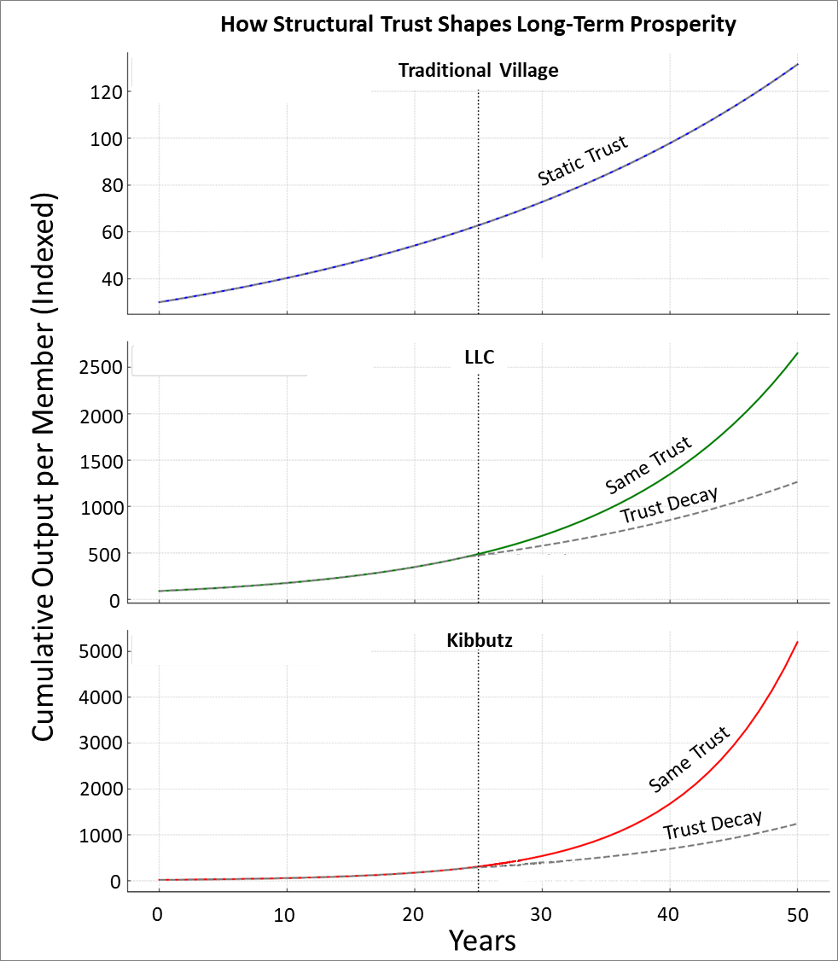

Figure: How Structural Trust Shapes Long-Term Prosperity. This chart compares the long-term output of three organizational models, Traditional Village, LLC, and Kibbutz, under two scenarios: sustained trust and trust decay after year 25. The deeper and more enduring the trust, the greater the prosperity. Note: the Y-axis scale differs between charts. The lesson is clear: growth depends less on effort and more on the structure that trust makes possible.

Traditional Village. Visualization: Flat and steady path. With low structural trust and limited capacity to coordinate complexity, the Traditional Village grows slowly and predictably. Its structure remains static, and so does its trajectory. Limited interdependence produces modest but steady results, without the conditions for compounding growth or emergence.
LLC. Visualization: A strong early curve, followed by a visible slowdown after year 25
The LLC benefits early on from clear roles, defined goals, and a shared mission. This structure supports coordinated growth, especially in the initial decades. However, when trust begins to erode, due to bureaucracy, fragmented incentives, or leadership turnover, its momentum slows. While it continues to outperform the Traditional Village, its long-term potential flattens as alignment weakens and coordination costs rise.

Kibbutz. Visualization: Exponential early growth, then gradual slowdown. With the highest initial levels of trust and structural coherence, the Kibbutz achieves rapid early growth. Its deeply integrated design enables efficient coordination, low friction, and sustained alignment across all aspects of life. Yet, as seen in many real-world Kibbutzim, cultural shifts and weakening collective purpose begin to slow its trajectory after year 25. Even so, the strong foundation laid in its early decades continues to generate compounding advantages, yielding long-term gains that far surpass the other models.

Insight Into the Diagrams
The diagrams reveal something subtle yet essential: the strength of an organizational structure is measured not only by how well it begins, but by how long it can sustain its internal coherence, and equally, by how well it is understood, maintained, and refined over time.
The Traditional Village model never possessed the structural capacity to compete in a modern economy. The LLC begins with coordination and clarity, but often struggles to preserve alignment as complexity increases. The Kibbutz builds coherence into its foundation, yet even it must continuously renew that alignment as culture shifts and conditions evolve.
Trust and interdependency are not philosophical ideals; they are economic engines. Like any engine, they must be deliberately designed, actively fueled, and regularly maintained. When that maintenance is neglected, systems do not fail because people lack skill or effort, but because the structure can no longer support the performance it once enabled.
The village model, rooted in familial bonds, is static and unscalable. It begins slowly, never accelerates, and never will. The LLC and the Kibbutz, by contrast, hold extraordinary potential. But when either falters, the appropriate response is not to question the model itself, but to assess how its practice has drifted from its design, and to restore the structure that once enabled its success.
Here we encounter a striking asymmetry, one shaped by familiarity and by history. When an LLC faces difficulty, no one doubts the model. Instead, leadership brings in advisors, revisits the mission, realigns teams, and restructures the organization. The framework is trusted; it is treated as a platform for repair, not abandonment.
But when a Kibbutz experiences similar strain, the response is often the opposite. Because the model is relatively young, lacks international parallels, and remains poorly understood, even among its members, the default assumption is that the structure itself is flawed. Though the most recent of the three, and with a proven track record throughout the 20th century, the Kibbutz is often dismissed as outdated, seen by some as relevant only to those who still hold to socialist ideals. This perception was not abstract to me. It was how many in my generation felt, myself included, when I made the difficult decision to leave the Kibbutz. Faced with challenges we did not fully understand, we questioned the model rather than its maintenance. And too often, that doubt leads to retreat, either toward the more familiar structure of an LLC or, in some cases, to the simplicity of a village, where every family stands alone.
This final message is for Kibbutz members, for those who care about its future, and for those seeking to establish one beyond Israel. The model is not the problem. It is, in fact, the most structurally resilient I have ever studied. But like any great design, it must be understood, maintained, repaired, and adapted - not replaced. What you hold is rare. And when truly understood, it holds lessons not just for you, but for the world, far beyond what you may yet imagine.

The Architecture of Prosperity
To understand why some organizations, communities, or nations flourish while others falter, we must look beyond effort, resources, or talent. These elements matter, but they are never enough on their own, and they are often more evenly distributed than we assume. What matters more, and often invisibly, is the architecture that holds them together. It is the structure of an organization that determines whether potential becomes sustained prosperity.
The village lacks the kind of architecture required to turn potential into prosperity. Its trust is personal, not structural, and its coordination is occasional rather than systemic. As a result, its growth remains limited, not by the character or effort of its people, but by the absence of mechanisms that align energy toward shared, compounding outcomes.
The LLC introduces structure and purpose, and for a time this allows it to accelerate. But without deeper cohesion, without systems that preserve alignment through turbulence, transitions, and time, its performance eventually levels off. Not because its people lack talent, but because the architecture can no longer support the full expression of that talent.
The Kibbutz, in contrast, embedded trust into its very foundation. Trust was not aspirational; it was structural. Members did not negotiate alignment; it was the very condition of participation. This design enabled extraordinary results, especially in the early decades, when coherence was high and purpose was shared economically, culturally, and emotionally. Yet even this model was not immune to entropy. Over time, particularly after fulfilling much of its original mission and vision, the Kibbutz began to lose its sense of direction. As societal shifts accelerated, the bonds of shared identity weakened, and performance declined, not because of failure or fatigue, but because the structure that once converted alignment into prosperity had begun to fray.
We see this same pattern in companies like Apple, which soared when vision and structure were aligned, stumbled when that alignment was lost, and rebounded when coherence was rebuilt. These are not anecdotes. They reflect a deeper principle rooted in the Universal Law of Increasing Complexity: sustainable growth depends on a system’s ability to maintain internal alignment, metabolize complexity, and deepen interdependency over time. Trust and interdependency are not simply ideals. They are structural forces that shape the long-term trajectory of every complex system.
And like all structural forces, they can be cultivated or neglected, reinforced or allowed to erode. They are not fixed. They must be consciously designed, consistently maintained, and repeatedly realigned.
Both the LLC and the Kibbutz reach their full potential when the five layers of complexity align, when how people work, relate, organize, believe, and feel are in sync. In social systems, this alignment does not happen by chance. It is shaped and sustained through shared core values, a unifying mission, and a clear vision. These are not slogans. They are tools for organizing society and directing collective energy. When used well, they cultivate trust and reinforce interdependency. When absent or unclear, even the best-designed organizations begin to drift. Trust fades, interdependency weakens, and cohesion slowly unravels. Most organizations do not fail because their systems stop working, but because they lose the story that once held them together, a story grounded in shared purpose. Some collapse. Others survive only by rediscovering and articulating a mission that resonates with their core values.
This brings us to a crucial distinction. The Kibbutz model is no more bound to Israel or socialism than the LLC is to Britain, where it originated, or the assembly line is to American car manufacturing, or powered flight to two bicycle builders from Ohio. Once we understand the blueprint of a successful structure, we are free to apply it wherever it fits, so long as we stay aligned with its essential design.
If we are serious about building organizations that prosper and endure, not just in years, but in vitality, creativity, and resilience, we must move beyond tools, charisma, and short-term optimization. We must design for structural coherence, for alignment maintained not by rules alone but by shared mission, and for trust that does not need to be negotiated in every interaction, but flows naturally from the system itself.
Because in the end, the greatest losses we suffer are rarely the result of collapse. They are the quiet, invisible accumulation of unrealized potential: the opportunities never pursued, the innovations never born, the futures that never arrive. Not because we lacked talent or ambition, but because we never designed the structure to foster trust, sustain alignment, and enable us to grow together.
The future belongs to those who excel at designing for trust, a trust rooted in interdependency, sustained through structure, and embedded in the system itself.

Appendix
Modeling Assumptions and Scenarios
This appendix outlines the conceptual model used to simulate the impact of trust and organizational structure on long-term economic performance. The model is intentionally simplified. It is not intended to predict the future, but rather to reveal the structural dynamics that often remain unseen.

Model Parameters
All values are normalized for comparison across organizational types:
- Trust Level (0 to 1): Reflects how deeply members believe in one another’s reliability and shared commitment. High trust reduces the need for supervision, negotiation, and redundancy.
- Complexity Factor (1.0 to 2.0): Measures how well the organization coordinates roles, manages interdependence, and transforms complexity into productive output.
- Growth Rate (%): Represents compounded annual economic output per member over a 50-year period.
Each model begins with the same baseline of individual productive capacity. What differs is how structure multiplies or limits this capacity through trust and complexity.

Parameter Summary
Organization | Trust Level | Complexity Factor | Growth Rate (Years 1–25) | Growth Rate Decay (After Year 25)
Traditional Village | 0.3 | 1.0 | 3% | 3%
LLC | 0.6 | 1.5 | 7% | 4%
Kibbutz | 0.9 | 2.0 | 12% | 6%

Why These Numbers Are Conservative
Consider a historical benchmark: when Henry Ford introduced the assembly line, productivity in his factories increased by nearly tenfold compared to the British system of individualized production. This leap was not due to better tools, but better structure, sequenced roles, shared flow, and interdependent coordination.
If we treat smallholder villages as today’s analog of the older British model, then both LLCs and Kibbutzim represent more integrated, assembly-line systems. They do not merely add people; they multiply output by aligning them and embedding mutual dependency into the structure itself.
- For the LLC, we assign a 7% annual growth rate, which is only a modest improvement over the village’s 3%. This reflects its moderate structure and formal roles, supported more by contract than by deep trust.
- For the Kibbutz, we assign a 12% annual growth rate, just four times the village’s, despite its full-spectrum integration of work, life, purpose, and governance. This modest multiplier reflects a conservative approach to modeling its holistic design.
These assumptions are deliberately cautious. We are not modeling Ford’s full 10x leap. Even modest multipliers demonstrate how small differences in structure, especially trust and interdependency, compound dramatically over time.
In the second scenario, presented as Growth Rate Decay, we introduce a structural shift that reflects patterns seen in many real-world cases. After years of early success, some organizations experience a slowdown. For demonstration, we modeled this shift beginning in year 25, roughly a generational timespan, when trust and interdependency begin to erode. In both the LLC and the Kibbutz, this decline may stem from cultural drift, leadership turnover, generational transition, or the fading of a once-unifying purpose. Growth slows. Meanwhile, the Traditional Village remains static throughout, serving as a baseline of structural stagnation.

Subscribe here, free!
"Mental and Economic Freedom Are Interconnected."

See you soon,
Nimrod


Dr. Nimrod Israely is the CEO and Founder of Dream Valley and Biofeed companies and the Chairman and Co-founder of the IBMA conference. +972-54-2523425 (WhatsApp), or email nisraely@biofeed.co.il

P.S.

If you missed it, here is a link to last week's blog, “Why Pressure-Ready Systems Are Built to Prosper? “.
P.P.S.
Here are ways we can work together to help your agro sector and rural communities step forward and shift from poverty into ongoing prosperity:
* Nova Kibbutz and consultancy on rural communities' models.

* Local & National programs related to agro-produce export models - Dream Valley global vertical value and supply chain business model and concept connects (a) input suppliers with farmers in developing economies and (b) those farmers with consumers in premium markets.

* Crop protection: Biofeed, an eco-friendly zero-spray control technology and protocol.

You can follow me on LinkedIn, YouTube, and Facebook.
*This article addresses general phenomena. The mention of a country/continent is used for illustration purposes only.

