

View Online and Translate
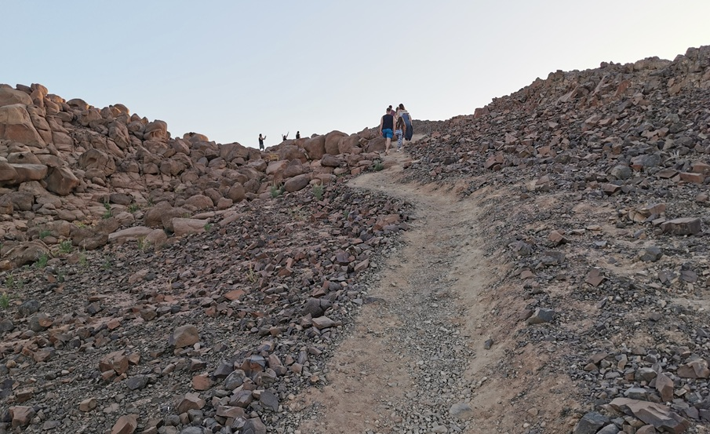

The Language of Science, and Why It Matters to You

Ensure you understand the meaning behind the words.

Before we delve into the heart of this column, I want to pause, not to introduce a new idea, but to ensure we're speaking the same language.
Language is made of words we can neither see nor hold. Once spoken, they vanish into the air, yet they shape everything. And that's the danger: we tend to underestimate what we can't touch. Yet some of the most potent forces in the universe are the ones we cannot see, like gravity, the Second Law of Thermodynamics, entropy, Genordo, and even the deeply human forces of love and trust.
And so, as we explore how complexity builds, how prosperity emerges, and why some systems thrive while others collapse, we often use terms like "law," "model," or "principle" as if they are self-evident. But that assumption is precisely where confusion begins, because when these words carry different meanings for different people, alignment unravels. We end up misreading one another, talking past each other, or worse, moving in opposite directions while thinking we're on the same path.

Driving
When you drive, you follow a combination of rules, some legal, like red lights and speed limits; others practical, like keeping your tires inflated. Beneath them all are deeper, invisible laws: friction, torque, gravity, always in effect, whether or not you understand them. Ignore them, and you won't get far, or eventually, you'll crash.
Now, imagine two drivers heading in the same direction. One travels on a highway; the other struggles along a dirt road. Both are moving toward the same destination, but while one arrives hours ahead, comfortably and safely, the other barely advances, worn down by potholes, mud, and exhaustion.
This is the difference between operating within a well-designed system and moving forward alone, without support, structure, or alignment with the principles that govern progress. And this, in many ways, is the story of millions of smallholder farmers worldwide.
A solonist farmer, working alone, selling locally, disconnected from any value chain, might be moving in the right direction. Their intentions are good; they want to grow and improve their livelihood. But their path is unpaved. They lack access to capital, logistics, certification, and support, the basic conditions for turning movement into real progress.
Now, compare that to a farmer who is part of a cooperative, a Kibbutz, or a coordinated export system. That farmer may not work harder or know more, but they operate within a structure, a kind of highway, with clearer direction, shared resources, and smoother rules.
The difference isn't always in effort. Often, it lies in structure, whether a person or system is aligned with the invisible laws that govern progress or working against them. This is why understanding the language of science matters so deeply. Let's revisit a few of the terms we often use and clarify why they're essential.
A scientific law isn't something we vote on and isn't a recommendation. Instead, it describes how the universe functions consistently, universally, and independently of belief. Gravity is a law. Thermodynamics is a law. These forces operate everywhere, all the time. You don't need to understand gravity for it to pull you down; its force works regardless.
The Universal Law of Increasing Complexity (ULIC), which we've been exploring together, belongs in this category. It states that systems increase in complexity and, as a result, gain new capabilities when they effectively organize their energy, structure, and direction. This is not a theory. It's a recurring pattern, visible in galaxies, cells, and societies.
Principles are the practical tools that help us work with those laws. Just as "maintain your engine" or "drive at a safe distance" helps prevent collisions, human systems rely on principles like "share resources," "specialize roles," and "align around a mission." You can break a principle and still function, but not for long.
Models are like maps: they simplify reality not to distort it, but to help us navigate it. No model can capture everything, but a well-constructed one reveals the essential features of the terrain and helps us make better decisions. A flawed model, by contrast, can lead us confidently in the wrong direction and sometimes, right off a cliff.
Formulas allow us to quantify how systems behave. Although not everyone needs to use them, it is essential that someone understands them. Without formulas, we're not steering; we're guessing.
Then there are the familiar words we hear in almost every organization: values, vision, and mission. They're often treated like slogans, but they're actually structural components of the engine that powers any system.
Values serve as your internal compass, preventing you from making short-term decisions that sabotage long-term sustainability. In a moving vehicle, values are the guardrails that keep you from veering off the road when the weather turns or visibility drops.
Vision is your GPS. It shows where you're headed and why the destination matters. Without it, you may still be in motion, but you're likely just circling the block.
Mission is your fuel. It powers your day-to-day activities. Without fuel, even the most robust vehicle stalls, and without a mission, people burn out, structures deteriorate, and even the best-designed systems lose their momentum.
When values, vision, and mission are clear and aligned, they generate momentum, not just motion, but meaningful, coordinated, and purpose-driven movement.
-Sometimes, when everything is aligned, when laws are respected, principles are followed, and the structure is sound, something remarkable happens: new capabilities emerge that none of the parts could achieve independently. These are called emergent capabilities.
For example, with a horse and cart, no matter how well you feed the horse or polish the wheels, you will never achieve cruise control. However, replace the horse with an engine, add steering, sensors, wheels designed for speed, and a computer, and suddenly, the car can maintain its own speed: that’s cruise control, an emergent capability.
Take it a step further: today, some cars can drive themselves, navigating traffic, staying in lane, choosing the fastest route. None of these abilities exists in the components alone. They emerge only when a system becomes complex enough, integrated enough, and guided by a clear mission.
This is true not only for machines but also for villages, companies, and countries. When a group reaches a certain level of organizational complexity, it unlocks new powers, such as scaling production, entering new markets, innovating, or protecting its people more effectively than any individual ever could.
That's why comparing countries based on their individual citizens is misleading. A country is not simply the sum of its people, but the result of how those people are integrated, and the level of complexity that integration enables. After all, you wouldn't try to measure a car's quality by inspecting its tires. The real difference lies not in the parts, but in how they're assembled, how the system is designed, structured, and performs as a whole.
Prosperity is misunderstood in much the same way. It's not just about wealth or income. It's the condition in which energy, direction, structure, and cooperation are aligned with the laws of complexity. Prosperity occurs when a system advances and takes its people with it.

Alignment
This column isn’t about inspiration. It’s about alignment. If we misuse our terms, confuse laws with preferences, or treat slogans as strategies, we risk driving without a map. And in a world governed by invisible laws, like the ULIC and gravity, that's not just inefficient; it's dangerous.
You don't need to understand gravity for it to affect you. But if you want to fly or unlock new capabilities, you'd better understand lift, drag, and thrust. The same is true for prosperity, innovation, and building systems that work.

Self-Reflection
I invite you to revisit the concepts and terms we've explored above with fresh eyes. Ask yourself:
- Are we applying the right principles?
- Are our values and vision integrated into a purpose-driven mission?
- Are we stuck on a dirt road, or are we laying down the infrastructure for a highway?
Because even when we’re headed in the right direction, without a shared understanding of terms and the language of science, we end up relying on scattered intuition instead of coordinated, engineered progress, and that’s how we remain stuck on the dirt roads of humanity.

==> Looking for a speaker to introduce revolutionary ideas in agriculture, economics, history, complexity, organizational structures, and the science of prosperity? WhatsApp me at +972-54-2523425

Subscribe here, free of charge!
"Mental and Economic Freedom Are Interconnected."

See you soon,
Nimrod


Dr. Nimrod Israely is the CEO and Founder of Dream Valley and Biofeed companies and the Chairman and Co-founder of the IBMA conference. +972-54-2523425 (WhatsApp), or email nisraely@biofeed.co.il

P.S.

If you missed it, here is a link to last week's blog, “Interdependence: The Starting Point of Prosperity - Part 2“.
P.P.S.
Here are ways we can work together to help your agro sector and rural communities step forward and shift from poverty into ongoing prosperity:
* Nova Kibbutz and consultancy on rural communities' models.

* Local & National programs related to agro-produce export models - Dream Valley global vertical value and supply chain business model and concept connects (a) input suppliers with farmers in developing economies and (b) those farmers with consumers in premium markets.

* Crop protection: Biofeed, an eco-friendly zero-spray control technology and protocol.

You can follow me on LinkedIn, YouTube, and Facebook.
*This article addresses general phenomena. The mention of a country/continent is used for illustration purposes only.

