

View Online and Translate

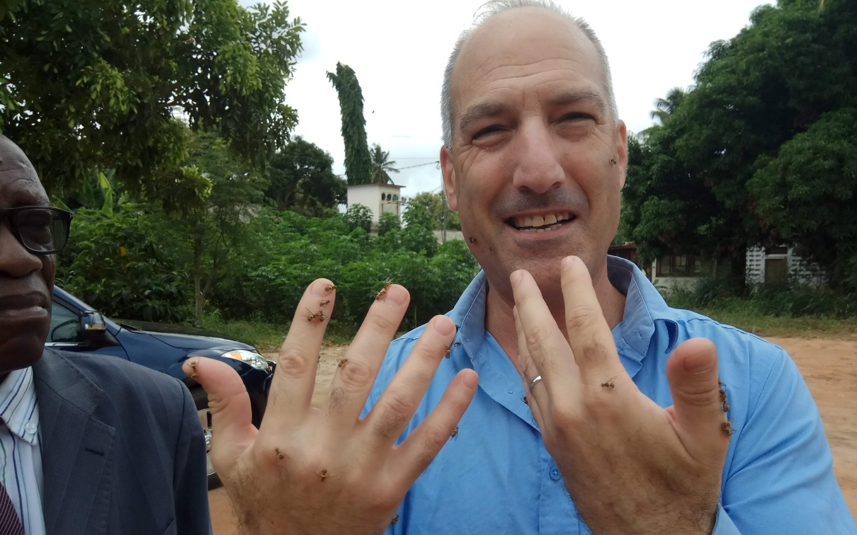
Interdependence: The Starting Point of Prosperity – Part 2
“Alone, we survive; together, we thrive.”

If Part 1 argued that poverty persists not from lack of effort but from outdated structures, then the next question is clear: What structures are needed to unlock prosperity today?

The answer is not more inputs into broken frames, but the creation of a new frame for community life structures of interdependence rooted in shared values, designed for complexity, and capable of turning human passion into collective prosperity.

In this second part, we explore what modern, mission-driven systems like Nova-Kibbutzim and Professional Villages can teach us about designing communities built for interdependence, complexity, and resilience.

Resolution: Designing for Interdependence

If poverty results from outdated structures, then prosperity must begin with new ones designed not for survival in isolation but for thriving through interdependence. These structures must be capable of converting human passion into coordinated energy and effort into shared, scalable success. This is not a theoretical shift, but a design challenge.

Future communities must be built around a new kind of infrastructure, not just roads, electricity, and irrigation, but organizational systems that align people, resources, and purpose around a shared mission. In a world shaped by complexity, interdependence is no longer optional; it is the baseline design requirement for sustainable prosperity.

Models like the Nova-Kibbutz and the Professional Village offer glimpses of what’s possible. Both share a common foundation: interdependence, shared purpose, and structural design rooted in values and mission. Yet, each applies these principles in distinct ways.

The Nova-Kibbutz emphasizes social cohesion, emotional belonging, and collective ownership, combining a strong communal ethos with modern business logic. The Professional Village, in contrast, emphasizes role specialization, market integration, and professional performance, while still grounded in shared identity and cooperation.

Neither is inherently better; they reflect different balances between social togetherness and functional specialization, each suited to different environments and community goals. What matters is not the label, but the structure’s ability to organize human energy around a shared mission in a way that fits its context.

The real question is not whether we replicate these specific models, but what kind of structure can help a community manage the full spectrum of modern complexity?

According to the Universal Law of Increasing Complexity (ULIC), prosperity arises when systems evolve to handle growing layers of complexity, without losing cohesion or direction. For rural communities, this now includes:
- Economic and technological complexity: markets, logistics, tools, infrastructure.
- Social and emotional complexity: trust, belonging, cooperation.
- Governance complexity: leadership, justice, decision-making.
- Cultural complexity: values, ethos, narratives, shared long-term vision and mission.
- Environmental complexity: sustainability, climate resilience, natural cycles.
- Educational complexity: knowledge transfer, innovation, and lifelong learning.

No traditional village, no matter how hardworking its members are, can manage all of this in isolation, and no amount of external inputs can compensate for a structure not designed to hold that complexity. So, rather than fixing broken systems with more tools, we must create systems built for what the world now demands. The challenge before us is not to choose between old and new models but to design structures that channel passion, support cooperation, and scale with complexity.

Whether we call them Nova-Kibbutzim, Professional Villages, or something entirely new, the task remains the same: to build human systems where interdependence is not a weakness to escape, but a foundation to build upon.

Interdependence: The Starting Point of Prosperity

For centuries, rural communities were designed for one purpose: survival. In a disconnected world, that was enough. But today, prosperity, not survival, is the baseline. And prosperity demands more. It requires structure, not just any structure, but one that channels human energy toward shared purpose. It requires systems capable of holding together emotional, social, and economic complexity. And above all, it demands a return to the deepest strength Homo sapiens ever evolved: interdependence.

One leading theory for why our species survived, while others like the Neanderthals vanished, is not that we were stronger, smarter, or faster. We weren’t. But we were better at collaborating in large, flexible, mission-driven groups. Our ability to effectively cooperate based on shared needs, not just within families or tribes, but with complete strangers, became the engine of survival, growth, and ultimately, civilization. That ancient strength still holds today.

Prosperity does not come from effort alone, nor from inputs or technology, though it cannot do without them. It comes from structure: systems that turn passion into energy, give values direction, and hold people together around a common purpose.

Poverty, especially in rural communities, persists not because people don’t work hard, but because they work within structures built for isolation. These systems were once well-suited for survival but never designed to deliver prosperity.

The answer is not to abandon community or tradition, but to redesign them for complexity, cooperation, and scale, anchored in shared values. When structure moves beyond dependence and embraces interdependence, it elevates a community’s complexity and its capacity for lasting prosperity.

The strongest families, tribes, companies, and nations have always succeeded not by making everyone the same, but by making everyone essential. They succeed by building systems where no one stands alone, and everyone contributes to something greater.

This is what we must build again: not programs, tools, or aid, but structures rooted in trust, driven by purpose, and designed to help us grow stronger, together. In the end, prosperity is not luck or charity but the result of structure. And the proper structure begins with interdependence.

We invest billions in technological innovation every year, chasing breakthroughs to drive the future. But how much do we invest in organizational innovation and in redesigning the systems that shape how we live, work, and grow? If prosperity depends on structure, then this is where true innovation must begin.

==> Looking for a speaker to introduce revolutionary ideas in agriculture, economics, history, complexity, organizational structures, and the science of prosperity? WhatsApp me at +972-54-2523425

Subscribe here, free of charge!
"Mental and Economic Freedom Are Interconnected."

See you soon,
Nimrod


Dr. Nimrod Israely is the CEO and Founder of Dream Valley and Biofeed companies and the Chairman and Co-founder of the IBMA conference. +972-54-2523425 (WhatsApp), or email nisraely@biofeed.co.il

P.S.
If you missed it, here is a link to last week's blog, “Interdependence: The Starting Point of Prosperity – Part 1“.

P.P.S.
Here are ways we can work together to help your agro sector and rural communities step forward and shift from poverty into ongoing prosperity:
* Nova Kibbutz and consultancy on rural communities' models.

* Local & National programs related to agro-produce export models - Dream Valley global vertical value and supply chain business model and concept connects (a) input suppliers with farmers in developing economies and (b) those farmers with consumers in premium markets.

* Crop protection: Biofeed, an eco-friendly zero-spray control technology and protocol.

You can follow me on LinkedIn, YouTube, and Facebook.
*This article addresses general phenomena. The mention of a country/continent is used for illustration purposes only.

