

View Online and Translate

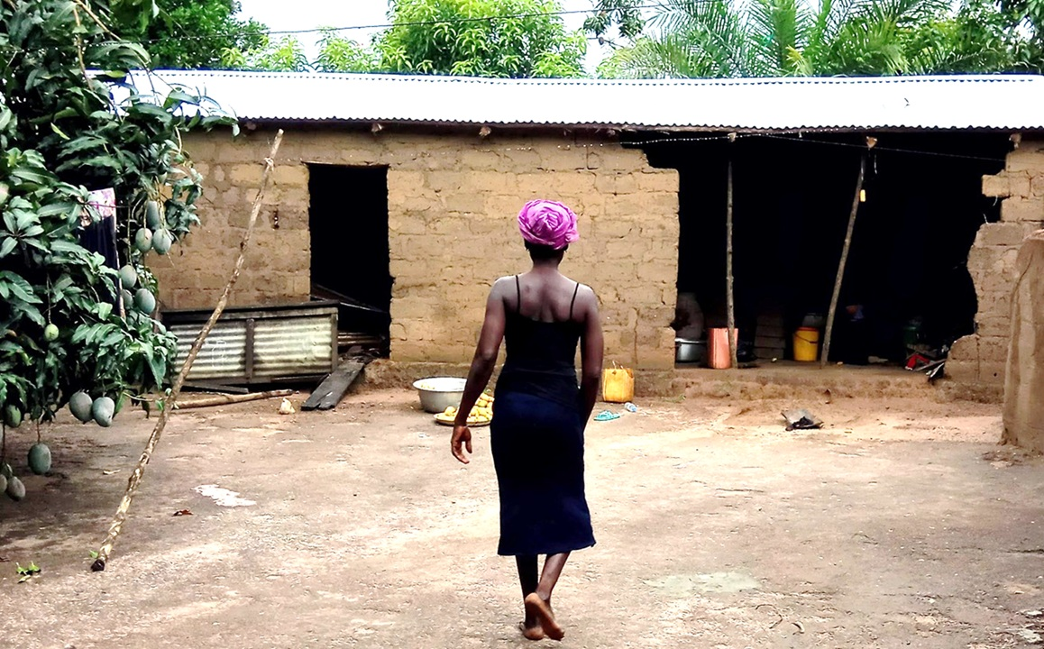
Interdependence: The Starting Point of Prosperity – Part 1
“Ubuntu: I am because you are.”
We live in a world that celebrates independence: the self-made entrepreneur, the heroic inventor, the lone farmer pulling a living from the soil. But a different truth emerges when we look more closely at human evolution, economic history, and the structures that actually produce prosperity.
Prosperity does not grow in isolation. It grows in systems where people share direction, roles, and responsibility. From families and tribes to Kibbutzim and LLCs, the most successful human structures are those built on interdependence.
Today, many rural communities remain poor not because they lack motivation, effort, tools, or intelligence, but because they still operate within structures designed for independence. This column challenges that design and explores how new mission-driven structures, like Nova-Kibbutzim and Professional Villages, can serve as practical examples of interdependence in action.

Why Prosperity Remains Elusive Without Structural Transformation
Imagine a village where everyone works hard, harvests diligently, and even adopts modern technologies, yet prosperity remains out of reach. It’s tempting to blame external factors: market prices, climate change, lack of capital, and, above all, the farmers themselves. These challenges matter. But beneath them lies a deeper, less visible barrier: the absence of a proper structure, one that ultimately determines whether a village can succeed or remain stuck in survival mode.
Without a system to organize human energy, focus collective effort, and channel resources toward a shared mission, even the best technologies and well-meaning aid scatter like seeds on barren ground. This is why so many rural initiatives achieve only short-term gains: they pour new inputs into an outdated, broken frame.
Real, lasting prosperity doesn’t emerge from effort or external support alone. It flows from within, through systems designed to concentrate energy toward a unified agreed direction, much like a laser focuses light into a beam strong enough to cut through steel. Technology, money, and aid can help, but only when the underlying structure is mission-driven and built for collaboration. Otherwise, they disperse and dissipate or simple - wasted.
If we want rural villages to thrive, we must begin with a clear premise: prosperity is not the result of effort or inputs alone but of structural design aligned with a common purpose.
When we create such systems as Nova-Kibbutzim and Professional Villages, we shift from scattered survival to scalable prosperity.

Where Real Energy Comes From: Passion, Mission, and Human Will
If prosperity depends on organizing human energy and focusing collective effort, it’s natural to ask where that energy comes from and how we channel it.
Millions of years ago, evolution gave us the tools. The energy that fuels resilience, creativity, and perseverance doesn’t come from external inputs but from within. Human energy flows from our deepest emotional currents; feelings like passion, love, and even hate. These emotions evolved to help us decide where to focus our effort, what to protect, and what to build.
Passion isn’t random; it arises when our actions align with a mission we believe in and feel connected to. A mission, in turn, comes from aligning our values with a vivid vision of the future, what we might call a dream. We saw this powerfully in Martin Luther King Jr.’s “I Have a Dream” speech. When people connect emotionally to a meaningful mission, they don’t just work; they commit. Passion creates will, and where there is will, there is a way.
We see this most clearly in the most essential structure humanity has ever built: the family. People don’t create families based on economic calculations or perfect timing. They do it out of love, passion, and belief in a shared future. Parents invest in their children without knowing what they’ll receive in return. We act because we care, because we see meaning in something larger than ourselves, and because we are able to generate energy and willing to invest it where our deepest feelings and hopes lie.
Do we build a family alone? No! Building a family teaches us that success doesn’t come from radical independence but from structured interdependence. Each member: husband, wife, and children, has a distinct role, yet no one thrives in isolation. They support one another emotionally, practically, and strategically. Just watch how parents respond when someone threatens their child, and you’ll see what human energy looks like when organized around love and purpose. This is not weakness. It is our deepest evolutionary strength.
For millions of years, humans survived by building not isolated lives but interdependent bands, communities, and tribes. The tribe was the first extension of the family, rooted in shared responsibility, role specialization, emotional bonds, and a common mission. Only much later, just 12,000 years ago, did the village emerge. Unlike the tribe, the village allowed for more individual autonomy. The city followed and took that separation further.
But then came the next evolutionary turn: models that reintroduced structured interdependence at a higher scale. The kingdom, the nation, the Kibbutz, and scalable legal entities like the LLC all bring people together through shared systems, defined roles, and collective direction.
Seen through the lens of evolution, it’s no surprise that the most prosperous societies and organizations, like LLCs and Kibbutzim, are those where individuals, out of free will and guided by passion, shared values, and a common vision, choose to operate with high levels of interdependence. In short, prosperity tends to follow wherever interdependence is highest by choice. This helps explain why global economic development surged with the appearance of the LLC and why the Kibbutz model thrived in environments where traditional villages barely survived.
In an age that often glorifies self-sufficiency, we must remember that the strongest systems, whether families, tribes, or businesses, are those built on structured interdependence, guided by shared values and a common mission.
Nova-Kibbutzim and Professional Villages are not inventions out of thin air; they are renewed expressions of an ancient blueprint, one in which emotional, social, and economic complexity converged within a single coherent structure, as was the case for over 2.5 million years in tribal societies. This natural integration, later fractured by the village and city models, must now be brought back together. When we do that, we don’t just design modern rural systems; we tap into the deep current of human evolution and open a path to prosperity that is as ancient as it is urgently needed.

When Passion Met Structure: Lessons from History’s Prosperity Breakthroughs
History’s greatest leaps in prosperity rarely came from luck, and almost never from money alone. They happened when human passion and shared purpose met the right structure, one strong enough to organize effort, reduce risk and friction, and scale trust.
Consider the early Kibbutzim in Israel. In the early 20th century, young pioneers arrived in a land of swamps, deserts, political instability, and life-threatening danger. They had almost no resources and no meaningful government support. What they did have was a shared dream, a clear mission, and a deep commitment to one another.
But passion alone wasn’t enough. What made the Kibbutz work was structured interdependence: shared ownership, division of labor, collective decision-making, and a mission each member lived daily. They pooled risk, coordinated effort, and acted as one, long before they had tractors, irrigation, or capital. They didn’t succeed because they had more, but because they were organized together with strong ties of interdependence.
This pattern repeats across time. The early American settlers didn’t survive by scattering, but thanks to building shared barns, forming patrols, and creating shared governance systems. Their survival wasn’t an act of rugged independence, but interdependence by design.
The world’s most successful companies did the same. They didn’t begin with wealth. They began with vision, trust, and a structure that allowed people to specialize and contribute to a shared goal.
Perhaps the clearest modern example is the Limited Liability Company (LLC). The LLC may be the most advanced legal structure ever created for organizing economic interdependence. It reduces personal risk, defines roles, and aligns incentives around a mission. It turns small teams into scalable engines of innovation. The LLC is not just a legal tool but a structural engine of prosperity.
Yet, most rural communities, especially in developing countries, remain trapped in pre-LLC organization structures: full personal risk, fragmented effort, no coordination, and no system to scale and direct human energy. They are expected to compete with corporate giants while relying on the logic of independence. This is not a cultural flaw, a motivation gap, or a structural mismatch. Because prosperity follows a pattern: passion without structure burns out, and structure without passion grows cold. But prosperity accelerates when the two are aligned and the structure is built for interdependence.
That is the opportunity we face today, not merely to fund or train rural communities, but to redesign the systems in which they live and work. The task is simple to state, yet transformational in impact: to give today’s villages what the LLC gave to business; structures capable of channeling human passion into energy, grounded in shared values and vision, and led by a common mission.

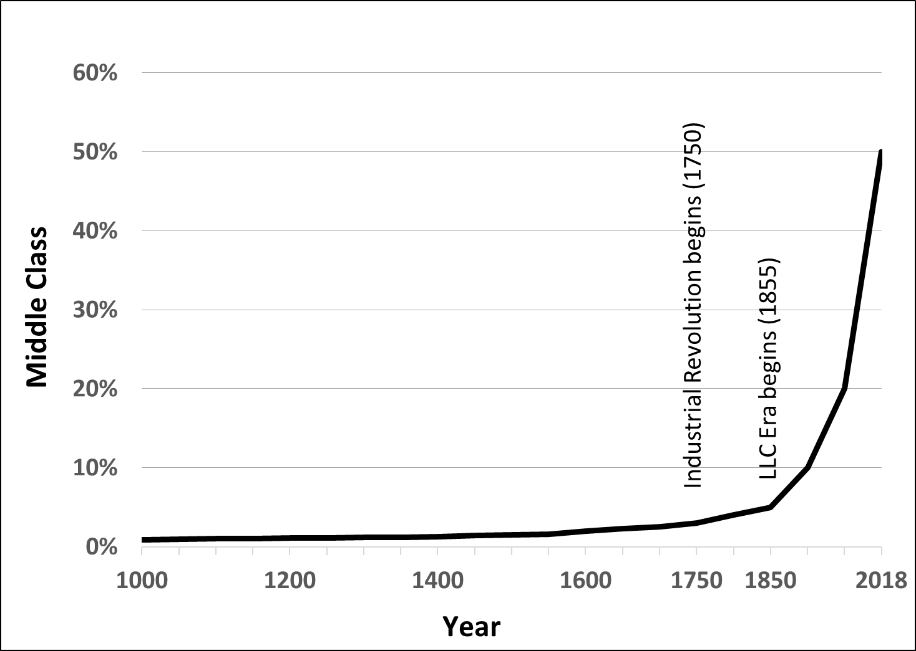
The chart represents the growing economic prosperity worldwide as a function of the growing percentage of the global population that is middle class or higher.

Why Rural Communities Stay Poor Today

While modern economies have mastered the structures that drive innovation and scale in business, science, and governance; many rural communities remain structurally stranded.

Across much of the world, farmers still live and work as they did millennia ago: alone, unintegrated, and economically exposed. They rise early, work hard, and adopt tools when possible, but they do it in complete isolation; planting alone, harvesting alone, selling alone.

They carry 100% of the risk in systems originally designed for survival, yet they must compete in markets built for prosperity, where scale, coordination, and specialization are essential. But how can they possibly do that when their village is not a business entity, their farm is not part of a team, and there is no shared mission to unite them? Worse still, they lack the basic advantages of integrated logistics and collective bargaining power.

This is not a failure of culture, intelligence or effort, but a failure of structure - a mismatch between an outdated design and a modern hyperconnected world.

The traditional village once made perfect sense. It was one of humanity’s most effective survival systems for thousands of years. In a world where trade was rare and trust stopped at the forest’s edge, self-sufficiency was brilliance. A self-sustaining farm in a self-sustaining village wasn’t just efficient, it was essential.

But that world is long gone. Today, value chains span continents, inputs are imported, and customers are global. In a single day, many of us see more strangers than our ancestors saw in a lifetime. The expectation is no longer to survive alone, but to thrive together.

So, the village model, once designed for disconnection, is tragically misaligned with modern complexity. Even with better seeds, more funding, or advanced training, rural transformation stalls. Without a structure for interdependence, energy dissipates, effort turns into exhaustion, hope fades into fatigue and poverty remains rooted in place.

Imagine trying to fly with wings but no cockpit, controls, or shared direction. You may lift off, but you won’t go far. Meanwhile, the global systems that farmers compete against, from certification to compliance, logistics to pricing, are designed for structured actors: companies, cooperatives, and governments.

This is the real tragedy: not poverty itself, but the fact that rural poverty has been made permanent by design. Fortunately, design can be changed. Just as the LLC revolutionized business by protecting risk, organizing effort, and scaling trust, we now need a structural revolution in rural life: one that reduces individual risk, organizes human energy around a shared mission, enables specialization and scale, and transforms scattered individuals into cohesive systems of human potential.

This is not theory; it is structural engineering for human flourishing, and the time to build it is now, before poverty cements itself as our chosen legacy.

Rural poverty is not the result of weak effort or poor intentions. It is the result of structural systems that were once designed for survival but are no longer fit for a complex, interdependent world. The challenge ahead is not simply to provide more aid or better tools, but to design new systems that match the realities of our time.

In Part 2, we will explore what those systems look like and how rethinking structure, through the lens of interdependence, can turn stagnation into sustainable prosperity.

==> Looking for a speaker to introduce revolutionary ideas in agriculture, economics, history, complexity, organizational structures, and the science of prosperity? WhatsApp me at +972-54-2523425

Subscribe here, free of charge!
"Mental and Economic Freedom Are Interconnected."

See you soon,
Nimrod


Dr. Nimrod Israely is the CEO and Founder of Dream Valley and Biofeed companies and the Chairman and Co-founder of the IBMA conference. +972-54-2523425 (WhatsApp), or email nisraely@biofeed.co.il

P.S.

If you missed it, here is a link to last week's blog, “Engineering Prosperity with Purpose: A Novel Model for Rural Transformation “.
P.P.S.
Here are ways we can work together to help your agro sector and rural communities step forward and shift from poverty into ongoing prosperity:
* Nova Kibbutz and consultancy on rural communities' models.

* Local & National programs related to agro-produce export models - Dream Valley global vertical value and supply chain business model and concept connects (a) input suppliers with farmers in developing economies and (b) those farmers with consumers in premium markets.

* Crop protection: Biofeed, an eco-friendly zero-spray control technology and protocol.

You can follow me on LinkedIn, YouTube, and Facebook.
*This article addresses general phenomena. The mention of a country/continent is used for illustration purposes only.

