

View Online and Translate
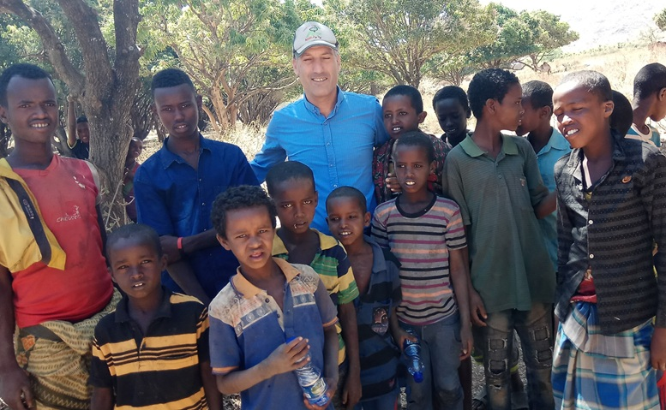
The Role of Entropy Within Genordo
“Entropy explains why things fall apart. Genordo explains how they come together.”

The Question
There is a question that has followed me for months. It is not about agriculture, rural development, or poverty, not even about human societies. It is a question about the deepest law of the universe itself: how creation is generated and formed.
When I began formulating what I now call Genordo, the Universal Law of Increasing Complexity (ULIC), my goal was practical. I was trying to understand why some farmers escape poverty while others remain trapped and why some nations rise while others decline.
I wanted a formula, based on a universal law, that could not only explain poverty and prosperity but also identify the essential elements that move communities from one to the other. More broadly, I sought to understand the growth of complexity, from simple atoms to life, from impoverished rural communities to thriving ones, and to use this knowledge to design a model that can lift farmers and their communities out of poverty.

Entropy
But, as I kept refining the Genordo formula, a deeper question emerged: If Genordo describes the journey from simplicity to complexity, from disorder to order, then what lies at the very beginning of the scale? Is entropy, the force of disorder, part of a separate scale, requiring a separate equation? Or is it simply the first point on the same continuum?
In short, is there one formula for the force building and creating complexity and another, different formula for the force degrading complexity? Or does one formula describe them both?
This question matters not only for scientific elegance but also for practical reasons. If poverty and prosperity are points on the same continuum, governed by the same formula, with poverty simply at the "low end" of the curve, then solutions are within reach. The same logic applies to chaos and order: one formula, with entropy at its lowest point on the scale.
The answer, I believe, is both profound and empowering: Entropy is not a rival to complexity, not the opposite law, but the early state of the same universal law.
The physics of entropy is well established. Boltzmann’s formula tells us: S = k ⋅ ln Ω
Here, S represents entropy, k is Boltzmann’s constant, and Ω is the number of possible microstates, or, in simpler terms, the number of ways energy and particles can arrange themselves. The more scattered and random the energy, the higher the entropy. Entropy always increases in a closed system. But here lies the crucial insight: our world is not a closed system.

Complexity
Earth, for example, receives vast external energy from the sun. Life itself is a story of how this energy is captured, organized, and directed. In doing so, local systems reduce their internal entropy while increasing complexity. This is precisely where entropy ends and Genordo begins.
At the bottom of the complexity scale, energy is scattered, random, without structure or purpose: a state we call entropy. High entropy describes systems where energy flows without purpose or organized direction. The particles are there, and the energy exists, but the system cannot use them to build anything meaningful. It cannot increase complexity.
This raises an even deeper question: can entropy exist outside the framework of Genordo at all? If Genordo describes the full scale of complexity, from its simplest beginnings to its most advanced forms, then entropy is not an external force but the opening chapter of the same story. We conclude that entropy does not stand outside Genordo; it lives within it as its very first step.
As we move up the scale of Genordo and complexity grows, energy is not merely present but channeled through structured forms, creating connections. Atoms combine into molecules, molecules form cells, cells organize into organisms, and organisms form societies. Each of these structures channels energy in a particular direction, enabling the system to increase complexity.
Direction with purpose, both a hurricane and a cell have structure and move energy. But only the cell channels its energy toward a clear and purposeful direction. The same is true for human societies: both a poor village and a thriving economy move energy, but the thriving economy channels it with greater efficiency and purpose.
In the language of Genordo: • Energy input moves from random to directed. • Structure moves from absent to organized. • Direction moves from none to emergent purpose. • Emergent output moves from degradation to creation.
It is important to understand that energy itself is constant, but its flow and form are not. What changes is how energy is captured, concentrated, and channeled. Without structure and direction with purpose, energy remains scattered and inert. Complexity emerges not because of "more energy" but because energy is organized to do meaningful work.

Genordo
This unified view places entropy and emergence capabilities on a single, continuous scale. There is no need for a separate formula for entropy. Entropy simply describes a system at its lowest state: with minimal energy concentration, structure, and direction. This is why I believe Genordo is not just a name but a reflection of reality itself.

Genesis
The ancient biblical story of creation offers a beautiful metaphor for Genordo. In fact, the name itself; Genordo, draws from this source: Genesis for creation and Ordo for order. Genordo is the journey from chaos to creation, from disorder to structure and purpose.
The Bible begins by describing the universe in its earliest state: tohu vavohu: formless and void, pure chaos, pure entropy. Darkness covered the deep, and there was no structure or order.
But energy is already present: "The spirit of God hovered over the waters." The Hebrew word for "spirit" here is ruach, which also means wind, breath, or dynamic force. In other words, motion and energy exist but without direction or structure.
In the Genordo framework, this describes a system at high entropy: energy is present but scattered and inert, not yet captured or organized. Creation begins not with the invention of energy but with its structuring and direction.
"Let there be light." Then comes the separation of light from darkness, the formation of sky, sea, and land, life, and humans, who are given purpose and the ability to name and order the world around them.
In modern scientific language, the first chapter of Genesis perfectly illustrates Genordo. Creation is not a separate force from chaos but the act of structuring existing energy by giving it direction and purpose.
The message is clear and elegant: energy already exists before structure and purpose arrive. It waits, like breath hovering over the waters, to be channeled into form and direction.
Genordo is, in many ways, the scientific echo of this ancient narrative: the continuous journey of using structure to transform energy through direction and purpose.

Name
Another important question is the naming of the law itself. Should it be called the Universal Law of Complexity or the Universal Law of Increasing Complexity?
There is an argument for the simpler name. Calling it the Law of Complexity captures the full range, from entropy to emergence, from randomness to purpose. It is a neutral and complete framing.
However, if we follow the spirit of Genesis, there is also a reason to retain Increasing Complexity. What interests us, as humans, is not to remain neutral but to move along the scale. We want to be in control and understand how to advance from poverty to prosperity, stagnation to growth, and disorder to creation.
My instinct, at least for now, is to keep the focus on the increase. The true power of this law lies not in description but in direction, in showing us how to move forward.

UNIFY
So, where does this leave us?
It leaves us with a beautiful, unified theory: chaos and creation are not separate laws but points on a shared continuum.
It leaves us with hope: just as there is no separate formula for poverty and prosperity, there is no separate formula for entropy and Genordo. Progress depends on using the right structures to channel available energy with purpose and direction. Failure to do so inevitably leads to poverty, hunger, wars, economic crises, and the many things we mistakenly view as misfortunes of fate.
We see, then, that solutions and progress are not mysterious forces or matters of luck. They are the direct result of the choices we make: how we structure and direct the energy already at our disposal.
And it leaves us with a task: to keep walking the scale of increasing complexity, to understand it better, and above all, to use it not merely to explain the past, but to shape the future.
Science and the Bible teach the same lesson: the forces at our disposal are the same ones that build stars and societies, and they can be harnessed to build prosperity. We just need to understand the formula - Genordo - and keep moving forward along its scale.

Appendix: Delving Into the Two Sides of Complexity
Entropy Formula
S = k ⋅ ln Ω
Entropy measures the number of possible configurations of particles in a system. Higher entropy means more disorder and less usable energy. It explains why systems in closed environments naturally drift toward breakdown and disorder.
However, we live in a world of increasing order — a world that works, evolves, and becomes more sophisticated than at any other time in history. Entropy alone does not explain this. Genordo does.

Exporting Entropy and Growing Complexity
Complex systems survive and grow not by avoiding entropy, but by managing it. They do this by exporting entropy outward into their environment. An ecosystem, a living organism, or an economy imports energy and matter, uses them to build internal structures, and exports waste — much of it in the form of heat and disorder. This is not optional; it is the essential strategy of complex systems.
As Nobel laureate Ilya Prigogine demonstrated through his theory of dissipative structures, systems increase their complexity by continuously dissipating waste and entropy into their surroundings. Without this outward flow, systems choke on their own disorder and collapse back down the scale of complexity. This process is not random. It is an essential step on the Genordo path toward complexity.

"Without exporting entropy, systems choke on their own disorder and collapse."

Why Complexity Needs More Than Energy
Raw energy is not enough. Energy without organization becomes heat death. To grow complexity, a system must:
1. Continuously import energy.
2. Build internal structures to channel that energy.
3. Maintain purposeful direction toward emergent outputs.
4. Export entropy to avoid collapse.
This is not philosophy; it is physical law.

Genordo: Completing the Equation
Genordo, the Universal Law of Increasing Complexity, completes the picture. It explains how systems rise along the scale of complexity, turning random flows of energy into structured, purposeful emergence: new molecules, new life forms, new technologies, and new societies, all possessing emergent capabilities.
Without Genordo, the entropy formula explains only decline. With Genordo, we see the full story of progress.

The Continuum of Complexity (Genordo Path)
All systems follow the same universal path from chaos to complexity. Yet, their outcomes differ based on the quality of their package: the strength of energy flow, the coherence of structure, and the clarity of direction.
We can visualize this journey along the scales of complexity through what I call the Genordo Path. This path captures how systems rise from scattered energy to emergent capabilities, through structure and purposeful direction.

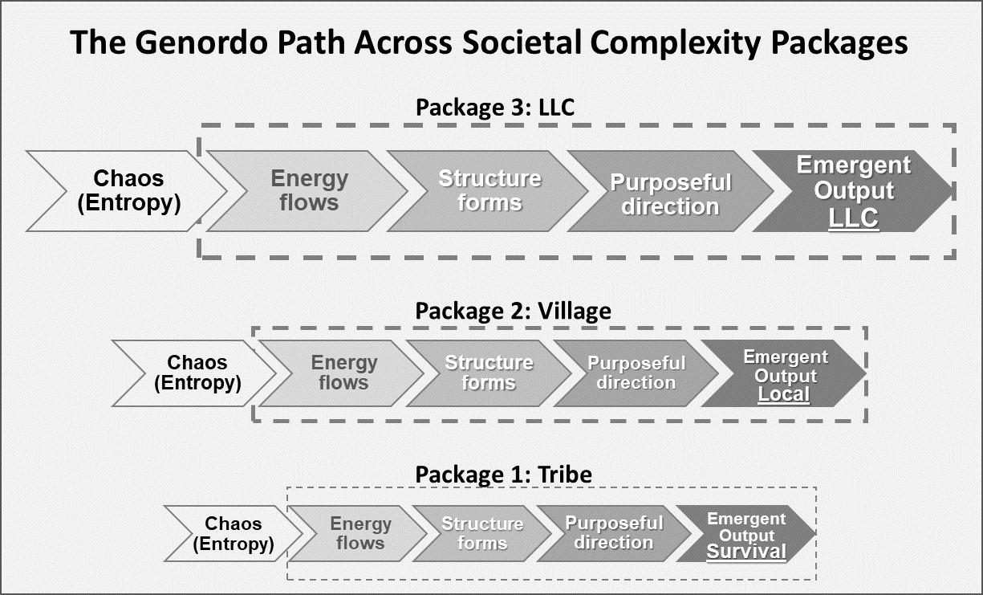
Figure: The Genordo path across societal complexity packages. All systems follow the same universal path from chaos to complexity. Their outcomes, however, depend on the quality of their package: energy flow, structure, and direction. A tribe operates with low energy, informal structure, and a survival focus. A village builds moderate energy, growing structure, and a local economy. An LLC operates with high energy, scalable structure, and integration into the global economy. The stronger the package, the greater the emergent output.

==> Looking for a speaker to introduce revolutionary ideas in agriculture, economics, history, complexity, Kibbutz, organizational structures, prosperity, and related topics? WhatsApp me at +972-54-2523425

Subscribe here, free of charge!
"Mental and Economic Freedom Are Interconnected."

See you soon,
Nimrod


Dr. Nimrod Israely is the CEO and Founder of Dream Valley and Biofeed companies and the Chairman and Co-founder of the IBMA conference. +972-54-2523425 (WhatsApp), or email nisraely@biofeed.co.il

P.S.
If you missed it, here is a link to last week's blog, “Seven Revolutions: The Structural Journey of Humanity from Tribes to Corporations”.
P.P.S.
Here are ways we can work together to help your agro sector and rural communities step forward and shift from poverty into ongoing prosperity:
* Nova Kibbutz and consultancy on rural communities' models.

* Local & National programs related to agro-produce export models - Dream Valley global vertical value and supply chain business model and concept connects (a) input suppliers with farmers in developing economies and (b) those farmers with consumers in premium markets.

* Crop protection: Biofeed, an eco-friendly zero-spray control technology and protocol.

You can follow me on LinkedIn, YouTube, and Facebook.
*This article addresses general phenomena. The mention of a country/continent is used for illustration purposes only.

