

View Online and Translate
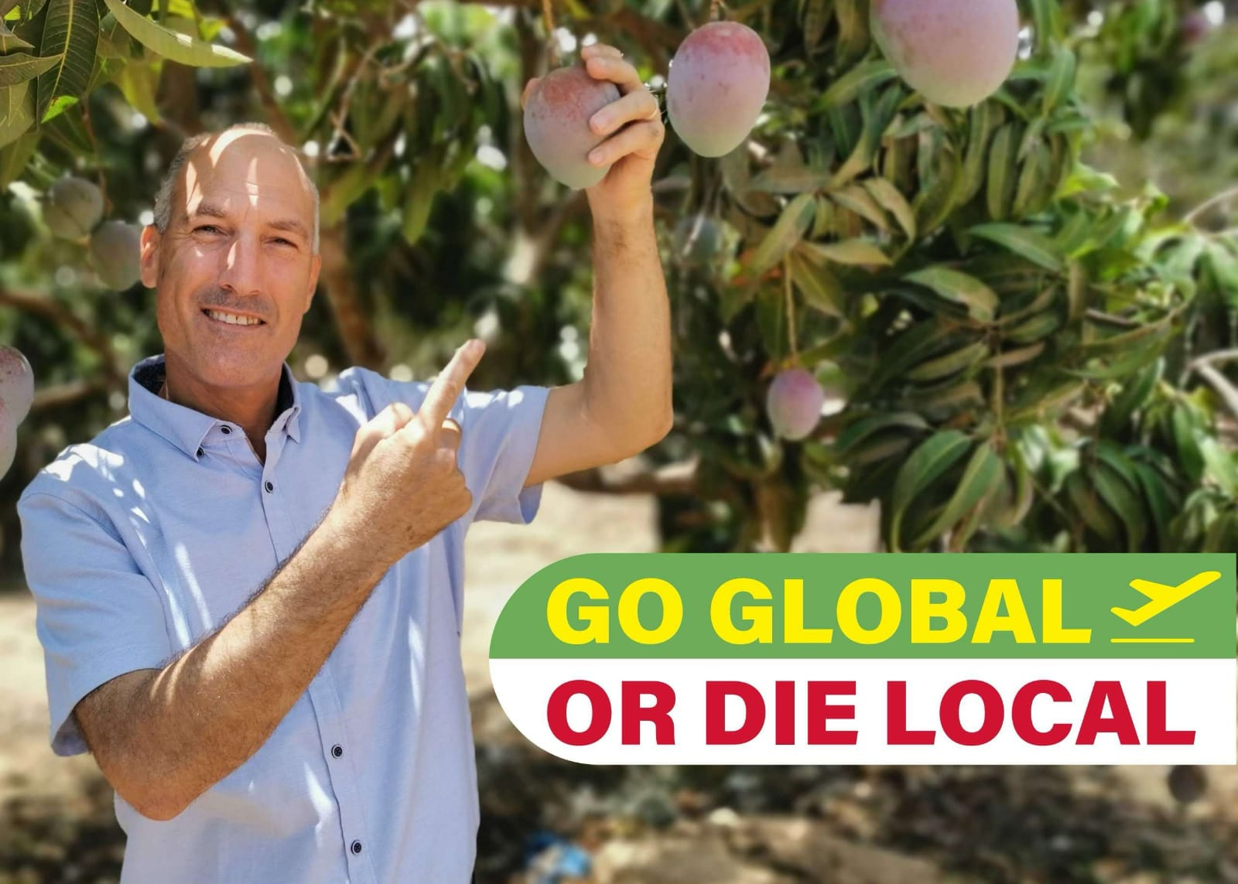

Go Global or Die Local
The Universal Secret of Thriving Systems: Flow Out or Fail

“No complex economic system can remain viable without exports.”

In my previous column, I argued that entropy is not the enemy of complexity but its beginning, the first rung on the ladder of what I now call Genordo, the Universal Law of Increasing Complexity. Just as darkness is not a force in itself but the absence of light, entropy is not an opposing power but the lowest state of complexity: disordered, scattered, and lacking direction.
But if complexity does not arise in opposition to entropy, but instead grows out of it, a deeper question emerges: what sustains complexity and makes it grow once it begins to form?
But if complexity doesn’t arise in opposition to entropy, but rather grows from it, a deeper question emerges: what allows complexity to keep evolving once it begins to form?
This isn’t a philosophical puzzle. It’s a biological, economic, and structural one. Complex systems don’t just need energy to grow; they need a continuous, directed flow to sustain that growth. And because Genordo describes open systems, that flow must involve regular exchange with the external environment of energy, materials, or information. Without that exchange, the system cannot advance. It stalls, stagnates, and eventually breaks down.
Whether a plant releases oxygen, an animal sweats to cool down, or a business exports goods, no complex system can grow without an outward flow. To survive, a system must release, or "export," part of what it generates.
Think of a company as a living organism: if it fails to release its waste or sell its products and services, entropy builds up internally: inventory accumulates, cash flow freezes, and the system begins to choke on its own output. In the language of Genordo, even production becomes a form of entropy- a kind of internal waste, if it cannot be released outward into the market. In this light, selling is exporting, and exporting is survival. What doesn’t flow outward turns toxic.
This isn’t an economic recommendation, nor is it globalization as ideology: it stems from the ULIC. Regardless of the reason, when systems’ outward flow is blocked by fear, isolation, inefficiency, or excessive control, they collapse under their own internal disorder.
Years ago, long before I had a name for this law, I coined a slogan to promote fresh produce exports in developing economies: Go Global or Die Local. At the time, it was practical business advice. Today, I see it for what it truly is: a universal principle.

The Solonist Trap
I’ve met hundreds of smallholder farmers across developing economies. These men and women rise with the sun, work with care, and live with dignity. They grow mangoes, avocados, cashews, and coffee, and they know their land intimately. And yet, year after year, most remain poor. Their yields may rise, their knowledge may deepen, and their tools may improve, but their livelihoods do not. How can that be? Because the structure they operate within lacks something essential: outward flow.
These farmers, whom I call solonists, work alone. They plant, harvest, and sell within the boundaries of their village or region. Their labor and products are real, but the energy of their work stays locked in a closed local loop, never exported outside it.
From a distance, it may appear like a self-reliant community, which many experts advocate for. But from a systems perspective, it’s more like a sealed container. There’s no external outlet for the surplus, no channel for exporting production, no network for absorbing shock or spreading risk. In other words, there is no relief valve for entropy. And the result is visible in the distance their produce travels.
If a farmer’s crop never leaves the field, say, because of pests, spoilage, or lack of market, 100% of the energy remains trapped. Entropy is at its peak. No complexity is created. Prosperity is near zero.
If the same crop makes it to the local village market, some entropy is released. Energy has moved, structure has formed, and a small amount of complexity and income is created.
But if that same mango travels hundreds or even thousands of kilometers, crossing national borders, and reaching a European supermarket or an urban wholesaler, a new kind of complexity emerges. Infrastructure is activated, cold chains are built, partnerships are formed, logistics are coordinated, and standards are met.
In that process, energy is transformed into structure, structure into direction, and direction into emergent prosperity.
The farther the product moves along the supply chain and the higher its perceived value, the more entropy can be exported from the local system and the more complexity can be built through structure, logistics, and market interaction. The farmer benefits, and so does the region and the country.
That’s why the solonist farming structure fails: it traps energy in the wrong place. Farmers work harder, but because they’re disconnected from global markets, their products remain local, valued only within a closed system, and priced accordingly. Without outward flow, the system slowly chokes on its own effort.
You can’t sell your way out of poverty if no one outside your village is buying. Solonism, under Genordo, isn’t just a limitation; it’s a structural dead end.

When Good Intentions Violate Universal Law
This insight reframes one of the most common strategies in global development: helping solonist farmers increase productivity. Year after year, billions $ are invested in better seeds, fertilizers, tools, and training; all aimed at boosting yield. And often, these programs succeed in raising output.
But when outward flow is not addressed — when farmers lack access to distant markets where perceived value is higher, lack effective sales channels, and lack the infrastructure to move their produce beyond the local system, all that additional energy stays trapped inside.
The result? A system that chokes on its own success.
Higher yields turn into unsold surplus: crops rot, prices crash, stress rises, the farmer must work harder than ever, and yet sinks deeper into poverty.
We see this pattern across almost every crop at the height of harvest season. In mango-producing regions, for example, when there’s no export channel, the domestic market floods, and prices collapse. Many farmers can’t sell their produce at all, not because the fruit is bad, but because the system has no outlet. The energy stays inside. Entropy builds. Frustration follows.
But when export channels are active, the opposite occurs: farmers reach distant, higher-value markets, and domestic prices rise, benefiting even local sellers, who enjoy higher prices. The system breathes. Energy flows outward. Prosperity is shared.
The challenge of releasing entropy runs even deeper. In many regions, pests like fruit flies destroy up to 50% of the crop before it ever leaves the field. Even when productivity rises, for example, with support from NGOs, the percentage of loss often remains unchanged. The result? More fruit, more effort… and more waste.
From a complexity standpoint, this is disastrous: output grows, but complexity doesn’t. Entropy increases instead. The farmer has invested more energy, but if the fruit stays in the field, whether due to pests or poor market access, the system doesn't evolve. It stagnates, then collapses.
These examples reveal a hard truth: growing more is not enough. What matters is what happens after the harvest, whether the system can remove disorder and extract value by exporting output to the highest-value destination possible. In Genordo’s terms, productivity without flow increases entropy, not prosperity. This is not a theoretical risk; it’s the lived reality of rural economies in developing countries: more output, less income, more effort, less stability, more training, less hope.
What’s missing isn’t energy; it is its release through channeling to export out of the local system. Without outward flow to distant, better-paying markets, the farmer’s effort has nowhere to go. And when energy can’t leave the system, it doesn’t generate prosperity; it builds pressure, increases entropy, and traps communities in persistent poverty.

From Cells to Cities: Outward Flow Is a Universal Requirement
The tragedy of solonist farmers is not an agricultural failure. It is a universal law that is violated. Any system that grows, whether biological, social, or economic, must move energy. It must not only absorb energy but also organize it and release what it cannot use.
This is obvious in biological cells: a cell absorbs nutrients, performs internal work, and expels waste. If it fails to do so, toxins build up, and the cell dies. The same goes for any living organisms.
The same rule applies in cities. Urban centers consume energy, food, information, and people, but they must also export waste, traffic, heat, and disorder. A city that fails to manage this flow becomes dysfunctional.
It's the same in companies: a business that produces goods but cannot sell them collapses under inventory, cost, and stress. A product without a buyer becomes not an asset but a burden.
Even Earth follows this principle. The planet receives solar energy but must radiate excess heat into space. Without that export, life would be impossible.
This is not a coincidence, it is Genordo in motion.
The Universal Law of Increasing Complexity states that systems rise in complexity only when they: (a) absorb energy, (b) build structure, (c) follow purposeful direction, and (d) outward flow (entropy export). Without that final step, the outward flow, the system stalls, overheats, or collapses.
That’s why export is not about globalization or ideology; it’s about entropy management and survival. Complexity requires more than energy. It requires movement. The system must flow, release waste, and follow a clear direction. Only then can energy be transformed into complexity.
Prosperity, then, is not defined by the presence of resources, but by the presence of a flow system, one capable of transforming incoming energy into structured, purposeful complexity, and releasing what cannot be used far enough outward to avoid internal collapse.
Every thriving system on Earth, from cells to cities and from bacteria to businesses, follows this law. Those that fail to flow collapse, and those that survive without outward flow stagnate; they may survive, but never prosper.

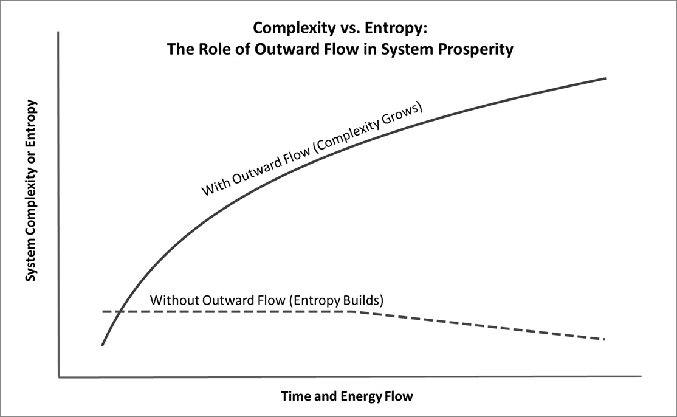
Figure: Systems that enable outward flow, whether cells, farms, or economies, transform incoming energy into rising complexity through structure and direction. When that flow is blocked, energy accumulates as internal disorder. Outward flow is not a luxury; it is a structural condition for survival and prosperity.

Designing Systems That Flow
If we accept that economic prosperity depends not only on what we produce but on how far that production flows and the level of perceived value it reaches, then it becomes clear why so many well-meaning development programs fall short.
They focus on inputs: seeds, tools, training, and sometimes on outputs, like higher yield. But they rarely concentrate on flow: on how that yield moves, where it goes, what structure carries it, and how far its value travels before it collapses back into entropy.
A mango on a tree holds no value until it reaches a buyer. A buyer across the street creates a little value, while a buyer across the ocean creates a lot. But reaching that buyer requires an advanced structure, clear direction, and outward flow, not just fruit.
The same applies to ideas, technologies, and policies; a brilliant solution that stays in a PDF on a government server is entropy. The same solution implemented across regions is complexity. This is the design challenge: to build systems that don’t just grow, but flow.
In agriculture, this means investing not only in farms but also in trade routes, cooperatives, export infrastructure, standards, branding, and logistics. It means designing for movement across distances, sectors, and borders.
In rural development, it means we should measure success not by tons harvested, but by entropy exported and complexity created, in the form of income, networks, resilience, and reputation.
In business, it means creating not just production capacity, but channels for constant release, so that effort turns into structure, structure into direction, and direction into prosperity. Prosperity isn’t the reward at the end; it results from sustained outward flow.
When we shift from asking “How much can we grow?” to asking “How far can we flow?” everything changes. We must stop designing programs that choke on their own output, stop blaming farmers for not escaping poverty, and stop mistaking activity for transformation. And we start building systems and societies that rise.

From Growth to Flow, My Turning Point
For many years, I believed what so many development experts still believe today: that the path to prosperity begins with better productivity. If farmers could grow more, with fewer losses, at higher quality, prosperity would follow.
I poured myself into that mission. At Biofeed, I spent years developing Freedome, a breakthrough zero-spray solution that controls fruit flies and prevents infestation. It worked. Farmers saw dramatic improvements in both the quantity and quality of their produce. But one thing didn’t change: their ability to profit.
It was painful, confusing, and even disheartening. I had given them a better tool, but their lives remained much the same. This forced me to look deeper, and what I saw changed everything. The problem wasn’t what they were producing, but where it went, or didn’t go.
High-quality fruit that never leaves the farm or even the country because of pests or a lack of premium markets increases entropy. That insight led me to create Dream Valley, not as an extension of Biofeed but as a completely different kind of system: one designed to help national agro sectors move and flow so that they can prosper.
Dream Valley was built to help farmers grow better produce and export it as far as possible to the highest-paying markets. Its purpose is to help them release the energy they’ve generated, now embodied in fresh fruit, and in doing so, unlock income, dignity, and stability.
In Genordo's language, it was about more than trade. It was about entropy management, about turning trapped energy into structure, direction, and prosperity.
That shift from increasing production to engineering flow didn’t just change my work; it changed how I see the world. Today, I know: a system that doesn’t flow cannot rise, a farmer who cannot export cannot prosper, and a society that can’t release its own energy will eventually choke on its own success.
Looking back, I see it clearly now: “Go Global or Die Local” was never a slogan. It was a law waiting to be discovered.
What I’ve come to understand is this: Prosperity doesn’t come from doing more, but from releasing and moving more. It begins the moment we stop holding energy in and start building structures that let it flow outward, with direction and purpose.

==> Looking for a speaker to introduce revolutionary ideas in agriculture, economics, history, complexity, organizational structures, and the science of prosperity? WhatsApp me at +972-54-2523425

Subscribe here, free of charge!
"Mental and Economic Freedom Are Interconnected."

See you soon,
Nimrod


Dr. Nimrod Israely is the CEO and Founder of Dream Valley and Biofeed companies and the Chairman and Co-founder of the IBMA conference. +972-54-2523425 (WhatsApp), or email nisraely@biofeed.co.il

P.S.
If you missed it, here is a link to last week's blog, “The Role of Entropy Within Genordo“.
P.P.S.
Here are ways we can work together to help your agro sector and rural communities step forward and shift from poverty into ongoing prosperity:
* Nova Kibbutz and consultancy on rural communities' models.

* Local & National programs related to agro-produce export models - Dream Valley global vertical value and supply chain business model and concept connects (a) input suppliers with farmers in developing economies and (b) those farmers with consumers in premium markets.

* Crop protection: Biofeed, an eco-friendly zero-spray control technology and protocol.

You can follow me on LinkedIn, YouTube, and Facebook.
*This article addresses general phenomena. The mention of a country/continent is used for illustration purposes only.

