

View Online and Translate

Seven Revolutions: The Structural Journey of Humanity from Tribes to Corporations
“We thrive when we work together, yet we are wired to drift apart.”

Complexity-Driven Historical Analysis
The progression of human societies follows a clear pattern: economic and technological complexity (ETC) has steadily increased, while community social complexity (CSC) has fluctuated and declined overall since the Neolithic Revolution, which the Agricultural Revolution is part of. This shift occurred as economic structures expanded beyond small, interdependent groups. The Universal Law of Increasing Complexity (ULIC) provides a framework for understanding these transformations, particularly in how societies balance internal cohesion (IN) - the strength of social bonds, and external integration (E) - their level of economic and technological interconnectivity.
» Internal Cohesion (IN): The degree of social and emotional bonds within a society, trust, shared identity, mutual support.
» External Integration (E): The level of economic and technological connectivity a society has, trade, governance, financial systems, scientific advancements.
As the graph trends indicate, a key pattern emerges: economic expansion and technological advancement have often come at the expense of social cohesion, leading to increased external integration (E) but declining internal cohesion (IN).

To better understand this trade-off and its implications for the future, we must examine how different societal structures have historically navigated the balance between economic progress and social stability. By doing so, we can assess whether the Universal Law of Increasing Complexity (ULIC) consistently explains the rise and fall of civilizations and whether it can serve as a predictive tool for designing more resilient socio-economic models.

Let’s explore how ULIC and complexity manifest across seven key organizational structure revolutions in human history.

1. The Hunter-Gatherer Era: Peak Social Complexity, Minimal Economic Growth

For millions of years, early hominins lived in small, tightly-knit bands of 30-50 individuals, where survival depended on close social bonds, cooperation, and shared resources. However, the Linguistic Revolution (~70,000 years ago) transformed human societies by dramatically increasing their capacity for communication, coordination, and abstract thought.

● Social Structure:
- Pre-Linguistic Era: Small foraging bands of 30-50 members with high interdependence.
- Post-Linguistic Era: More complex tribal groups (100-150 members), forming stable, face-to-face communities. Larger coalitions (300-1,000+ members) began emerging for seasonal gatherings, alliances, and shared rituals.

● Economic Model: Subsistence-based economy with minimal surplus. Food and resources were shared within small groups, preventing wealth accumulation.

● ULIC Perspective: Strong Internal Cohesion (IN): Close-knit relationships, deep social interdependence. Limited External Integration (E): Small-scale economies, minimal long-distance trade.

The Linguistic Revolution allowed human groups to form myths, establish shared identities, and organize beyond kinship ties. This marked the first step toward larger cooperative societies, setting the stage for the later shift to settled life.

2. Villages and The Agricultural Revolution: Economic Complexity Surges, Social Complexity Begins to Decline

The transition to agriculture (~12,000 years ago) was a turning point in human history, fundamentally reshaping economic and social structures. As early humans shifted from hunter-gatherer lifestyles to farming, their settlements grew, and societies became less egalitarian.

● Social Structure: Between 12,000 and 6,000 years ago, early agricultural villages emerged in fertile regions, enabling larger, semi-permanent settlements. Kinship groups initially remained central, but as food surpluses grew, social stratification took hold. Traditional tribal bonds (100-150 members) weakened, giving way to settlements of hundreds or thousands, requiring governance and hierarchy. The rise of chiefs, ruling elites, and priestly classes marked the shift to centralized power, replacing the egalitarianism of earlier societies. Social roles became rigid, and status was increasingly tied to wealth and land ownership. This transition laid the groundwork for cities, organized economies, and large-scale governance, shaping the civilizations that followed.

● Economic Model: Food surpluses enabled the rise of private property, trade, and occupational specialization (e.g., potters, blacksmiths, traders). As settlements expanded, value and supply chains developed to serve growing markets, laying the groundwork for early economic systems.

● ULIC Perspective: Rapid increase in External Integration (E): Surplus food enabled trade and larger economic systems. Decline in Internal Cohesion (IN): Traditional interdependent tribal bonds weakened, replaced by hierarchical structure.

For the first time in history, economic and social complexity began to diverge. While early villages still maintained some communal aspects, the shift toward accumulated wealth, land ownership, and rigid social structures led to inequality and hierarchy. This transition set the stage for the rise of cities, empires, and bureaucratic governance.

3. Early Cities & Ancient Civilizations: Bureaucratic Growth, Declining Social Bonds

The rise of city-states and early civilizations marked a turning point in human history. As economies grew more sophisticated, social structures became more hierarchical, and kinship-based networks were replaced by bureaucratic governance.

● Social Structure: Hierarchical societies with rigid class divisions, where bureaucracies replaced kinship-based systems. Power became centralized under rulers, priestly elites, and administrative institutions.

● Economic Model: Driven by large-scale trade, labor specialization, and early financial instruments such as currency, taxation, and formalized contracts.

● ULIC Perspective: External integration (E) expanded, enabling greater economic and technological advancements, but internal cohesion (IN) declined, as societies grew beyond familiar kinship structures, leading to urban isolation and social fragmentation.

While economic prosperity surged, social bonds weakened, reducing emotional security and the communal support systems that had once defined human life. This shift paved the way for empires, institutional governance, and large-scale economies, but at the cost of weakening interpersonal connections.

4. Feudalism & Mercantilism: Stability with Limited Scalability

Feudalism established a semi-stable social order, where localized, community-based structures provided security but constrained large-scale economic progress. The rigid hierarchy of lords, vassals, and serfs created a system of mutual dependence, yet mobility and innovation remained limited.

● Social Structure: Localized feudal estates functioned as self-sufficient units, where serfs depended on lords for protection. While community bonds remained strong, the rigid hierarchy restricted social mobility.

● Economic Model: Agriculture-based economy with limited trade. Wealth was tied to land ownership, and economic activity was largely localized, except for controlled trade routes.

● ULIC Perspective: Moderate internal cohesion (IN) provided social stability, but external integration (E) remained low, limiting large-scale economic expansion.

With the rise of mercantilism, economic complexity increased as global trade networks expanded, yet heavy state control and protectionist policies prevented economies from scaling beyond national boundaries. While commerce and early banking systems grew, economic progress remained constrained by monopolistic trade practices and government-imposed restrictions.

5. Industrial Capitalism & The Nation-State: Rapid Expansion, Declining Local Cohesion

The Industrial Revolution (18th-19th centuries) fundamentally reshaped human societies by shifting economies from agrarian production to mechanized industry. The emergence of factories, mass production, and urbanization led to an unprecedented surge in economic and technological complexity. Simultaneously, the nation-state became the dominant form of political organization, replacing feudal and monarchic systems with centralized governance, legal standardization, and state-backed capitalism.

● Social Structure: Traditional community-based living gave way to urban wage labor, where individuals relied on corporations rather than local kinship networks for survival. While national identity and civic institutions replaced feudal loyalties, local communities became less interdependent.

● Economic Model: Mass production, mechanization, and industrial finance enabled large-scale economic growth. The emergence of corporations, banks, and stock markets allowed for unprecedented capital accumulation and wealth concentration.

● ULIC Perspective: External integration (E) surged as global trade and industrial economies scaled rapidly. However, internal cohesion (IN) declined as industrial societies fragmented traditional social units, replacing interdependent communities with bureaucratic governance, and individualistic labor markets.

While industrial capitalism raised living standards, it also eroded traditional forms of community, widened wealth gaps, and created large-scale economic dependencies, leading to both prosperity and societal instability.

6. The Limited Liability Corporation (LLC) Revolution & The Digital Age: Peak Economic Complexity, Minimal Social Cohesion – and Attempts to Rebalance

The Limited Liability Corporation (LLC), introduced in the 19th century, transformed economies by separating ownership from liability, enabling unprecedented scalability. This model perfected external integration (E), driving global trade, corporate expansion, and financial markets, making economies more interconnected and efficient than ever before.

In the 20th and 21st centuries, the Digital and AI Age extended these dynamics further. Multinational tech corporations, financial markets, and automation detached economic activity from human-scale relationships, reinforcing individualistic labor structures, remote work, and digital transactions as primary economic drivers.

While these advancements maximized economic and technological complexity (ETC), they came at a severe cost to community social complexity (CSC), as corporate and digital systems replaced traditional community networks.

● Social Structure: The LLC and corporate-driven economies replaced local, kinship-based communities with individualistic, profit-driven structures. As work and economic security became tied to corporations rather than communal or familial ties, social bonds weakened, and people became increasingly reliant on institutions rather than personal relationships.

● Economic Model: The corporate capitalist system allowed for unlimited growth and global trade, leading to mass production, financial markets, and digital economies that transcended national and local economies. AI and automation further disconnected labor from production, reducing human interdependence in work structures.

● ULIC Perspective: External integration (E) reached its peak, but internal cohesion (IN) hit historic lows as traditional social structures eroded under corporate expansion and digital fragmentation. The LLC model succeeded in scaling wealth and efficiency, but at the cost of eroding human bonds and reducing community resilience.

7. The Kibbutz: A Working Model for Harmonizing Economic and Social Complexity

As the LLC reached its peak, some novel models emerged to counterbalance the extreme social fragmentation it created. Among the most structured and deliberate of these was the Kibbutz movement in Israel in the early 20th-century.

Unlike traditional socialist experiments, Kibbutzim embraced the scalability of industrial and corporate economies while preserving strong internal social bonds. Their model combined shared ownership, communal decision-making, and economic cooperation, ensuring that technological progress did not come at the expense of human well-being and emotional security.

Notably, the core debate in the Kibbutz’s early years wasn’t economic, it was social: Should the Kibbutz remain small and intimate, or expand into larger collective structures?

This reveals that the Kibbutz was not merely an alternative economic model, but an attempt to redesign human social organization to maintain the cohesion that had been eroded by industrial capitalism.

● Social Structure: Kibbutzim maintained close-knit, cooperative communities with strong social bonds, where members shared resources and responsibilities, avoiding the alienation common in both rural villages and urban corporate economies.
● Economic Model: While initially agrarian, Kibbutzim adapted industrial and technological advancements, proving that a highly productive economy could coexist with strong social ties.
● ULIC Perspective: The Kibbutz’s organizational structure balances IN and E, demonstrating that economic complexity (ETC) and community social complexity (CSC) do not have to be at odds. While they did not scale to replace corporate capitalism, they offered a working model for integrating economic efficiency with human-centered social structures.

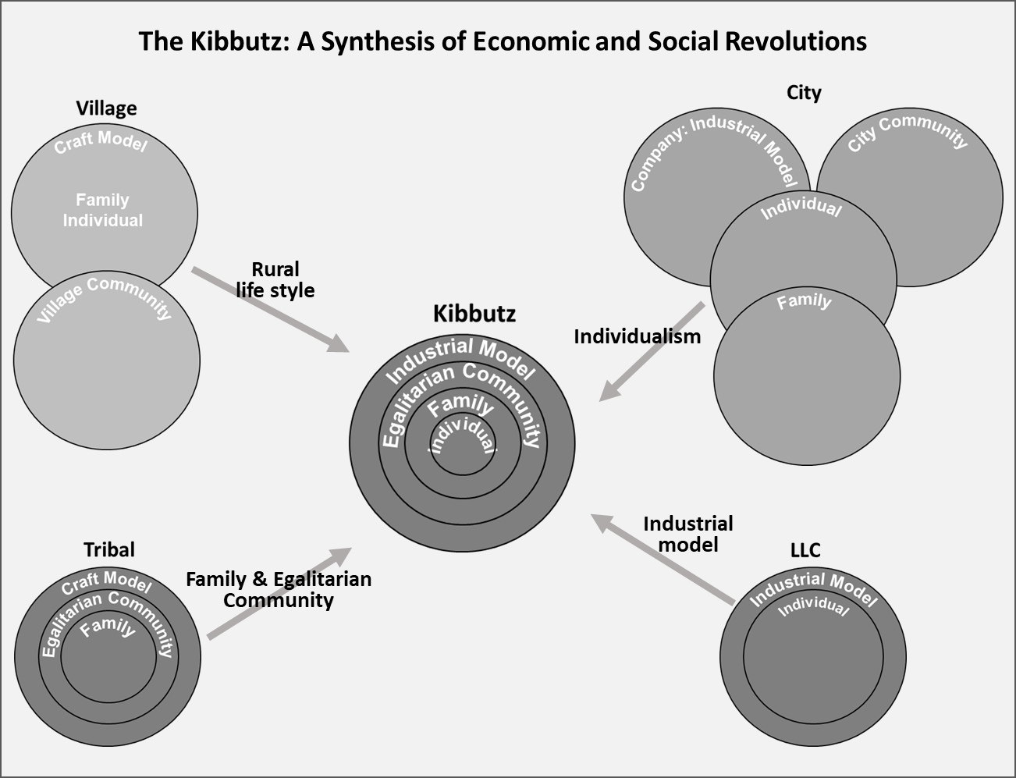
Figure: The Kibbutz model integrates elements from tribal, village, and industrial structures—combining communal bonds with economic scalability. Unlike other models that moved toward individualism, the Kibbutz preserves internal cohesion while adopting the tools of modern economic systems.

Insights: The Sixth Revolution as a Crossroads

The LLC enabled unparalleled economic growth, but it also created a world where individuals depend on corporations and digital economies rather than community networks. As a result, humanity faces a critical choice: Continue scaling economic complexity at the cost of eroding human bonds. Or, find ways to restructure societies and economies to integrate both prosperity and community cohesion.

The Kibbutz movement remains one of the few proven models demonstrating that economic and social complexity can thrive together. Moving forward, societies will need new models that balance external integration (E) with internal cohesion (IN), ensuring that economic progress serves not just markets but human well-being itself.
Before dismissing the Kibbutz model, consider this: for 2.5 million years, hominins lived in bands, groups, and tribes, mostly as nomadic foragers. Only 12,000 years ago, early villages and agriculture appeared, and even then, it took another 6,000 years for villages to house 50% of the global population. When that threshold was crossed, the first cities emerged (6,000 years ago), introducing new economic and social structures that reshaped human life.
Today, with 50% of the world's population living in cities, the divergence between economic and social complexity is at its peak. We are once again at a threshold. If history is any indication, the next phase of human organization is already taking shape, whether we recognize it or not.
Will we take an active role in shaping a model that reconnects economic progress with human cohesion, or will we let it unfold at the cost of even deeper social fragmentation?

The Big Picture: Complexity, Prosperity, and the Future of Human Societies
From the earliest hunter-gatherer bands to today’s highly networked global economies, human civilization has been shaped by a constant tension between economic and technological expansion on the one hand and the cohesion of social structures on the other. For millions of years, community and economy evolved in tandem, supporting deeply interdependent societies.
The Linguistic Revolution allowed larger coalitions to emerge, strengthening both social and economic complexity. However, the Agricultural Revolution marked the first great divergence: as food surpluses enabled the rise of villages and cities, economic complexity accelerated, while the tribal bonds that had defined human interaction for millennia began to weaken.
Each subsequent transformation, cities, empires, feudalism, industrial capitalism, and the rise of corporations, further widened this gap. As external integration (E) through trade, finance and technology grew, internal cohesion (IN), the depth of human social bonds, steadily declined. The Limited Liability Corporation (LLC) Revolution, and later the Digital & AI Age, brought economic and technological complexity to unprecedented heights, but they also fragmented communities, turning economic security into an individual rather than a collective responsibility. Today, we stand at the peak of this divergence: an era of hyper-connected global commerce but increasingly disconnected human relationships.
History suggests that civilizations that fail to balance economic growth with social cohesion risk collapse. The Kibbutz movement and similar experiments in communal living serve as reminders that there are alternative paths and models that embrace economic efficiency without abandoning the deep human need engraved in our biology and genes for connection and belonging.
The question we must ask ourselves is this: Can we redesign our institutions, economies, and technologies in ways that restore the balance between external integration and internal cohesion? Can we move beyond a system that maximizes economic output while eroding social bonds and instead create one that fosters both prosperity and human well-being?
The answer to these questions may determine the future trajectory of civilization itself.

Takeaways
» Social cohesion weakens when structure scales without shared purpose or connection.
» History reveals: prosperity without community leads to fragmentation and fragility.
» Kibbutzim prove economic scale can coexist with social depth.

==> Looking for a speaker to introduce revolutionary ideas in agriculture, economics, history, complexity, organizational structures, and the science of prosperity? WhatsApp me at +972-54-2523425

Subscribe here, free of charge!
"Mental and Economic Freedom Are Interconnected."

See you soon,
Nimrod


Dr. Nimrod Israely is the CEO and Founder of Dream Valley and Biofeed companies and the Chairman and Co-founder of the IBMA conference. +972-54-2523425 (WhatsApp), or email nisraely@biofeed.co.il

P.S.
If you missed it, here is a link to last week's blog, “Did Our Economy Split from Our Social Needs?”.
P.P.S.
Here are ways we can work together to help your agro sector and rural communities step forward and shift from poverty into ongoing prosperity:
* Nova Kibbutz and consultancy on rural communities' models.

* Local & National programs related to agro-produce export models - Dream Valley global vertical value and supply chain business model and concept connects (a) input suppliers with farmers in developing economies and (b) those farmers with consumers in premium markets.

* Crop protection: Biofeed, an eco-friendly zero-spray control technology and protocol.

You can follow me on LinkedIn, YouTube, and Facebook.
*This article addresses general phenomena. The mention of a country/continent is used for illustration purposes only.

