

View Online and Translate
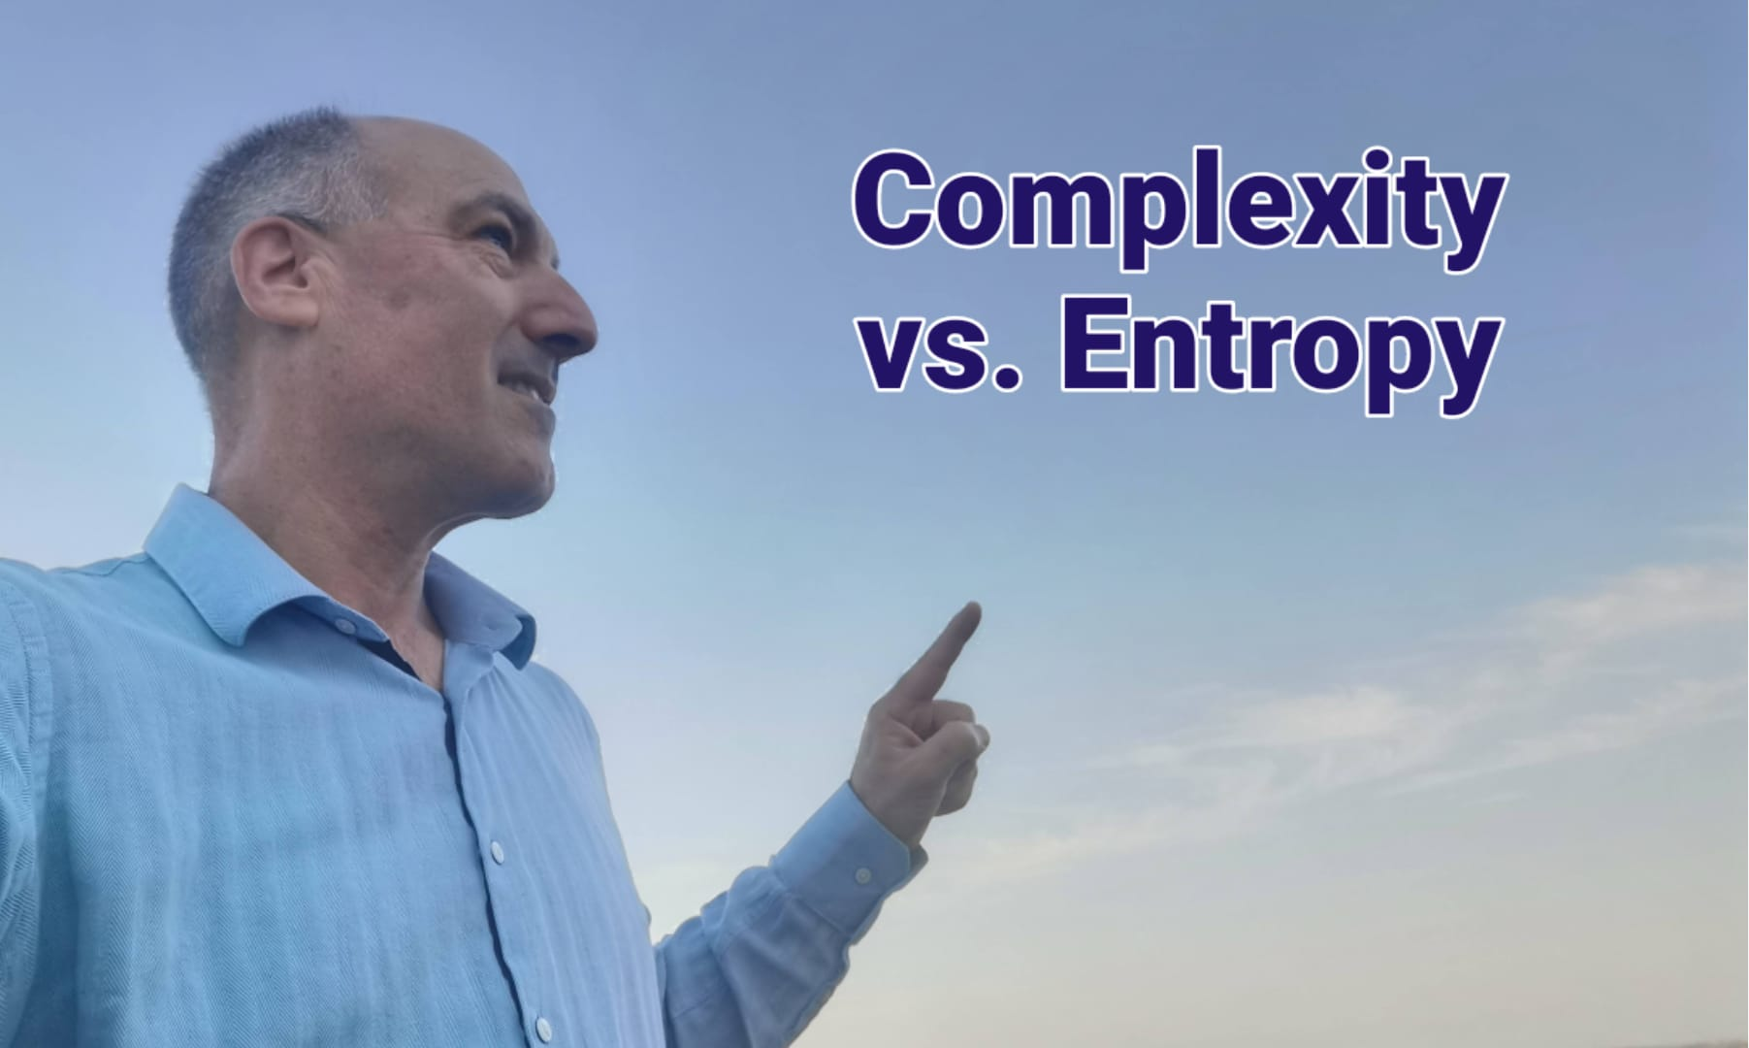

Does The Universal Law of Increasing Complexity Contradict Entropy?

"Shaped by universal laws, poverty must also be understood, explained, and managed within them"

Across all cultures and beliefs, whether religious or atheist, humans share a deep-seated conviction that life, the universe, and our experiences are not merely a string of random events. We instinctively seek patterns, principles, and explanations—searching for the blueprint that shapes existence. As Albert Einstein famously remarked, when referring to the universe, “God does not play dice”, reflecting the belief that order, not randomness, underlies reality and that predictable laws, some yet to be discovered, govern our world.
As a scientist, my mission is to uncover this blueprint. As a human fellow, it is part of my duty to translate these insights into practical applications that anyone can apply to improve human well-being. As an entrepreneur with a social conscience, I measure success not by abstract discoveries or financial gains alone but by their real-world impact on people’s lives.
This pursuit of understanding is not a detached academic exercise; it is an urgent, practical endeavor to shape a better future.
Just as uncovering the laws of aerodynamics allowed humans to fly, understanding the fundamental laws that govern prosperity can enable us to engineer a world where poverty is no longer an enigma but a solvable equation. When that happens, prosperity, like flight is, will no longer be a distant dream for hundreds of millions but a reality within reach for every farmer.
* If you haven't read the previous column, I strongly recommend that you stop here and read it before continuing: The Universal Law of Increasing Complexity.

The Role of Scientific Laws
Imagine, 50,000 years ago, a couple standing atop of a hill, watching a majestic bird soar effortlessly through the sky. The linguistic and cultural revolution had already begun 20,000 years earlier, shaping their ability to think, communicate, and dream. As they watch in awe, the man turns to the woman and shares his vision: “I wish we could fly like that bird”.
For the next 50,000 years, this dream remained just that, a fantasy. Across generations and continents, countless individuals attempted to replicate the flight of birds, crafting wings from feathers, fabric, or wood, only to face inevitable failure. But something changed. Today, we not only fly, we soar higher, faster, and farther than any bird.
So what made the difference? What allowed humanity to finally take to the skies?
The breakthrough came when humanity stopped imitating results and invested in uncovering underlying mechanisms. That changed everything; instead of flapping artificial wings, we turned to science, revealing the fundamental laws of flight: principles like aerodynamics, pressure, lift, and thrust. During the Scientific Revolution, researchers systematically studied these forces, which shaped birds' evolution for millions of years. Armed with this knowledge, engineers designed flying machines that not only replicated nature’s efficiency but ultimately surpassed birds in speed, altitude, and endurance.
For 2.5 million years, hominins observed birds with envy, and for 300,000 years, Homo sapiens roamed the Earth without making any technological progress toward flight. But once scientific laws and principles were uncovered, within just a few centuries, humanity mastered the skies—and even ventured beyond Earth into space.
Progress in aviation became possible only when we stopped imitating and guessing and began applying recently discovered universal laws, turning uncertainty into predictable success.
The same principle applies to prosperity. Efforts to eliminate poverty often focus on providing solonist farmers in developing countries with advanced technologies, yet without addressing the fundamental laws governing economic progress. Just as early aviation efforts failed by simply imitating birds, and as dressing someone in a doctor’s uniform wouldn’t make them a medical expert; the attempts to replicate the visible tools of developed economies, without understanding the structures that enabled their success—are doomed to fail. True prosperity requires uncovering and applying the mechanisms that drive societal advancement.
The Universal Law of Increasing Complexity (ULIC) seeks to fill this gap by revealing the fundamental mechanisms that drive societal advancement. By identifying the core forces that enable emergent capabilities, ULIC provides the long-missing scientific foundation explaining why some societies progress while others stagnate. Moreover, ULIC serves as the theoretical backbone for the Prosperity Formula and the Togetherness-Prosperity Principle, offering not just insight but a practical framework for sustainable development.
Just as aviation, engineering, computer science, and medicine became predictable sciences built on universal laws, so too must the path to prosperity. For the first time in history, we have the theoretical foundation necessary to systematically design sustainable prosperity rather than relying on trial and error.
This is why, despite being a lifelong farmer, agricultural scientist, and entrepreneur, I now dedicate my efforts to uncovering the fundamental laws, formulas, models, and principles that shape prosperity.

ULIC and the Second Law of Thermodynamics
In the previous column, I introduced ULIC. However, no one should assume that ULIC is a proven law; this requires rigorous testing, analysis, and validation. A major challenge in introducing a new scientific law is ensuring it doesn’t contradict accepted laws and, even better if it aligns with well-established principles and can widen our understanding of the universe.
One of the most foundational principles in science is the Second Law of Thermodynamics, which states that entropy, i.e., disorder, tends to increase in a closed system over time. This raises an important question: if disorder is always increasing, how is it possible for complexity to grow in the universe, in life, or in human societies?
The key distinction is that the Second Law of Thermodynamics refers to closed systems, while ULIC applies to open systems, those that receive sustained energy input. To understand this, let’s contrast ULIC and the Second Law in different contexts and follow it with a real-world example:
Entropy in a Closed System: If a system is closed off from external energy sources, it will decay into disorder.
Complexity in an Open System: If a system receives sustained energy and is structured effectively, it can develop emergent capabilities, counteracting entropy locally.
Example: Separated Machine Parts vs. A Working Machine
Entropy in a Closed System (Scattered Machine Parts): A pile of disassembled machine parts—gears, motors, belts—lies scattered in a workshop. Without structure or coordination, their potential remains unrealized. Over time, they rust, degrade, and become worthless—entropy at work.
Complexity in an Open System (Assembled Machine): Now, the same parts are assembled into a working machine. Gears interlock, motors drive movement, and the system produces valuable output; fueling growth, reinvestment, and expansion. Assembled, it creates more than it consumes, sustaining itself while generating new economic value.
The Parallel to Solonist Farmers: Solonist farmers are like scattered machine parts, each working in isolation, disconnected from support, supply chains, financing, and markets. Alone, they struggle to create value but remain trapped in subsistence. But when farmers integrate into structured organizations, such as Kibbutzim, cooperatives, agricultural LLCs, or value-chain partnerships, they function like an assembled machine: complexity increases, productivity rises, and prosperity becomes self-sustaining.
At every level, when energy, structure, and direction are aligned, complexity increases and generates emergent capabilities. Thus, ULIC does not contradict the Second Law; instead, it completes it by explaining how order arises within systems despite entropy.

How Complexity Grows in Open Systems
At every level; physics, chemistry, biology, and societies, three conditions must be met for systems to evolve and sustain their complexity:
» Sustained Energy Input – A continuous energy source to fuel development.
» Structure Formation – The emergence of systems that store and channel energy more efficiently.
» Purposeful Direction – Internal and external pressure guiding complexity toward emergent capabilities.
These principles apply across all domains. The key to progress is not just having energy but also structuring it effectively and directing it toward purposeful outcomes. Let’s examine how this plays out across different levels.

Internal vs. External Forces Across Domains
At every level of complexity—whether in physics, chemistry, biology, or societies—both internal and external forces shape the evolution of structures. Here, we can see examples of how those forces impact systems:

Domain | Internal Forces  (Holding Structures Together & Storing Energy for Stability) | External Forces  (Applying Pressure, Driving Complexity Growth & Energy Transformation) | How Energy is Stored, Channeled, and Transformed
Physics | Electromagnetic & nuclear forces (stabilize atomic structure) | Gravitational collapse, supernova explosions | Stars fuse elements, releasing energy that fuels planetary and chemical complexity
Chemistry | Covalent bonds, intermolecular forces (maintain molecular stability) | Temperature, pressure, radiation (trigger reactions) | Molecular complexity enables energy capture and transformation (e.g., ATP in cells)
Biology | DNA/RNA coding, cellular metabolism (store & regulate energy) | Natural selection, environmental pressures, competition | Multicellular life structures evolve, enabling higher efficiency in energy usage and new biological functions
Societies | Internal cohesion (shared vision, mission, myths, and stories) holding institutions & governance | External competition & collaboration (trade, war, geopolitical shifts, economic rivalries) | Social structures enable resource coordination, innovation, and economic productivity

Across all domains, the interplay between internal and external forces determines the trajectory of increasing complexity, guiding how energy is stored, channeled, and transformed into new emergent capabilities.

The Energy Source of Societies: Togetherness
In physics, chemistry, and biology, energy fuels complexity growth, allowing systems to form and sustain themselves. In human societies, the direct analogy is togetherness, which manifests as:
Internal Cohesion – The bonds within organizations, teams, and nations that foster alignment, motivation, and a shared vision, mission, and goals, all rooted in core values.
External Collaboration – The networks between groups, industries, and nations that facilitate large-scale coordination, trade, and synergy, driving sustained complexity and prosperity.
This dynamic mirrors chemistry, where a molecule’s stability and functionality depend on the strength of its intramolecular and intermolecular bonds—forces that not only hold the structure together but also store and regulate energy. Likewise, in human societies, an organization’s resilience and longevity are determined by the strength of its internal connections, while its economic potential is directly tied to the depth and efficiency of its social bonds.
Just as molecular bonds serve as reservoirs of energy, enabling chemical reactions and transformations, the true energy source of societal complexity is togetherness—internal cohesion and external collaboration—not merely financial capital or labor. Economic prosperity emerges not as an independent driver but as a byproduct of strong, well-structured social systems that integrate individuals into larger, purpose-driven networks, where cooperation amplifies innovation, adaptability, and long-term sustainability.

The ULIC Across Levels
To further illustrate how complexity grows across domains, let’s expand our table to explicitly show the three key conditions, Energy Input, Structure Formation, and Purposeful Direction—that drive increasing complexity.

Domain | Starting Point: Low Complexity | Final Structure: High Complexity | Energy Source: Sustained Input | Structure Formation: Organization & Stability | Purposeful Direction: Guiding Complexity Toward Emergent Capabilities
Physics | Interstellar gas clouds | Stars | Nuclear fusion | Celestial bodies form under gravity | Gravitational forces guide star formation, enabling planetary and chemical complexity
Chemistry | Individual atoms | Complex molecules | Bonding energy | Molecular bonds store and release energy | Chemical reactions drive molecular complexity
Biology | Single-celled life | Multicellular organisms | ATP from mitochondria | Cellular organization emerges, increasing efficiency | Natural selection optimizes functions and structures
Societies | Small nomadic bands | Global economies | Togetherness (Internal & External) | Economic, cultural, religious, and governance institutions | Shared missions, cultural narratives, and economic innovation drive societal complexity

At every level, complexity emerges when energy is continuously supplied, structures are efficiently formed to store and channel energy, and a guiding force directs complexity toward emergent capabilities.

Implications for Prosperity and Development
The ULIC provides a powerful framework for understanding why some societies prosper while others stagnate:
» Poverty persists where one or more key elements, energy, structure, or direction, are missing.
» Prosperity flourishes where all three align, allowing sustained growth and emergent capabilities.
This is why copying technologies alone fails; technology is an accelerator, not a creator of prosperity. The key is designing better, more complex structures, just as science allowed us to design better aviation structures.
All we ever wanted, even when not realizing it, is to have a blueprint to prosperity. If the ULIC holds, poverty is not an enigma; it is a solvable equation. And just as understanding aerodynamics led to the conquest of the skies, understanding the laws of complexity will allow humanity to engineer prosperity for all. In such a case, the Universal Law of Increasing Complexity is our flight manual for the future.

My Request to You: Test, Challenge, and Contribute
Scientific progress thrives on open critique, rigorous validation, and relentless testing. The Universal Law of Increasing Complexity (ULIC) is a newly proposed universal law—one that must be refined, expanded, and rigorously examined. If it withstands the most stringent scientific scrutiny, it has the potential to reshape our understanding of complexity, prosperity, and societal evolution. However, if proven inconsistent, unfounded, or lacking predictive power, it must be abandoned—just as any hypothesis or theory that fails the test of reality.
I invite you, my reader, to engage:
Scrutinize the ULIC framework – Can you find contradictions or alternative explanations?
Apply it to real-world cases – Does it accurately predict prosperity patterns across history?
Share with friends and experts – Invite physicists, economists, and historians to weigh in.

One decisive disproof is enough to invalidate a law, while multiple validations strengthen it. Let us work together, investors, businesspeople, academics, scientists, entrepreneurs, leaders, and decision-makers, to ensure that ULIC is refined, tested, and ultimately recognized for what it can contribute.

Beyond Science, Toward Action
Take a moment to consider the profound implications of ULIC. If this law holds true, it has the potential to redefine our approach to economic development, social structures, and technological progress. More importantly, it offers a new scientific foundation for transforming poverty into sustainable prosperity—not through trial and error but through a structured, law-driven understanding of complexity and emergent capabilities.
It could mean that we have been approaching prosperity the wrong way all along—that the answers do not lie in short-term interventions but in understanding and designing systems that inherently generate prosperity.
Takeaway Messages
» Complexity grows when energy, structure, and direction align in open systems.
» Togetherness is the key energy source driving societal complexity and prosperity.
» ULIC transforms prosperity from trial-and-error into a predictable, scientific framework.

==> Looking for a speaker on agro-business, economic development in developing economies, or a related tailored topic? Contact me +972-54-2523425.
==> Let me know how I can help you achieve your goals.

If you got to here, read this column, and enjoyed it, please be nice to your friends, share it with them, or help them Subscribe.
"Mental and Economic Freedom Are Interconnected."

See you soon,
Nimrod


Dr. Nimrod Israely is the CEO and Founder of Dream Valley and Biofeed companies and the Chairman and Co-founder of the IBMA conference. +972-54-2523425 (WhatsApp), or email nisraely@biofeed.co.il

P.S.
If you missed it, here is a link to last week's blog, “The Universal Law of Increasing Complexity”
P.P.S.
Here are ways we can work together to help your agro sector and rural communities step forward and shift from poverty into ongoing prosperity:
* Nova Kibbutz and consultancy on rural communities' models.

* Local & National programs related to agro-produce export models - Dream Valley global vertical value and supply chain business model and concept connects (a) input suppliers with farmers in developing economies and (b) those farmers with consumers in premium markets.

* Crop protection: Biofeed, an eco-friendly zero-spray control technology and protocol.

You can follow me on LinkedIn, YouTube, and Facebook.
*This article addresses general phenomena. The mention of a country/continent is used for illustration purposes only.

