

View Online and Translate
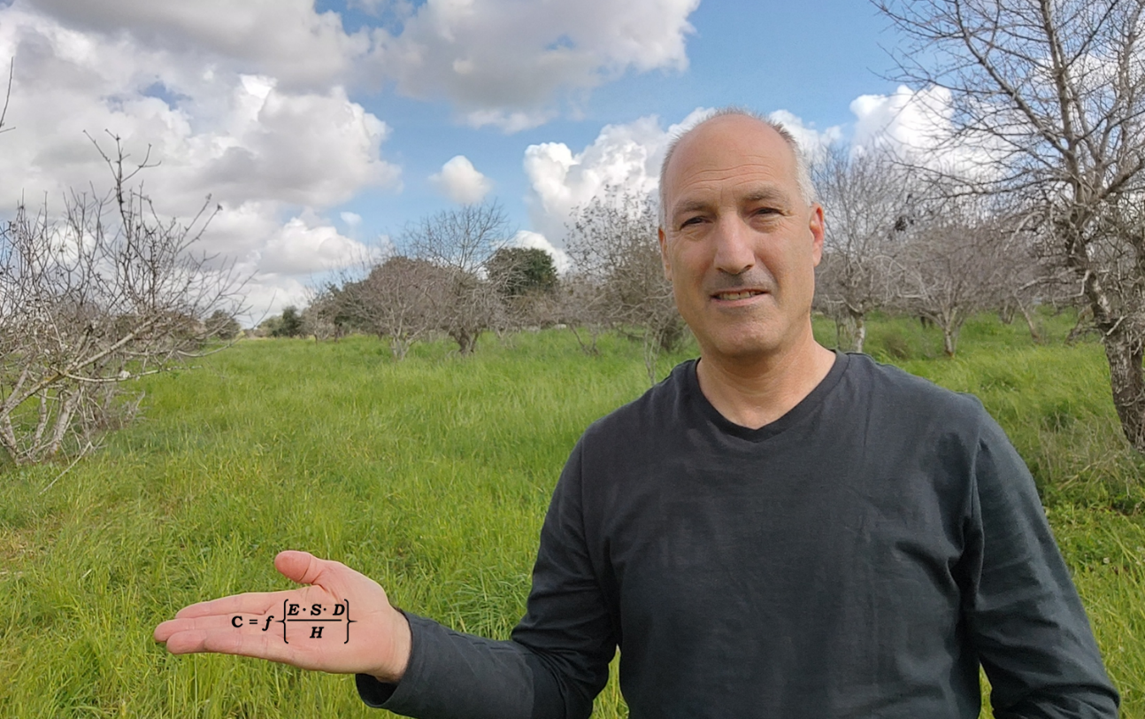

Does The ULIC Have a Mathematical Foundation?

"In a world governed by entropy, one should wonder what drives order, structure, and progress."

Why Do Some Societies Prosper While Others Stagnate?
Imagine two villages. Both receive the same technology, modern irrigation, fertilizers, and farming equipment. One village thrives, doubling its output and wealth. The other remains stuck in poverty. Why?
For decades, development efforts have assumed that technology alone drives prosperity. If farmers struggle, give them better tools. If productivity remains low, provide even more advanced machinery. Yet, time and again, these efforts fall short, revealing a fundamental misunderstanding: technology is only a tool. Without a structured system to integrate and direct it, even the most advanced innovations fail to generate sustained progress.
The missing ingredient? A structured, scalable system that directs resources effectively, this is what the Universal Law of Increasing Complexity (ULIC) explains.
This column introduces ULIC’s mathematical foundation, not just as an abstract concept but as a practical tool to engineer prosperity. Before we delve into the numbers, let’s first explore why complexity, not just technology, determines success.
You may ask: Wouldn’t it be more useful to focus on better machinery, subsidies, and financing rather than mathematical equations? After all, what does math have to do with poor farmers and their prospects for prosperity?
The connection is profound. For decades, the dominant approach to solving farmers’ poverty has been technology-driven, assuming that if productivity is low, providing better tools will solve the problem. When these efforts fall short, the response is often the same: more investment in efficiency-enhancing technology and capital.
This logic extends beyond agriculture. Economists and policymakers worldwide assume technological progress is prosperity's primary driver. Governments, corporations, and international institutions pour billions into AI, biotechnology, and automation, believing that technologies are the leading factor in raising global living standards, including those of impoverished farmers.
But history tells a different story. If technology alone created prosperity, then:
* Simply handing advanced tools to subsistence farmers would have eradicated poverty.
* Industrialized nations would never experience recessions.
* The Soviet Union, one of the most technologically advanced states of its time, would have thrived, while South Korea, once a poor agrarian society, would have failed.
Clearly, something else is at work. But what is it?
The missing factor is the simultaneous blend of energy, structure, and direction that, when properly implemented, fuels economies and organizations, but when failed, leads to the collapse of empires, societies, and organizations.
Technology alone does not generate prosperity. It is merely a tool that enhances efficiency. Without an underlying complex system that directs and integrates energy and resources, technology alone cannot take us to the next level of complexity.
The ULIC framework reveals that increasing complexity is the real engine of sustained progress.
Why Do We Need a Formula?
Imagine designing a skyscraper without understanding the laws of physics. Would you guess where to place support beams, or would you use precise equations to ensure stability? Just as physics provides a framework for construction, ULIC offers a mathematical foundation for understanding complexity growth, allowing us to predict why some systems thrive while others collapse.
Economic and societal progress is no different. Without a formula, we rely on intuition and luck. ULIC provides a structured, measurable framework that allows us to predict why some systems thrive while others collapse and understand the mechanism that drives those.
Just as physics equations explain how structures hold together, ULIC’s formula explains how complexity grows and why prosperity emerges in some societies and not in others.
This column lays the mathematical foundation of ULIC, elevating it from an idea to a predictive tool that policymakers, economists, and business leaders can use to engineer prosperity systematically rather than relying on trial and error.
To establish this predictive framework, we must first address a fundamental challenge:
While the universe trends toward entropy and decay, we continuously observe the emergence of order and complexity. What counterforce allows structured systems to evolve and persist?

Entropy vs. Complexity: A Fundamental Question
If entropy drives systems toward disorder, what fundamental principle explains the persistent emergence of complex structures, ranging from galaxies and biological life to economies and technological civilizations?
The Second Law of Thermodynamics states that in a closed system, entropy always increases, leading to decay and disintegration over time. Yet, despite this universal tendency toward disorder, we live in a world filled with structure, organization, and increasing complexity.
From the formation of galaxies and the emergence of life to the rise of civilizations and the digital economy, order is continuously being created and growing in complexity.
This paradox demands an explanation.
If entropy dominates the universe, what counterforce allows complex structures to emerge and thrive?

Genordo: The Universal Principle of Ordered Growth
The name Genordo comes from the Latin words Genesis (creation) and Ordo (order), representing the emergence of structured complexity. While entropy describes the natural tendency toward disorder, Genordo is the counterforce that drives the formation of ordered, functional systems, from molecules assembling into life to societies organizing into economies and technological civilizations.
Genordo is the force that counteracts entropy, driving the emergence of complexity, from biological life to economic prosperity. While entropy represents disorder, Genordo channels energy into structured, purpose-driven systems. Without it, energy is wasted, resources remain untapped, and potential remains unrealized. When Genordo exceeds entropy, systems grow more complex; when it weakens, stagnation and decay take hold.

Understanding Entropy: The Absence of Complexity Growth
If Genordo is the active force that drives complexity forward, Entropy is the absence of that force, allowing systems to decay and collapse.
Entropy does not act; it simply describes what happens when energy is not structured and directed toward emergent capabilities.
This can be understood using the darkness-light analogy:
Darkness is not a force in itself; it is simply the absence of light.
Entropy is not an active destructive force; it is what happens when Genordo fails to operate.

When Does Entropy Increase?
Entropy thrives when any of the three essential drivers of complexity: energy, structure, or direction, are missing or insufficient:
Lack of Energy Input (E) → Without sustained energy flow, systems degrade.
Weak Structural Formation (S) → Without stable structures, energy cannot be stored or channeled effectively.
Absence of Purposeful Direction (D) → Without direction, even structured systems lack the ability to generate emergent capabilities.
In such cases, entropy dominates, and the system collapses into disorder.

Entropy vs. Genordo: A Comparison
Concept | Entropy (H) | Genordo (G)
Effect | Disorder, decay | Order, complexity
Universal Scope | Applies to all isolated systems | Applies to structured, evolving open systems
Force Direction | Breakdown over time | Formation and evolution
Explanatory Power | Describes why systems decay | Explains how complex systems emerge and evolve
Engineering Use | Helps understand system degradation | Helps design, upgrade, and optimize complex systems
Historical Analysis | Describes entropy-driven collapses (e.g., the Roman Empire’s fall) | Explains why history developed the way it did
Examples | Glass breaking, star fading, social collapse | Life emergence, technology evolution, societal progress
Now that we have identified the fundamental forces at play; Entropy (H) and Genordo (G), we can quantify how these forces interact to shape structured systems.

The Genordo Equation: The Complexity Formula
To quantify complexity growth, we must break it down into its core components. Across all domains, physics, chemistry, biology, and human societies, three essential factors drive complexity:
» Energy Input (E): The continuous flow of resources into a system.
» Structural Formation (S): The system’s ability to organize and store energy.
» Purposeful Direction (D): The guiding forces that channel complexity toward functional outcomes.
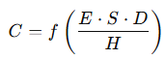
However, complexity does not increase indefinitely. Entropy (H) counteracts these forces, resisting structure formation and accelerating disintegration. Thus, complexity growth (C) can be mathematically defined as:
C=f(E⋅S⋅D/H)
This equation provides a universal framework for understanding why complexity emerges, thrives, and sometimes collapses. While energy fuels potential, only when it is structured and directed does it generate sustained progress.

The Capabilities Formula
If complexity growth enables greater functionality, we must define how emergent capabilities arise.
This is captured in the Universal Formula for Emergent Capabilities:
EC = f ((IE+EE) / H)
where:
IE = Internal Energy
EE = External Energy
H = Entropy

The Complexity-Purpose Nexus
Visual representation of how energy input and purposeful direction drive emergent capabilities.
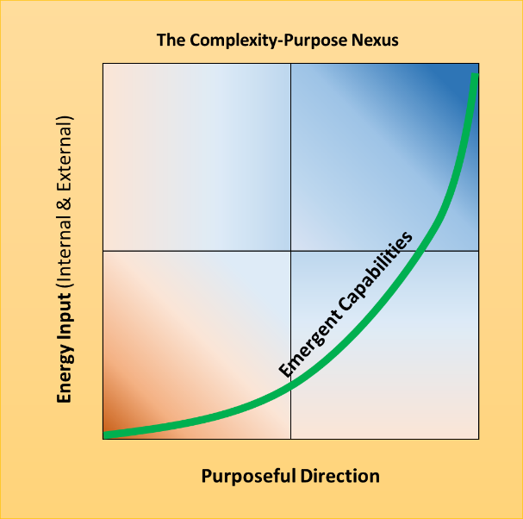

The Prosperity Formula
For human societies, prosperity is a direct function of external and social integration over internal disintegration:
P = f ((EI+SI) / ID)
where:
P = The sustained ability to generate and expand well-being by effectively channeling resources through structured, cohesive, and purpose-driven systems.
EI = External Integration (trade, alliances, open markets)
SI = Social Integration (internal cohesion, governance, shared values)
ID = Internal Disintegration (corruption, conflict, fragmentation)
This equation shows why societies that maximize integration and minimize disintegration sustain long-term prosperity.

The Togetherness-Prosperity Principle
How shared core missions and social cohesion drive prosperity.
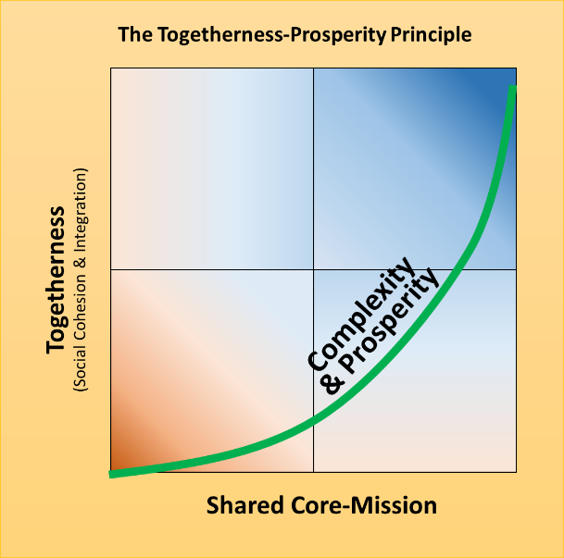

The Universal Engine of Progress: ULIC in Action
If the Universal Law of Increasing Complexity (ULIC) is correct, then prosperity, like all complexity growth, is not random; it follows structural principles. Just as the laws of physics determine how matter behaves, ULIC governs how energy, structure, and direction interact to shape complexity across all domains.
This law extends far beyond human societies. It explains why biological life evolved from single cells to multicellular organisms, why civilizations rise and fall, and why economies expand or stagnate. Until now, we have been able to answer the "how" and "what" of these transformations. ULIC finally gives us the "why", the underlying mechanism that drives them. You could think of ULIC as the blueprint for increasing complexity, which, in human societies, translates into prosperity, innovation, and long-term growth.
Evolution itself is a subset of ULIC, operating within biological systems. The same underlying forces that drive increasing complexity in nature also govern the expansion of history, technology, and economies. When energy is effectively structured and directed, new capabilities emerge, whether in the form of advanced life, industrial revolutions, or economic prosperity.
ULIC is more than a theory, it is a universal blueprint for complexity growth. It explains why civilizations rise, economies expand, and technological revolutions occur. But can it predict the future? In the next column, we will put ULIC to the test, applying it to major historical transformations to assess its explanatory and predictive power.

Takeaway Messages
» Genordo explains why complexity emerges and what counteracts entropy.
» Energy alone does not create progress; it must be structured and directed.
» ULIC offers a predictive framework for history, economics, and technology.

==> Are you looking for a keynote speaker who can introduce your audience to revolutionary ideas in agriculture, economics, and the science of prosperity? I challenge conventional thinking and explore how history, complexity, and organizational structures shape our world and how we can leverage them to create lasting change.
📞 Call me at +972-54-2523425 to discuss how I can contribute to your next event.

Subscribe here, free of charge!
"Mental and Economic Freedom Are Interconnected."

See you soon,
Nimrod


Dr. Nimrod Israely is the CEO and Founder of Dream Valley and Biofeed companies and the Chairman and Co-founder of the IBMA conference. +972-54-2523425 (WhatsApp), or email nisraely@biofeed.co.il

P.S.
If you missed it, here is a link to last week's blog, “Does The Universal Law of Increasing Complexity Contradict Entropy?”
P.P.S.
Here are ways we can work together to help your agro sector and rural communities step forward and shift from poverty into ongoing prosperity:
* Nova Kibbutz and consultancy on rural communities' models.

* Local & National programs related to agro-produce export models - Dream Valley global vertical value and supply chain business model and concept connects (a) input suppliers with farmers in developing economies and (b) those farmers with consumers in premium markets.

* Crop protection: Biofeed, an eco-friendly zero-spray control technology and protocol.

You can follow me on LinkedIn, YouTube, and Facebook.
*This article addresses general phenomena. The mention of a country/continent is used for illustration purposes only.

