

View Online and Translate


Did Our Economy Split from Our Social Needs?
“The pursuit of technological progress leads to a fundamental question: who are we, and what truly matters to Homo sapiens?”

Complexity, Progress and Fragmentation
A thought that has long troubled me is the stark growing contrast between technological progress and social development. Imagine transporting people from the Revelation at Mount Sinai 3,500 years ago into today’s world. The sight of airplanes, skyscrapers, and smartphones would leave them convinced that aliens had taken over the planet. And yet, in matters of human relationships, morality, and social structures, they would feel right at home. They would recognize our laws against murder, theft, and slavery and would understand the concepts of villages, cities, and governments.
How is it that we have mastered flight, split the atom, mapped the human genome, and developed AI, yet our social and emotional evolution has barely budged? What does this tell us about the nature of progress? More importantly, what if we could advance our social and emotional development as we have with technology? What extraordinary possibilities might humanity unlock?
In the previous column, we explored how the rapid acceleration of economic and technological complexity has left social and emotional complexity behind, creating a growing misalignment that impacts prosperity and well-being. This raises an urgent question: How have historical societal structures influenced this divergence, and what lessons can we extract to design a more balanced future?
Addressing poverty and fostering prosperity require a deeper understanding of Complexity, not only in economic and technological terms but also in the evolution of social and emotional structures. If we aim to build sustainable, thriving societies, we must ensure that our guiding principles - the Universal Law of Increasing Complexity (ULIC), Genordo (i.e., the opposite term of entropy), and the Prosperity Formula - are robust enough to serve as a reliable foundation for future policies and economic models.
While today’s world boasts unprecedented technological and economic progress, the foundations of human social structures are steadily eroding. Our ancestors; though materially poorer before the Agricultural Revolution, enjoyed stronger communal bonds, deeper emotional fulfillment, and a level of belonging we can scarcely imagine. If we fail to recognize and address the widening gap between economic advancement and social cohesion, we risk forging a future in which material prosperity thrives while emotional and communal well-being collapses, a rift that could ultimately lead to widespread instability, alienation, and unrest.
To understand the historical evolution of societies, it is crucial to define two key dimensions of complexity:
» Economic & Technological Complexity (ETC): Measures the sophistication of economic and technological systems, including trade networks, financial institutions, industrial production, and digital economies. A higher ETC reflects greater economic interdependence, technological advancements, and institutional complexity.
» Community Social Complexity (CSC): Represents the depth of human social structures, including kinship networks, interdependence, communal support, and the cohesion of societal bonds. A higher CSC reflects stronger community ties, mutual reliance, and shared social responsibilities.
For millions of years, ETC and CSC evolved together, supporting small but deeply interdependent societies. The Agricultural Revolution (~12,000 years ago) marked the first major split: as food surpluses enabled larger, more specialized settlements, economic complexity grew, but tight-knit tribal bonds weakened. The rise of cities, feudalism, and modern economies accelerated this divide, as large-scale trade and corporate structures distanced individuals from traditional community support systems.
While economic and technological complexity (ETC) has surged over time, driving extraordinary material progress, community social complexity (CSC) has often declined, weakening human social bonds. This divergence has shaped the rise and fall of civilizations, as illustrated in the figure below.
Today, economic and technological complexity (ETC) is at an all-time high, while community social complexity (CSC) has reached historic lows. Modern societies no longer depend on direct community networks; instead, they rely on financial systems, state institutions, and digital platforms; advancing prosperity, but often at the cost of deepening social fragmentation.
As previously illustrated in “Modern Economic Case Study: South Korea, North Korea, the Soviet Union, China, and the USA”, history suggests that societies prioritizing economic expansion at the expense of social cohesion risk collapse. If we are to build a sustainable and thriving future, we must rethink how we structure human connections alongside technological progress.

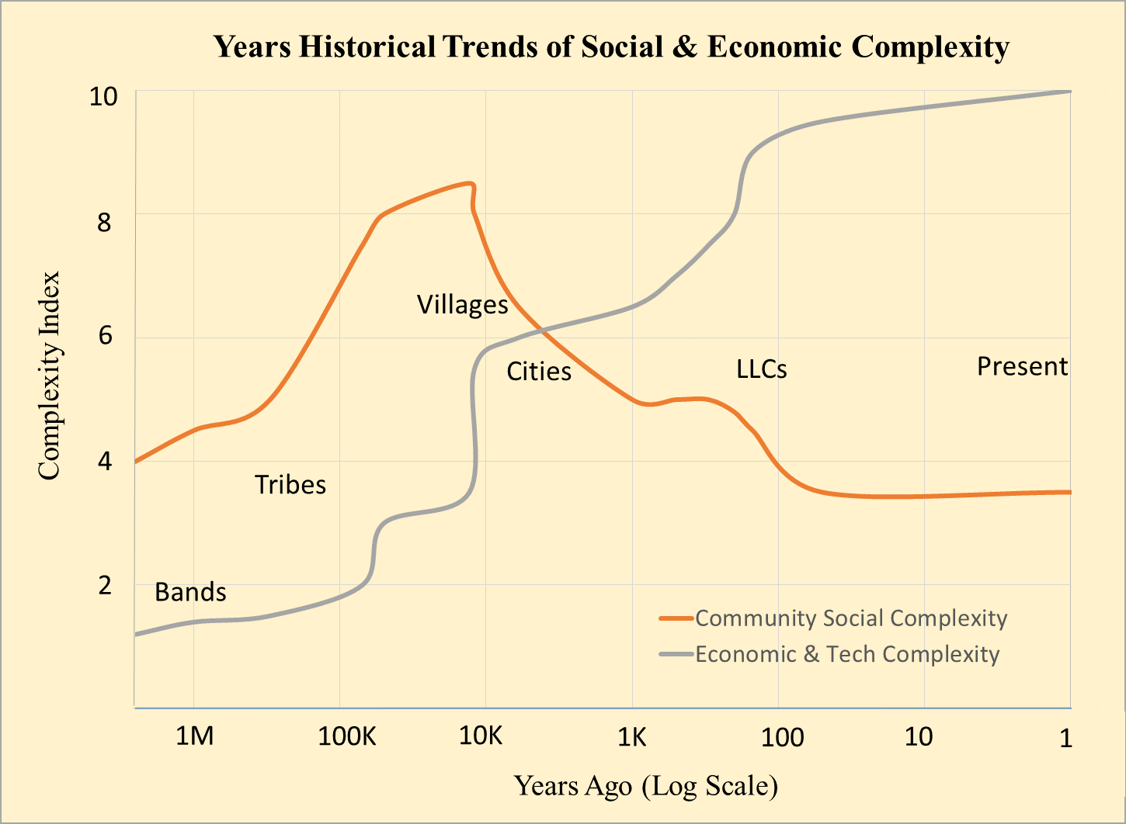
Figure: Historical Trends in Economic and Social Complexity. This figure illustrates the trajectory of hominin economic and social complexity over the past 2.5 million years. The Agricultural Revolution marked the first major divergence: while economic and technological complexity began to scale dramatically, traditional social bonds started to erode. This growing imbalance has only accelerated in modern times.

How did we get to this divergence? And are there proven models that offer a more balanced path forward? In the next column, we trace seven revolutions in human organizational structures, and what they reveal about our future.

Takeaways
» Economic progress surged while emotional and social evolution stagnated.
» Since the Linguistic Revolution, technology has evolved with culture; emotions still evolve with biology
» Modern prosperity masks a deepening crisis of social cohesion.

==> Looking for a speaker to introduce revolutionary ideas in agriculture, economics, history, complexity, organizational structures, and the science of prosperity? WhatsApp me at +972-54-2523425

Subscribe here, free of charge!
"Mental and Economic Freedom Are Interconnected."

See you soon,
Nimrod


Dr. Nimrod Israely is the CEO and Founder of Dream Valley and Biofeed companies and the Chairman and Co-founder of the IBMA conference. +972-54-2523425 (WhatsApp), or email nisraely@biofeed.co.il

P.S.
If you missed it, here is a link to last week's blog, “A Historical Perspective of the Growing Gap Between Economic and Community Complexity”.
P.P.S.
Here are ways we can work together to help your agro sector and rural communities step forward and shift from poverty into ongoing prosperity:
* Nova Kibbutz and consultancy on rural communities' models.

* Local & National programs related to agro-produce export models - Dream Valley global vertical value and supply chain business model and concept connects (a) input suppliers with farmers in developing economies and (b) those farmers with consumers in premium markets.

* Crop protection: Biofeed, an eco-friendly zero-spray control technology and protocol.

You can follow me on LinkedIn, YouTube, and Facebook.
*This article addresses general phenomena. The mention of a country/continent is used for illustration purposes only.

