

View Online and Translate
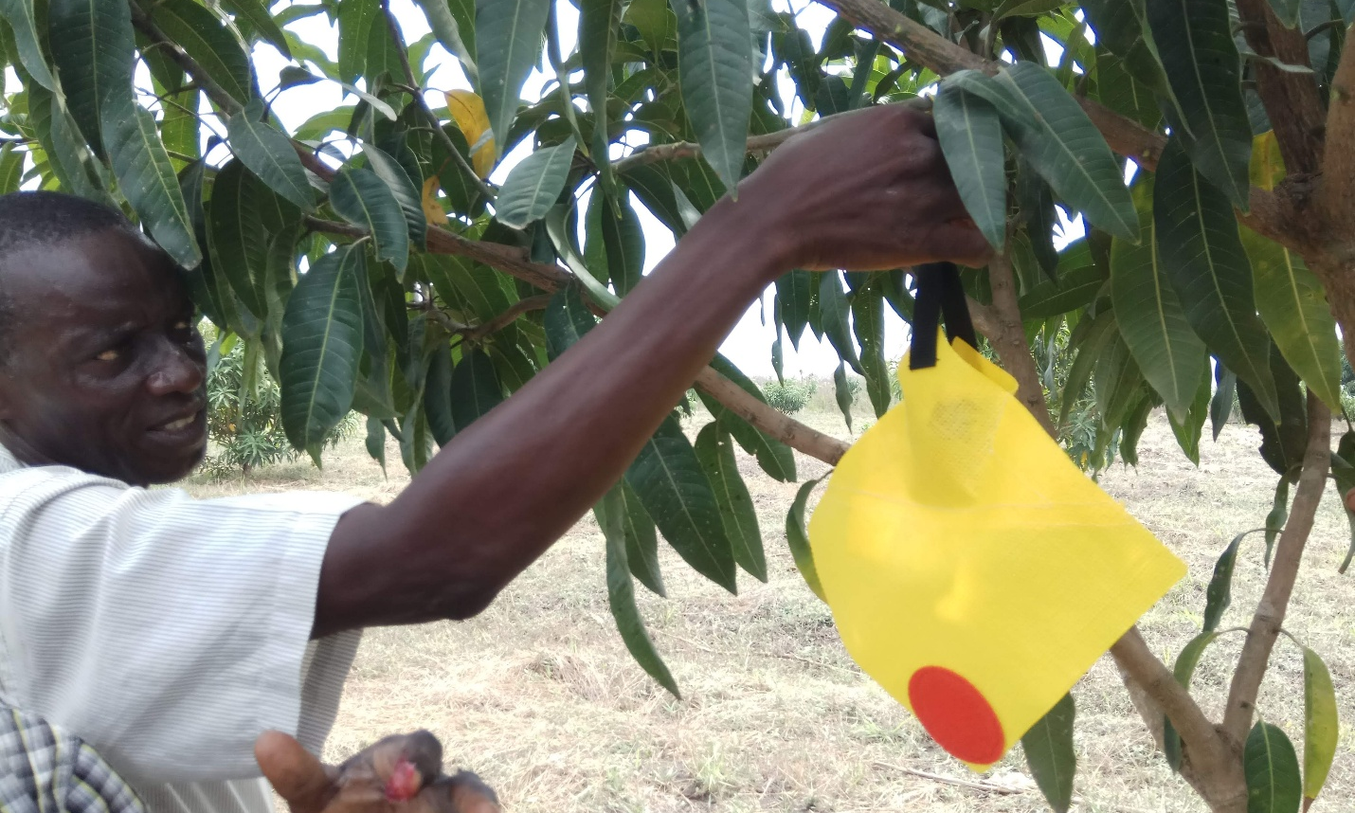

A Historical Perspective of the Growing Gap Between Economic and Community Complexity

“Know where you came from and where you are going” (The Jewish Mishnah)

Complexity, Prosperity, and Happiness
Complexity is a force that expands human capabilities, drives progress and shapes societies.
It has played a key role in increasing prosperity and can even contribute to greater happiness. Therefore, achieving the global goal of lifting millions of farmers out of poverty requires a deep understanding of this force. Helping impoverished farmers escape poverty clarifies what we seek to avoid for them, but do we have a clear vision of what we want for them, including the type of community in which they can thrive?

What is Complexity?
Complexity refers to the growing interconnections, dependencies, and layers of organization within a system. Throughout human history, it has evolved across multiple dimensions: social, emotional, economic, and technological.
For millions of years, Complexity advanced at the slow pace of genetic evolution, shaping hominin societies to fit their environments. Expanding into new habitats with different climates or adopting new food sources required biological adaptations - alterations at the genome level that unfolded over thousands or even millions of years. This equilibrium was disrupted after the Linguistic Revolution and later accelerated by the Agricultural and LLC Revolutions, shifting the primary driver of Complexity from biological to cultural evolution. Unlike genetic evolution, which operates at a glacial pace, cultural evolution unfolds within decades or even years, fueled by humanity’s unique ability to collectively envision and construct shared futures.
What changed? Economic and technological Complexity shifted from genetic evolution, which unfolds over thousands or millions of years, to cultural evolution, where transformations occur within a single generation. As a result, economic and technological progress surged exponentially while social and emotional structures remained largely static.
This rapid shift has driven economic growth but also contributed to social fragmentation. Traditional community bonds have weakened and been replaced by corporate employment, digital communication, and institutional security. It was a fundamental shift from the interdependent communities in which humans evolved.
The Paradox of Modern Life:
- Technologically, we can live on the Moon.
- Economically, we live in isolated apartments in cities.
- Socially, we are trapped in community structures designed 12,000 years ago.
- Emotionally, we are cave people, driven by our genetics, perfectly wired for life in nomadic bands of 50 to 150 hunter-gatherers.
Understanding this growing misalignment between accelerating economic and technological complexity and stagnant social and emotional structures is crucial. If we seek to build societies that foster both prosperity and well-being, we must confront this widening gap; where our ability to innovate and expand economically far outpaces our capacity to adapt socially and emotionally.

The Diverging Paths of Human Complexity
Understanding the growing misalignment between accelerating economic and technological complexity and stagnant social and emotional structures is crucial. While material progress has surged exponentially, social cohesion and emotional well-being have failed to keep pace. This widening gap between innovation and human fulfillment defines a major challenge of modern life.
We are at a critical inflection point. Technological and economic advancements continue to reshape the world at an unprecedented pace, yet our social and emotional frameworks remain rooted in structures that evolved for small, tightly-knit communities. As a result, we navigate vast urban environments, digital interactions, and corporate ecosystems that offer efficiency but often lack deep personal connections. If we do not address this imbalance, we risk building a future where economic prosperity comes at the cost of human well-being.
This divergence raises pressing questions: Are we engineering societies for prosperity at the cost of well-being and happiness? What can we learn from past societal structures to design a future that balances economic success with emotional fulfillment?
Since the Agricultural Revolution, economies have advanced rapidly while social and emotional support systems have lagged, deepening the misalignment between material progress and human needs. As societies became more sophisticated, tight-knit community structures diminished, raising important questions about the impact on well-being.

The ULIC and the Prosperity Formula Perspective
The Universal Law of Increasing Complexity (ULIC) explains how societies evolve by layering new structures over existing foundations. However, complexity does not progress uniformly across all domains; technological complexity has surged while social and emotional structures have struggled to keep pace.
For millions of years, social and emotional structures evolved in sync with genetic changes. However, after the Linguistic and Agricultural Revolutions, the transition to cultural evolution triggered an exponential rise in technological complexity. While economies and institutions adapted quickly, human psychological needs remained essentially unchanged, creating a growing disconnect between material prosperity and well-being.
The Prosperity Formula shows that long-term stability hinges on balancing two forces: internal cohesion (IN), which fosters trust and shared purpose, and external integration (E), which drives economic expansion and global connectivity. As societies advanced, external integration (trade, globalization, corporations, and technological innovation) increased exponentially, while internal cohesion (family bonds, community stability, and emotional security) weakened. This imbalance explains why economic prosperity at an organizational, national, or corporate level does not necessarily translate into individual well-being.
Thus, the real challenge is not merely advancing economic and technological progress but ensuring that social and emotional complexity evolves in parallel. Without alignment, societies may achieve economic power yet suffer from a weakened sense of belonging and emotional fragility, leading to political instability, social fragmentation, and a global rise in loneliness and mental health crises.

A Challenge for the Future
The modern world offers unprecedented material wealth, yet many individuals feel more isolated and unfulfilled than ever before. Understanding the growing gap between economic & technological complexity and social & emotional well-being is essential for designing a future that integrates prosperity with human fulfillment.
In the next column, we will explore potential solutions—from alternative community models to mission-driven economic structures—that may offer a path forward in restoring balance.

Takeaway Messages
» Economic-technological progress and social-emotional development evolve at partially independent paces.
» Happiness and true prosperity depend on balancing different forms of complexity.
» Modern societies fuel wealth while potentially eroding internal cohesion.

==> Looking for a speaker to introduce revolutionary ideas in agriculture, economics, history, complexity, organizational structures, and the science of prosperity? WhatsApp me at +972-54-2523425

Subscribe here, free of charge!
"Mental and Economic Freedom Are Interconnected."

See you soon,
Nimrod


Dr. Nimrod Israely is the CEO and Founder of Dream Valley and Biofeed companies and the Chairman and Co-founder of the IBMA conference. +972-54-2523425 (WhatsApp), or email nisraely@biofeed.co.il

P.S.
If you missed it, here is a link to last week's blog, “Can We Engineer Prosperity (Part 2)”
P.P.S.
Here are ways we can work together to help your agro sector and rural communities step forward and shift from poverty into ongoing prosperity:
* Nova Kibbutz and consultancy on rural communities' models.

* Local & National programs related to agro-produce export models - Dream Valley global vertical value and supply chain business model and concept connects (a) input suppliers with farmers in developing economies and (b) those farmers with consumers in premium markets.

* Crop protection: Biofeed, an eco-friendly zero-spray control technology and protocol.

You can follow me on LinkedIn, YouTube, and Facebook.
*This article addresses general phenomena. The mention of a country/continent is used for illustration purposes only.

